Phase 1 – Recursion Mindset Reset

Question 1
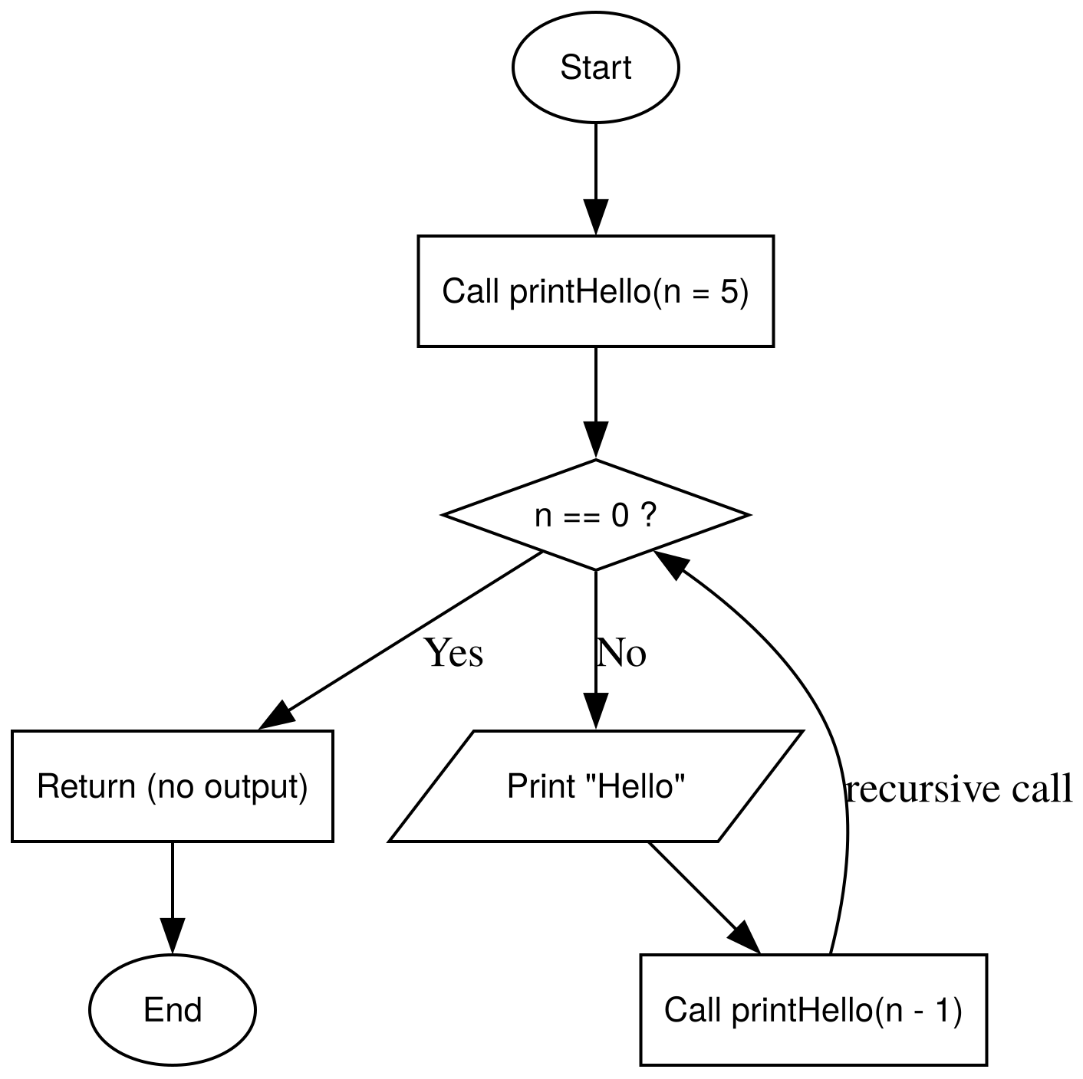 | void print_hello(int n) {  // recur pritns hello  if (n == 0) {  return ;  }  cout << "Hello World!" << endl;  print_hello(n-1);  }

Question 2
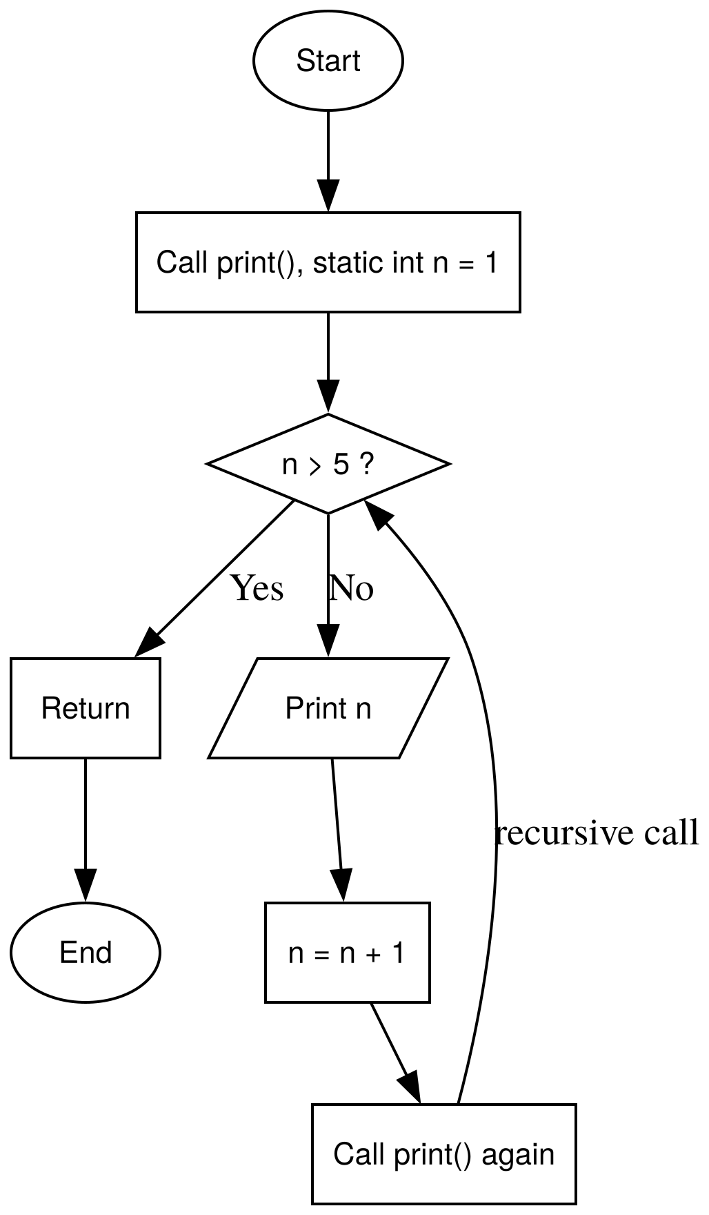 | void print_1_to_5() {  static int c = 1;  if (c > 5) {  return;  }  cout << c << endl;  c++;  print_1_to_5();  }

Question 3
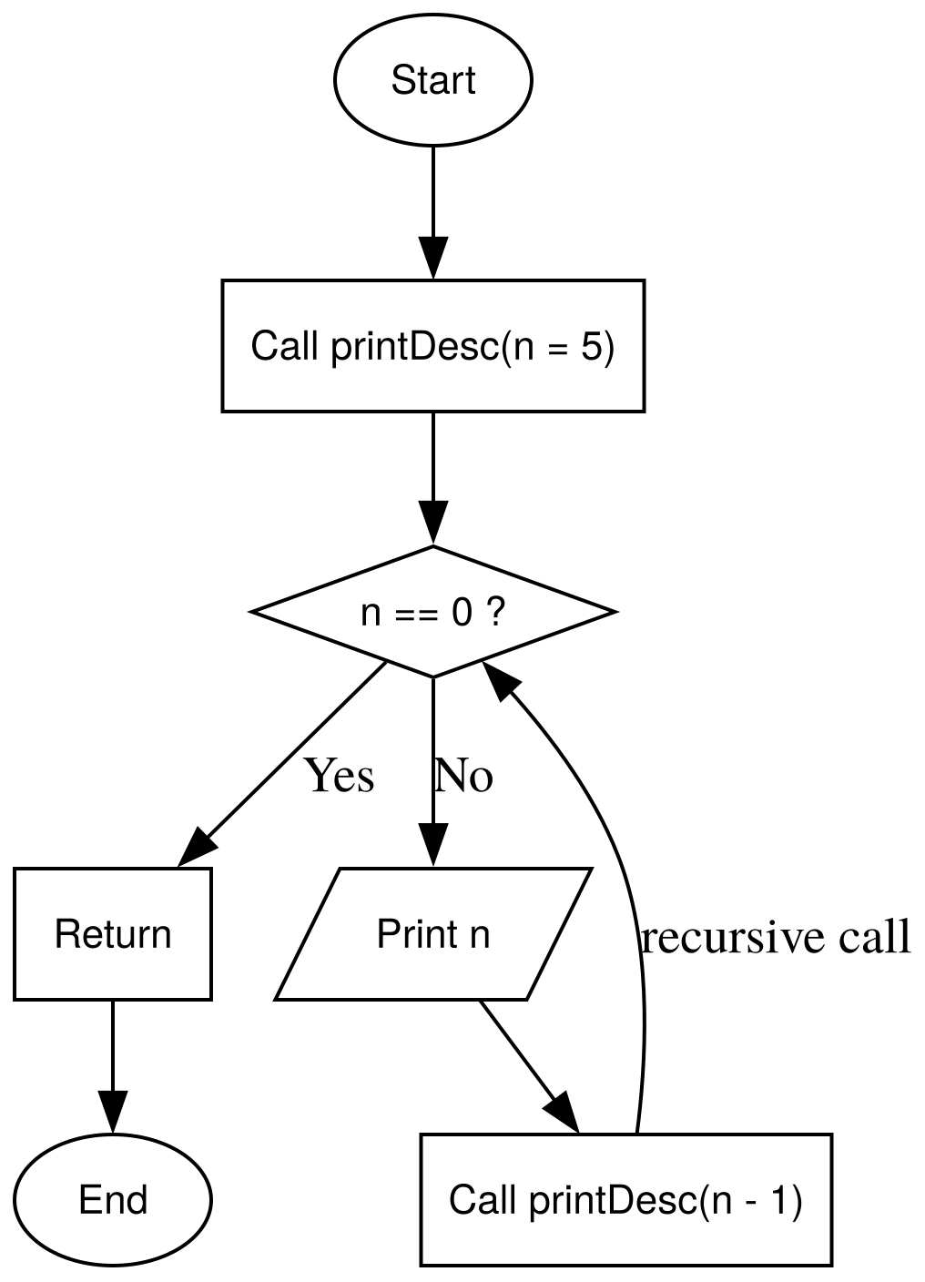 | void print_5_to_1(int n) {  if (n < 1) {  return;  }  cout << n << endl;  print_5_to_1(n - 1);  }

Question 4
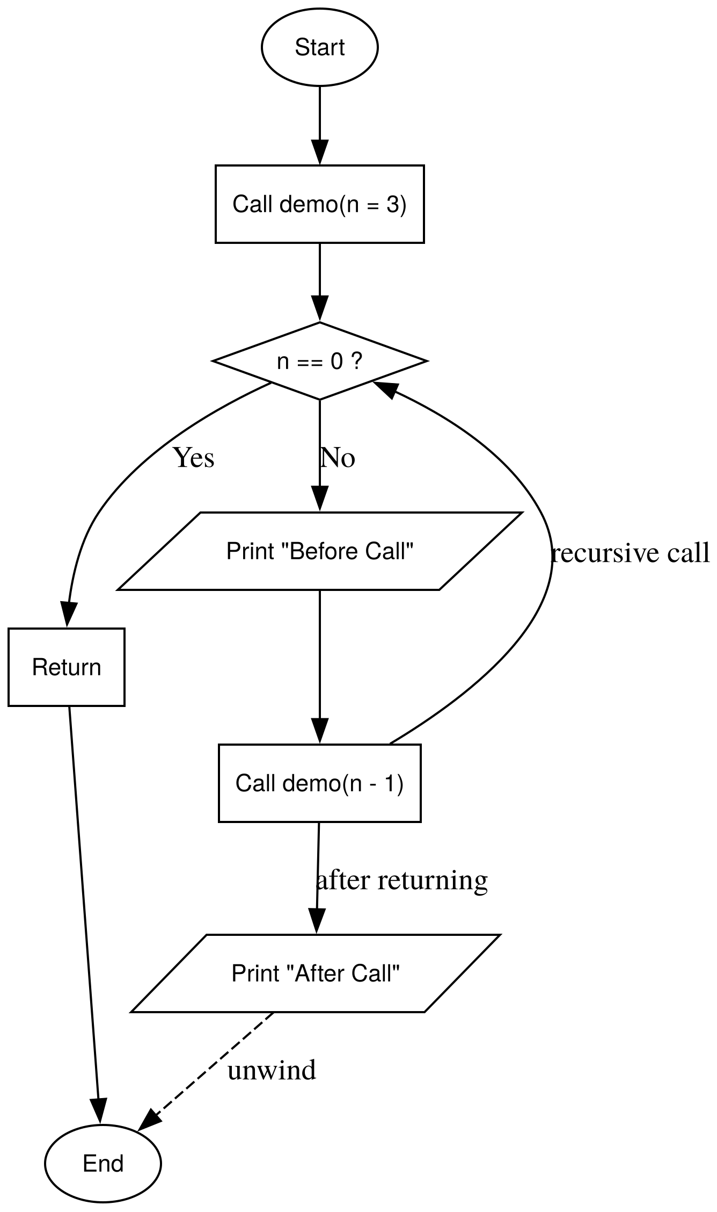 | void obeserving_order(int n) {  if (n < 1) {  return ;  }  cout << "Before call: " << n << endl;  obeserving_order(n-1);  cout << "After call: " << n << endl;  }

Question 5
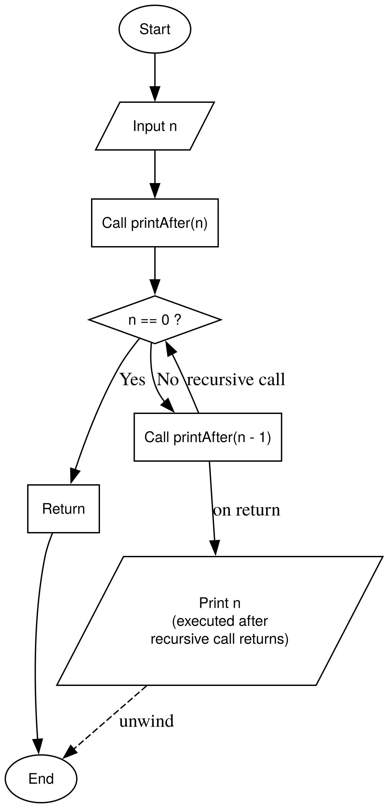 | void print_1_to_n_after(int n) {  if (n < 1) return ;  print_1_to_n_after(n-1);  cout << n << endl;  }

Question 6
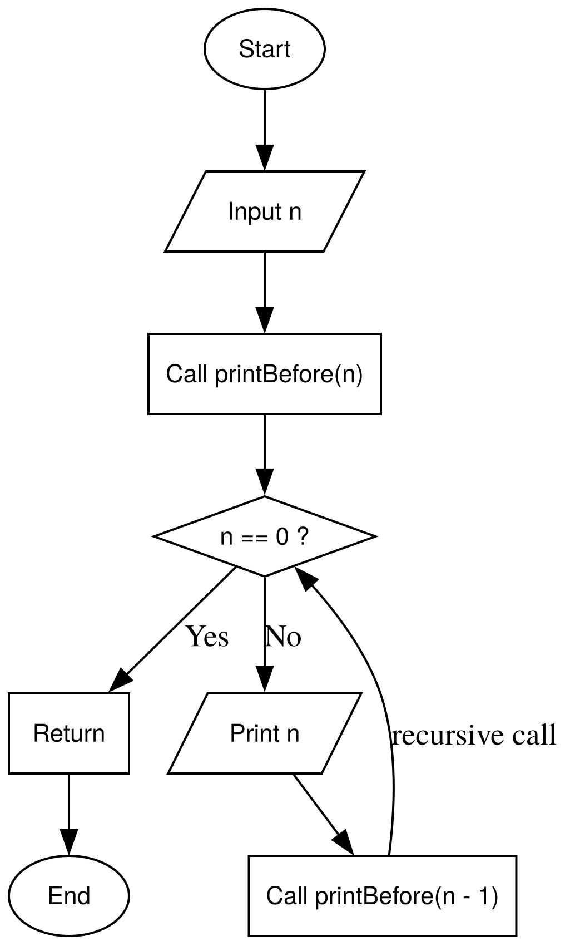 | void print_1_to_n_before(int n, int curr) {  if (curr > n) return ;  cout << curr << endl;  print_1_to_n_before(n, curr+1);  }

Question 7
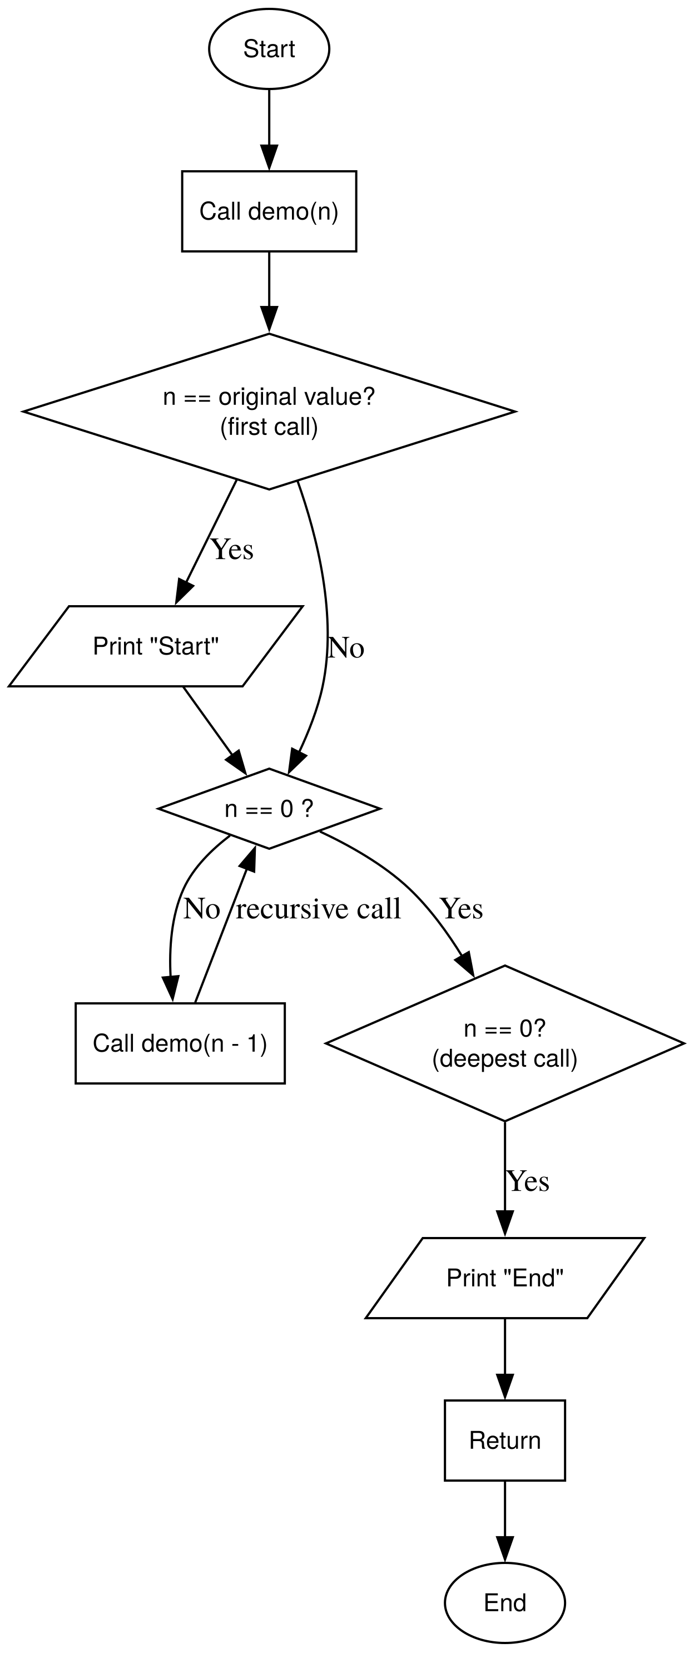 | void print_start_2_end(int n) {  static bool is_first = true;  if (is_first) {  cout << "Start" << endl;  is_first = false;  }  if (n == 0) {  cout << "End" << endl;  return;  }  print_start_2_end(n-1);  }

Question 8
void print_current_n(int n) {
if(n==0) return ;
cout << "Current n: " << n << endl;
print_current_n(n-1);
}

Question 9
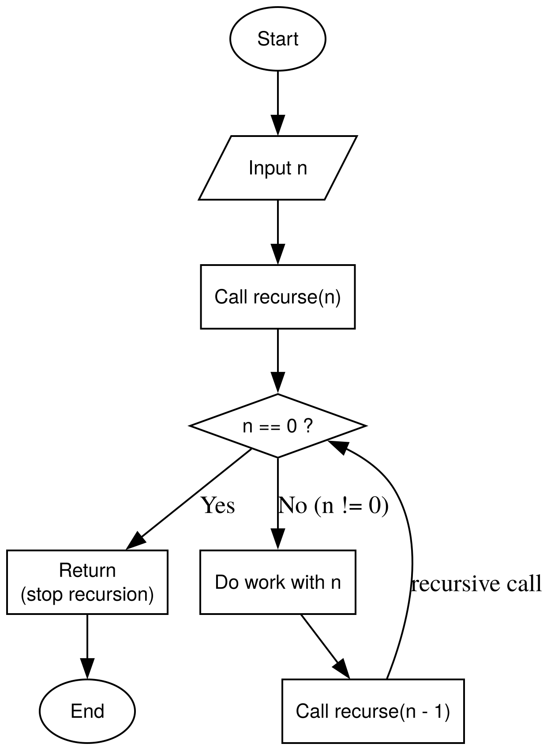 | void stop_at_zero(int n) {  if (n == 0) return ;  stop_at_zero(n-1);  }

Question 10
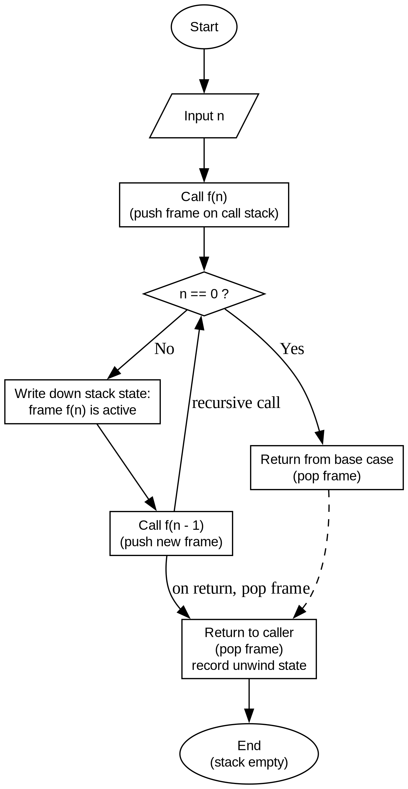 | Dry-run for print_5_to_1(5):  Call Stack Pushing:  print_5_to_1(5): Prints 5 -> Calls print_5_to_1(4)  print_5_to_1(4): Prints 4 -> Calls print_5_to_1(3)  print_5_to_1(3): Prints 3 -> Calls print_5_to_1(2)  print_5_to_1(2): Prints 2 -> Calls print_5_to_1(1)  print_5_to_1(1): Prints 1 -> Calls print_5_to_1(0)  print_5_to_1(0): Base case reached (0 < 1) -> Returns  Call Stack Popping:  print_5_to_1(0) popped off stack  print_5_to_1(1) popped off stack  print_5_to_1(2) popped off stack  print_5_to_1(3) popped off stack  print_5_to_1(4) popped off stack  print_5_to_1(5) popped off stack -> Execution finishes  Output:  5  4  3  2  1

Phase 2 – Linear Number Recursion

Question 1
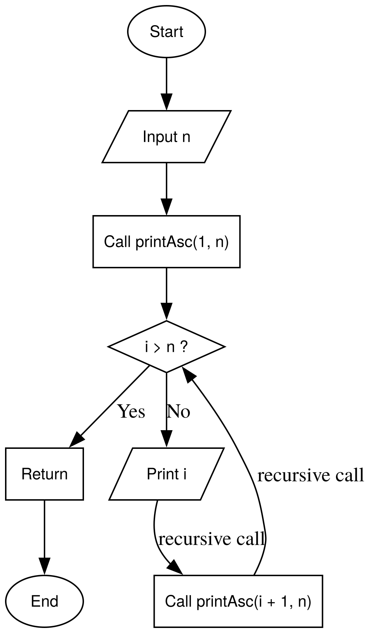 | void print_1_to_n_recur(int c, int n) {  if (c> n) return;  cout << c << endl;  print_1_to_n_recur(c+1, n);  }

Question 2
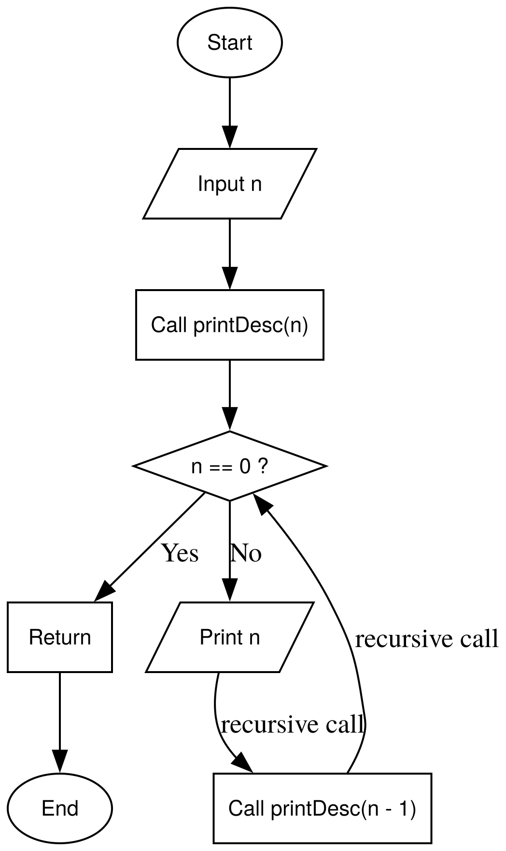 | void print_n_to_1(int n) {  if (n == 0) return ;  cout << n << endl;  print_n_to_1(n-1);  }

Question 3
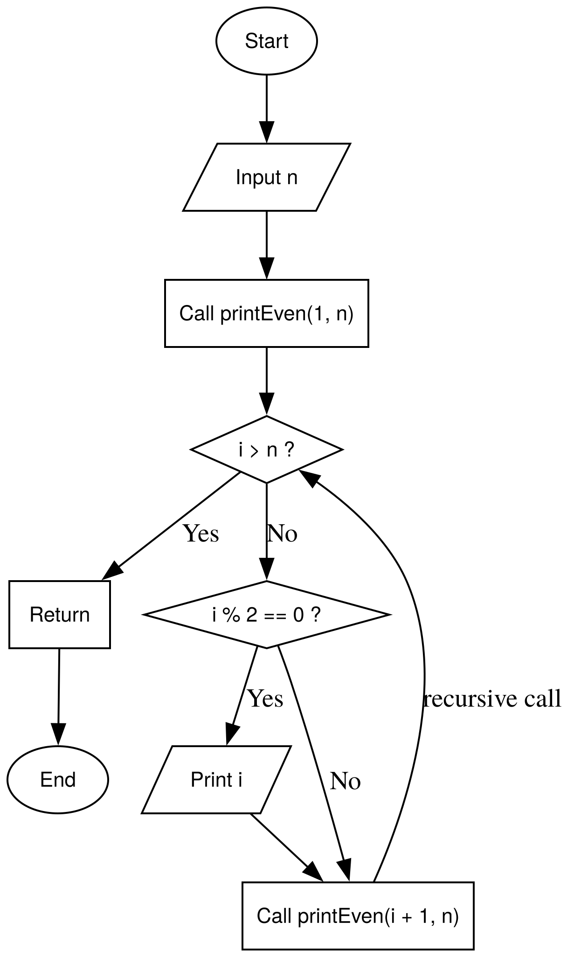 | void print_1_to_n_recur_even(int c, int n) {  if (c > n) return;  if (c % 2 == 0) cout << c << endl;  print_1_to_n_recur_even(c+1, n);  }

Question 4
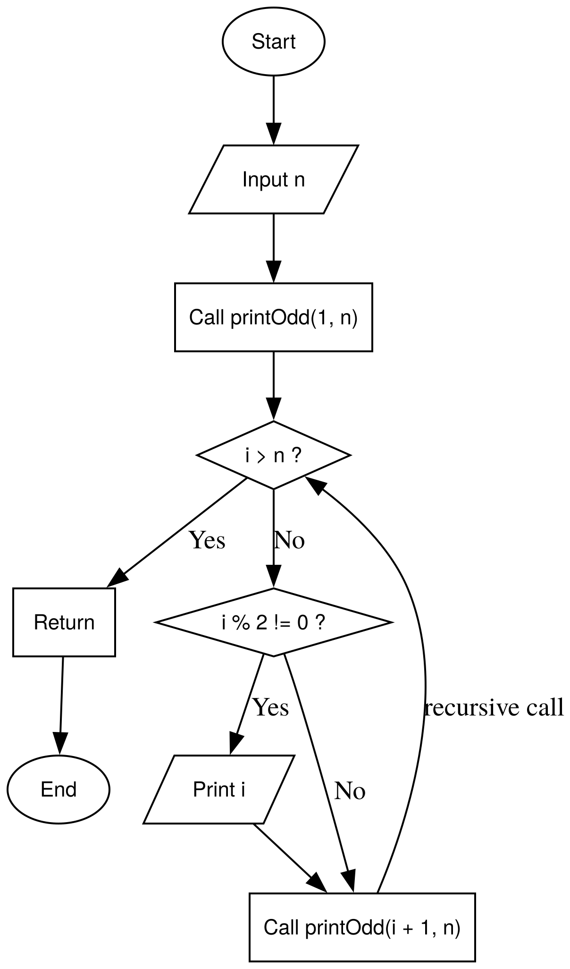 | void print_1_to_n_recur_odd(int c, int n) {  if (c > n) return;  if (c % 2 == 1) cout << c << endl;  print_1_to_n_recur_odd(c+1, n);  }

Question 5
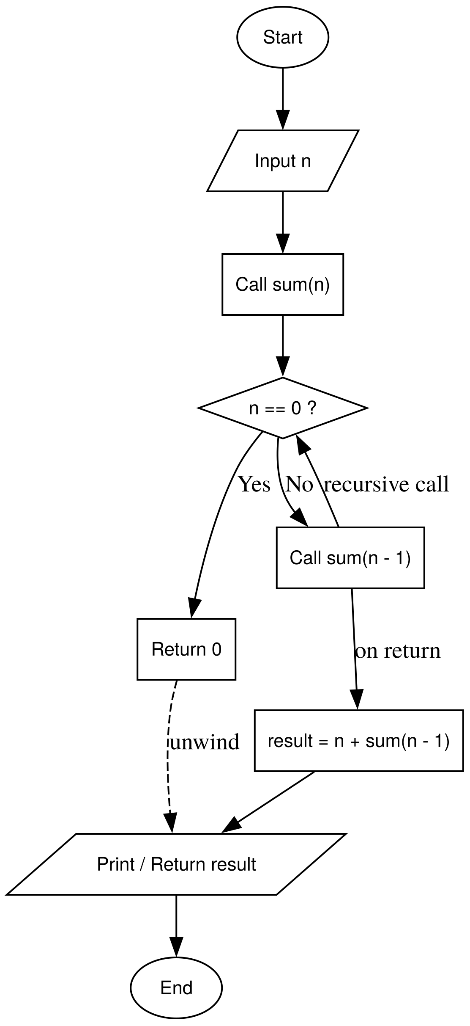 | ll recur_sum(ll n) {  if (n <= 0 ) {  return 0;  } else {  return n + recur_sum(n-1);  }  }

Question 6
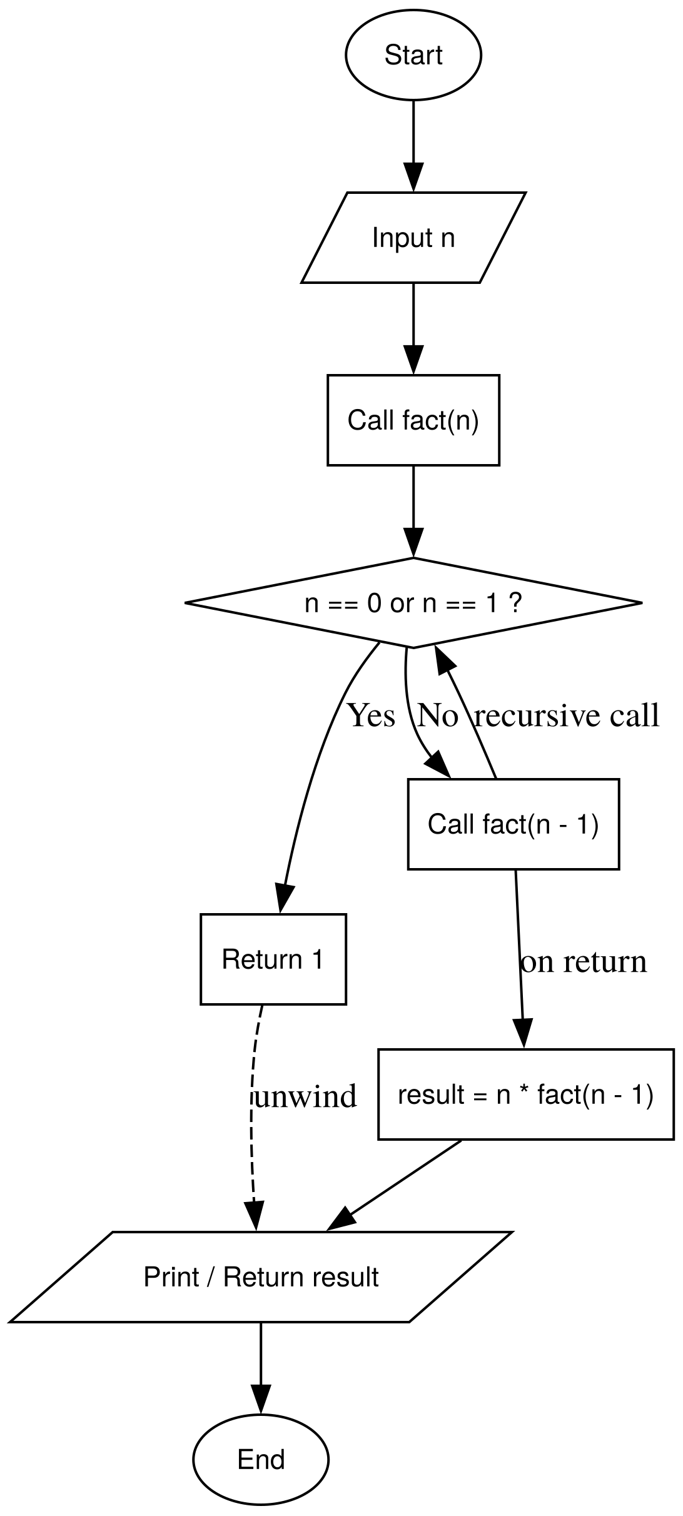 | ll fact_recur(int n) {  if (n ==0 || n == 1) {  return 1;  } else {  return n * fact_recur(n-1);  }  }

Question 7
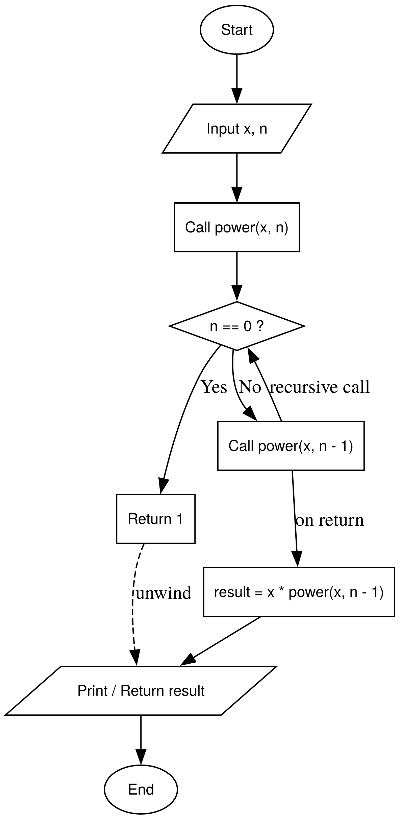 | ll calc_power(int x, int n) {  if (n ==0) return 1;  return x * calc_power(x, n-1);  }

Question 8
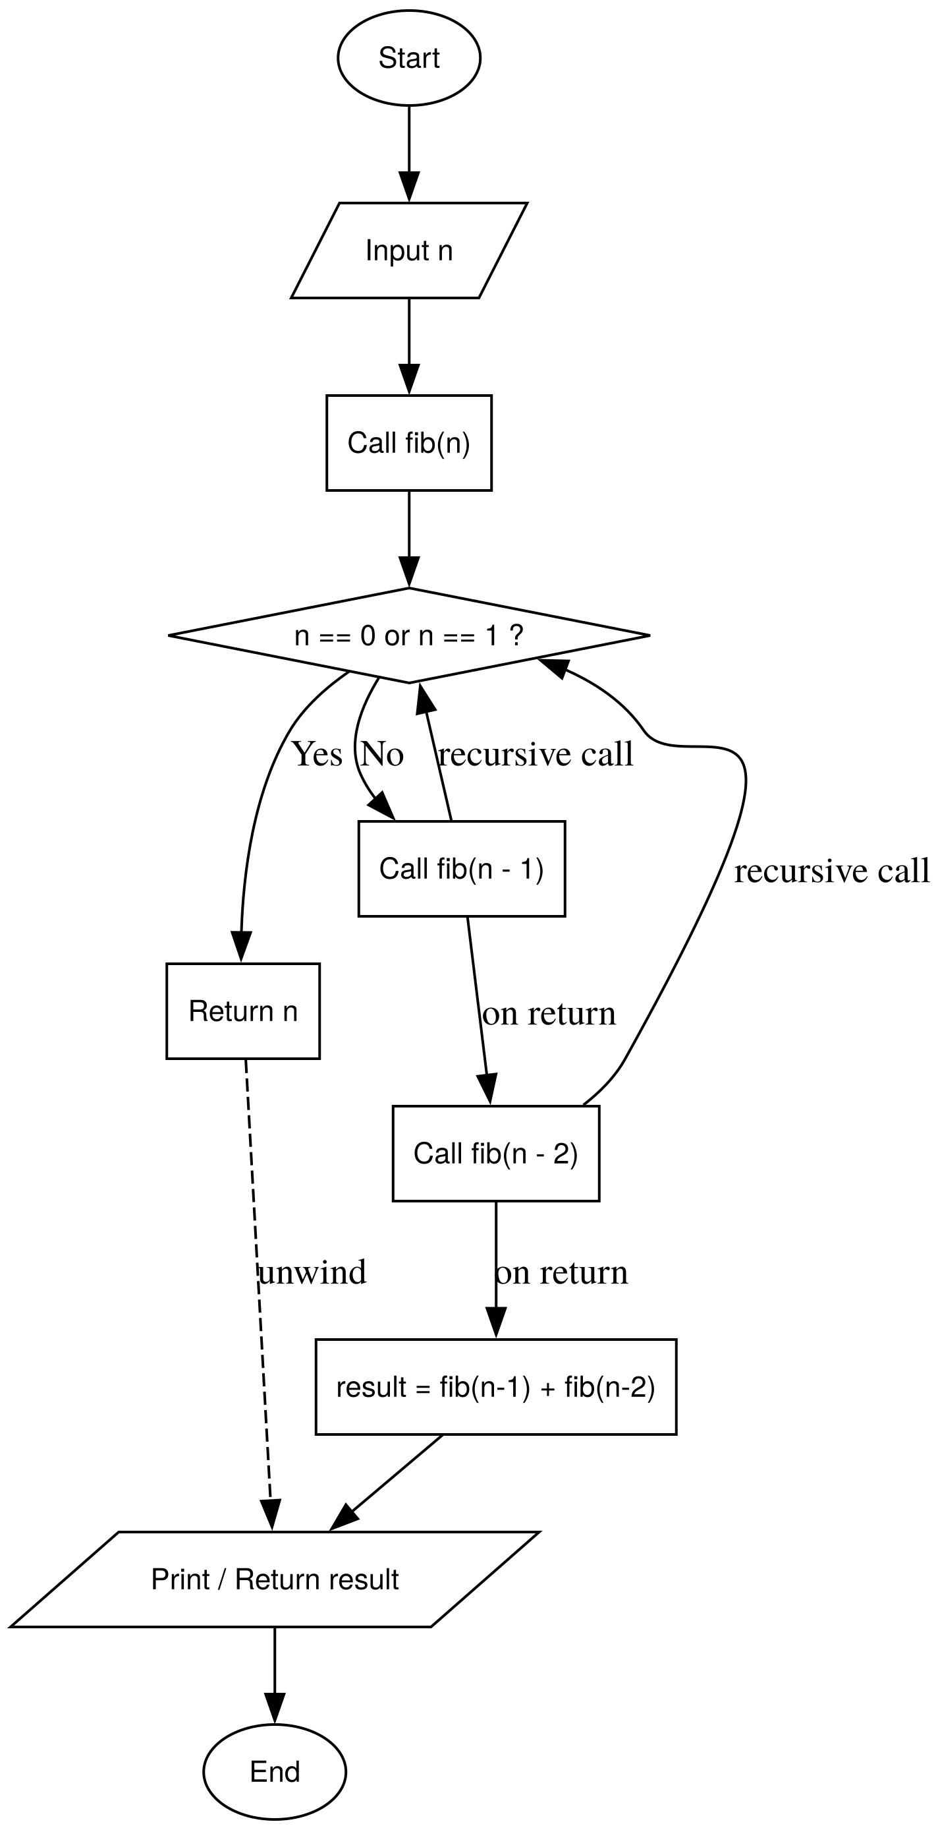 | ll fibonacci(int n) {  if (n == 0) {  return 0;  } else if (n == 1) {  return 1;  }  else {  return fibonacci(n-1) + fibonacci(n-2);  }  }

Question 9
ll fibonacci(int n) {
if (n == 0) return 0;
if (n == 1) return 1;
return fibonacci(n-1) + fibonacci(n-2);
}

void print_fibbonaci(int n, int i = 0) {
if (i >= n) {
cout << endl;
return;
}
cout << fibonacci(i) << " ";
print_fibbonaci(n, i+1);
}

Question 10
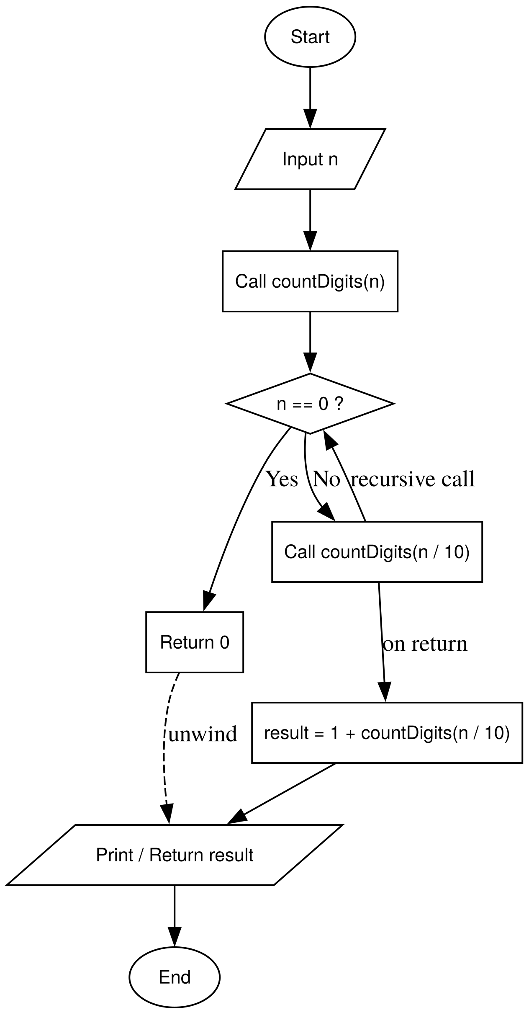 | int count_digits(ll n) {  if (n < 10) return 1;  return 1 + count_digits(n/10);  }

Question 11
int sum_digits(int n) {
if (n == 0) return 0;
return (n % 10) + sum_digits(n/10);
}

Question 12
int prod_digits(int n) {

if (n == 0) return 1;
return (n % 10) * prod_digits(n/10);
}

Question 13
ll rev_num(ll n, ll rev = 0) {
if (n == 0) return rev;
return rev_num(n / 10, (rev * 10) + (n % 10));
}

Question 14
bool palindrome(ll num, int left, int right=-1) {
// if num is neg, return false
if (num < 0) {
return false;
}
if ((num <= 9 && num >= 0)) {
return true;
}

string s = to_string(num);

if (right == -1) {
right = s.length() -1;
}

// base case if the pointers cross or meet, every digit is matched then
if (left >= right) return true;

// if digits at current pointers dont match., then not a match
if (s[left] != s[right]) {
return false;
}

// pointers returned ,but number retained
return palindrome(num, left+1, right-1);
}

Question 15
string decimal_bin(ll n){

// base case when n == 0;
if (n==0) return "0";
if (n==1) return "1";

return decimal_bin(n/2) + (char)((n%2) + '0');
}

Question 16
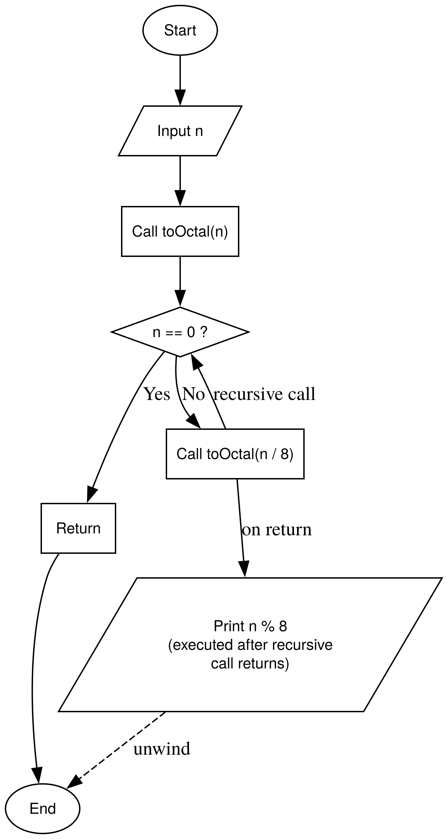 | string oct_deci(ll n) {  // base case when == 0  if (n==0) return "0";  // return remainder if n < 8  if (n < 8) return to_string(n);  return oct_deci(n / 8) + (char)((n % 8) + '0');  }

Question 17
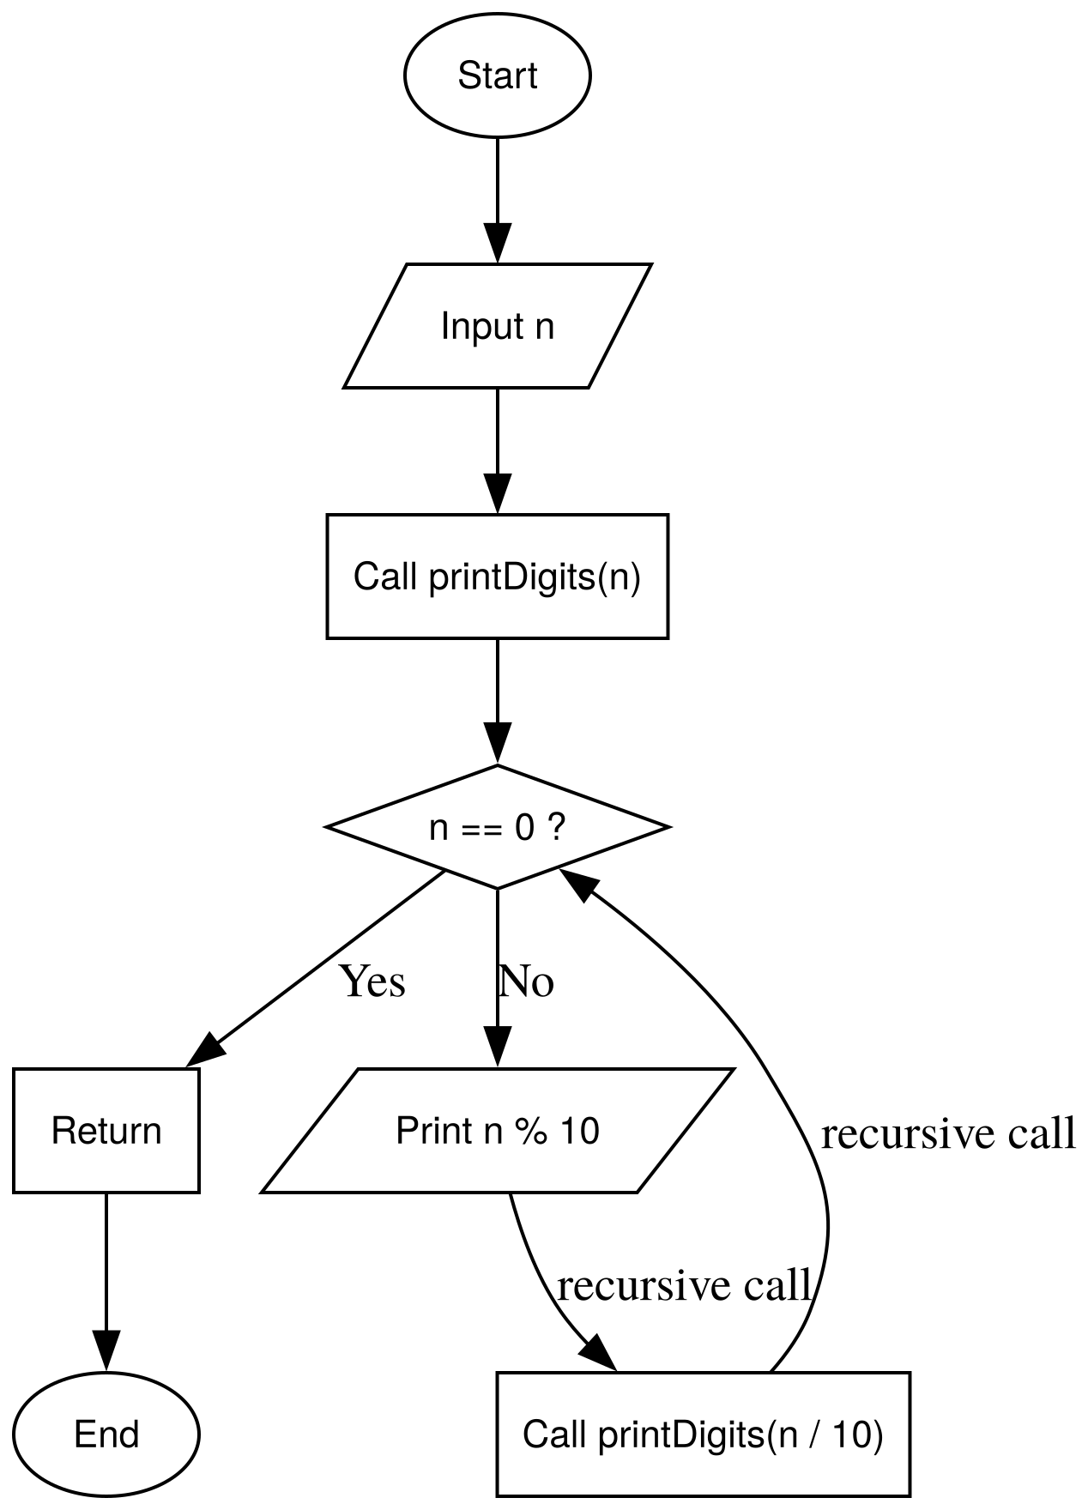 | void print_digit_normal(ll n) {  if (n < 0) n = -n;  if (n==0) return;  // gcc is forced to recurisvely call this formula till base case. and then pritns num  print_digit_normal(n / 10);  cout << (n%10) << endl;  }

Question 18
void print_digit_rev(ll n) {
if (n < 0) n = -n;
// base case
if (n == 0) return;

cout << (n%10) << endl;
print_digit_rev(n/10);
}

Question 19
void print_word(int n) {
switch (n) {
case 0: cout << "Zero "; break;
case 1: cout << "One "; break;
case 2: cout << "Two "; break;
case 3: cout << "Three "; break;
case 4: cout << "Four "; break;
case 5: cout << "Five "; break;
case 6: cout << "Six "; break;
case 7: cout << "Seven "; break;
case 8: cout << "Eight "; break;
case 9: cout << "Nine "; break;
} }

void print_digits_words(ll n) {
if (n==0) return;

// recurive call
print_digits_words(n/10);

// prints word up the stack
print_word(n % 10);

}

Question 20
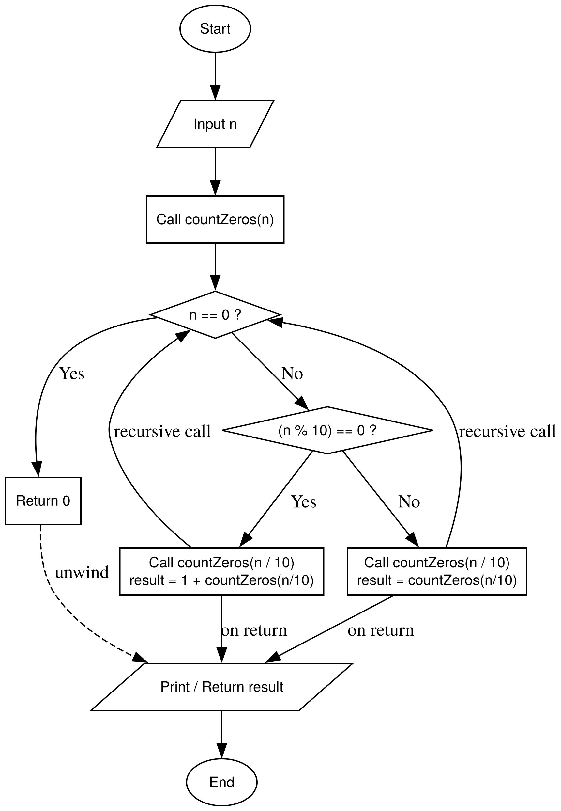 | int count_zero_recur(ll n) {  if (n < 0) n = -n;  if (n < 10) return (n == 0) ? 1 : 0;  return ((n % 10 == 0) ? 1 : 0) + count_zero_recur(n/10);  }

Phase 3 – Mathematical Thinking With Recursion

Question 1
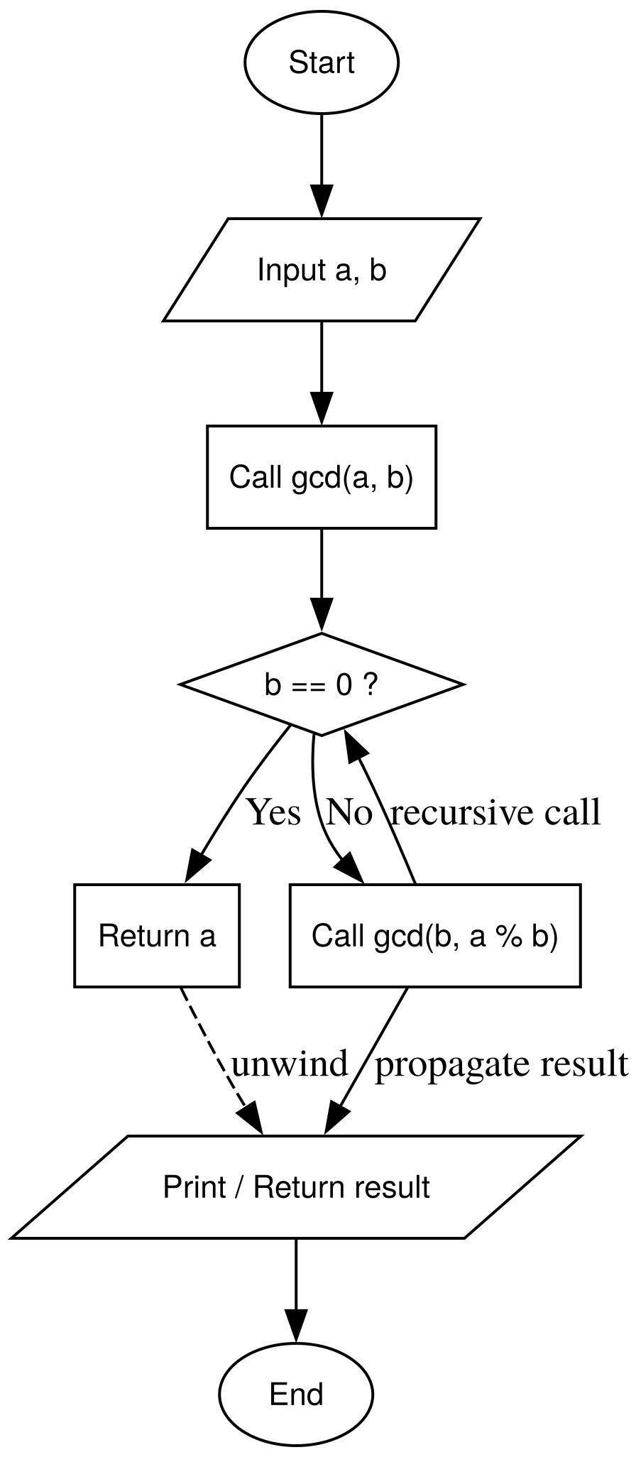 | ll gcd_euclid(ll a, ll b) {  // base case  if (b == 0) return a;  return gcd_euclid(b, (a % b));  }

Question 2
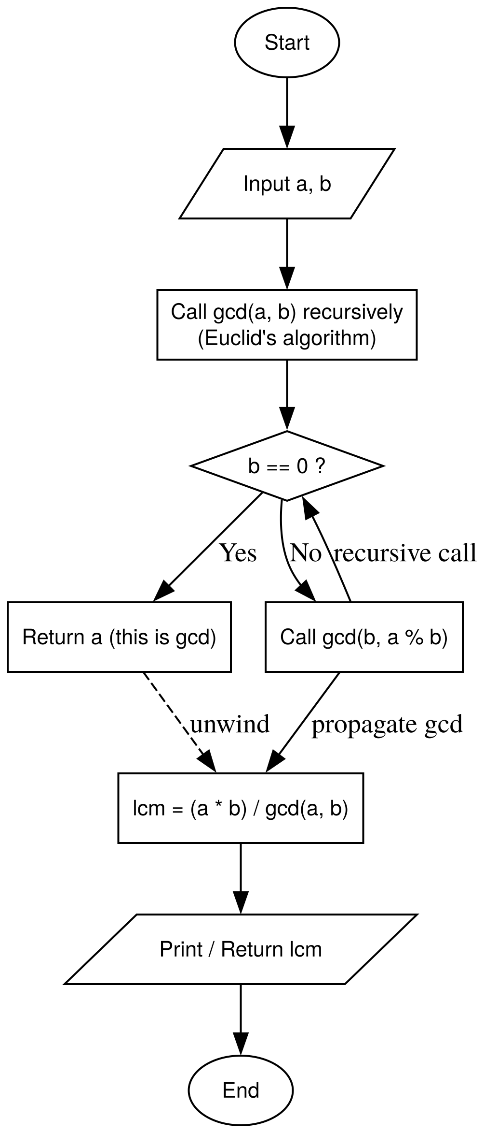 | ll gcd_euclid(ll a, ll b) {  if (b == 0) return a;  return gcd_euclid(b, a % b);  }  ll lcm(ll a, ll b) {  a = abs(a);  b = abs(b);  if (a == 0 || b == 0) return 0;  return (a / gcd_euclid(a, b)) * b;  }

Question 3
ll ncr_recursive(ll n, ll r) {
// base cases
if (r > n) return 0;
if (r== 0 || r == n) return 1;

return ncr_recursive(n-1, r - 1) + ncr_recursive(n-1, r);
}

Question 4
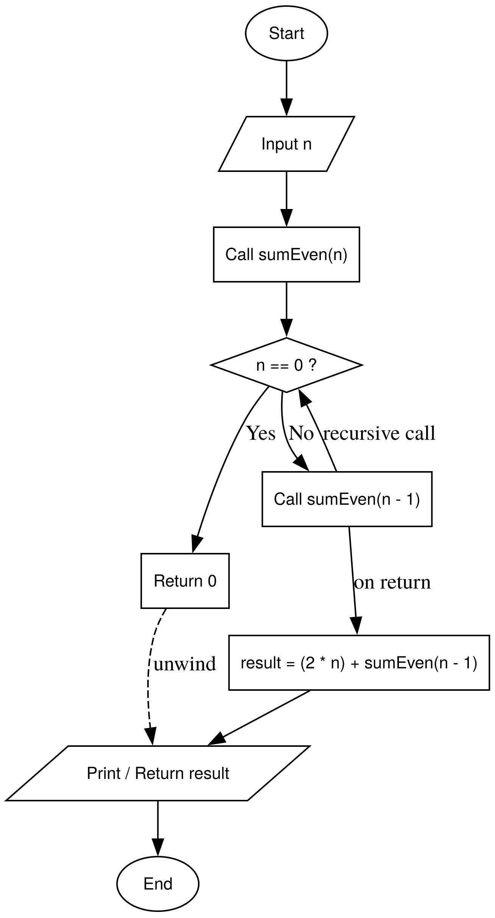 | ll sum_first_n_even(ll n) {  if (n==0) return 0;  return (2*n) + sum_first_n_even(n-1);  }

Question 5
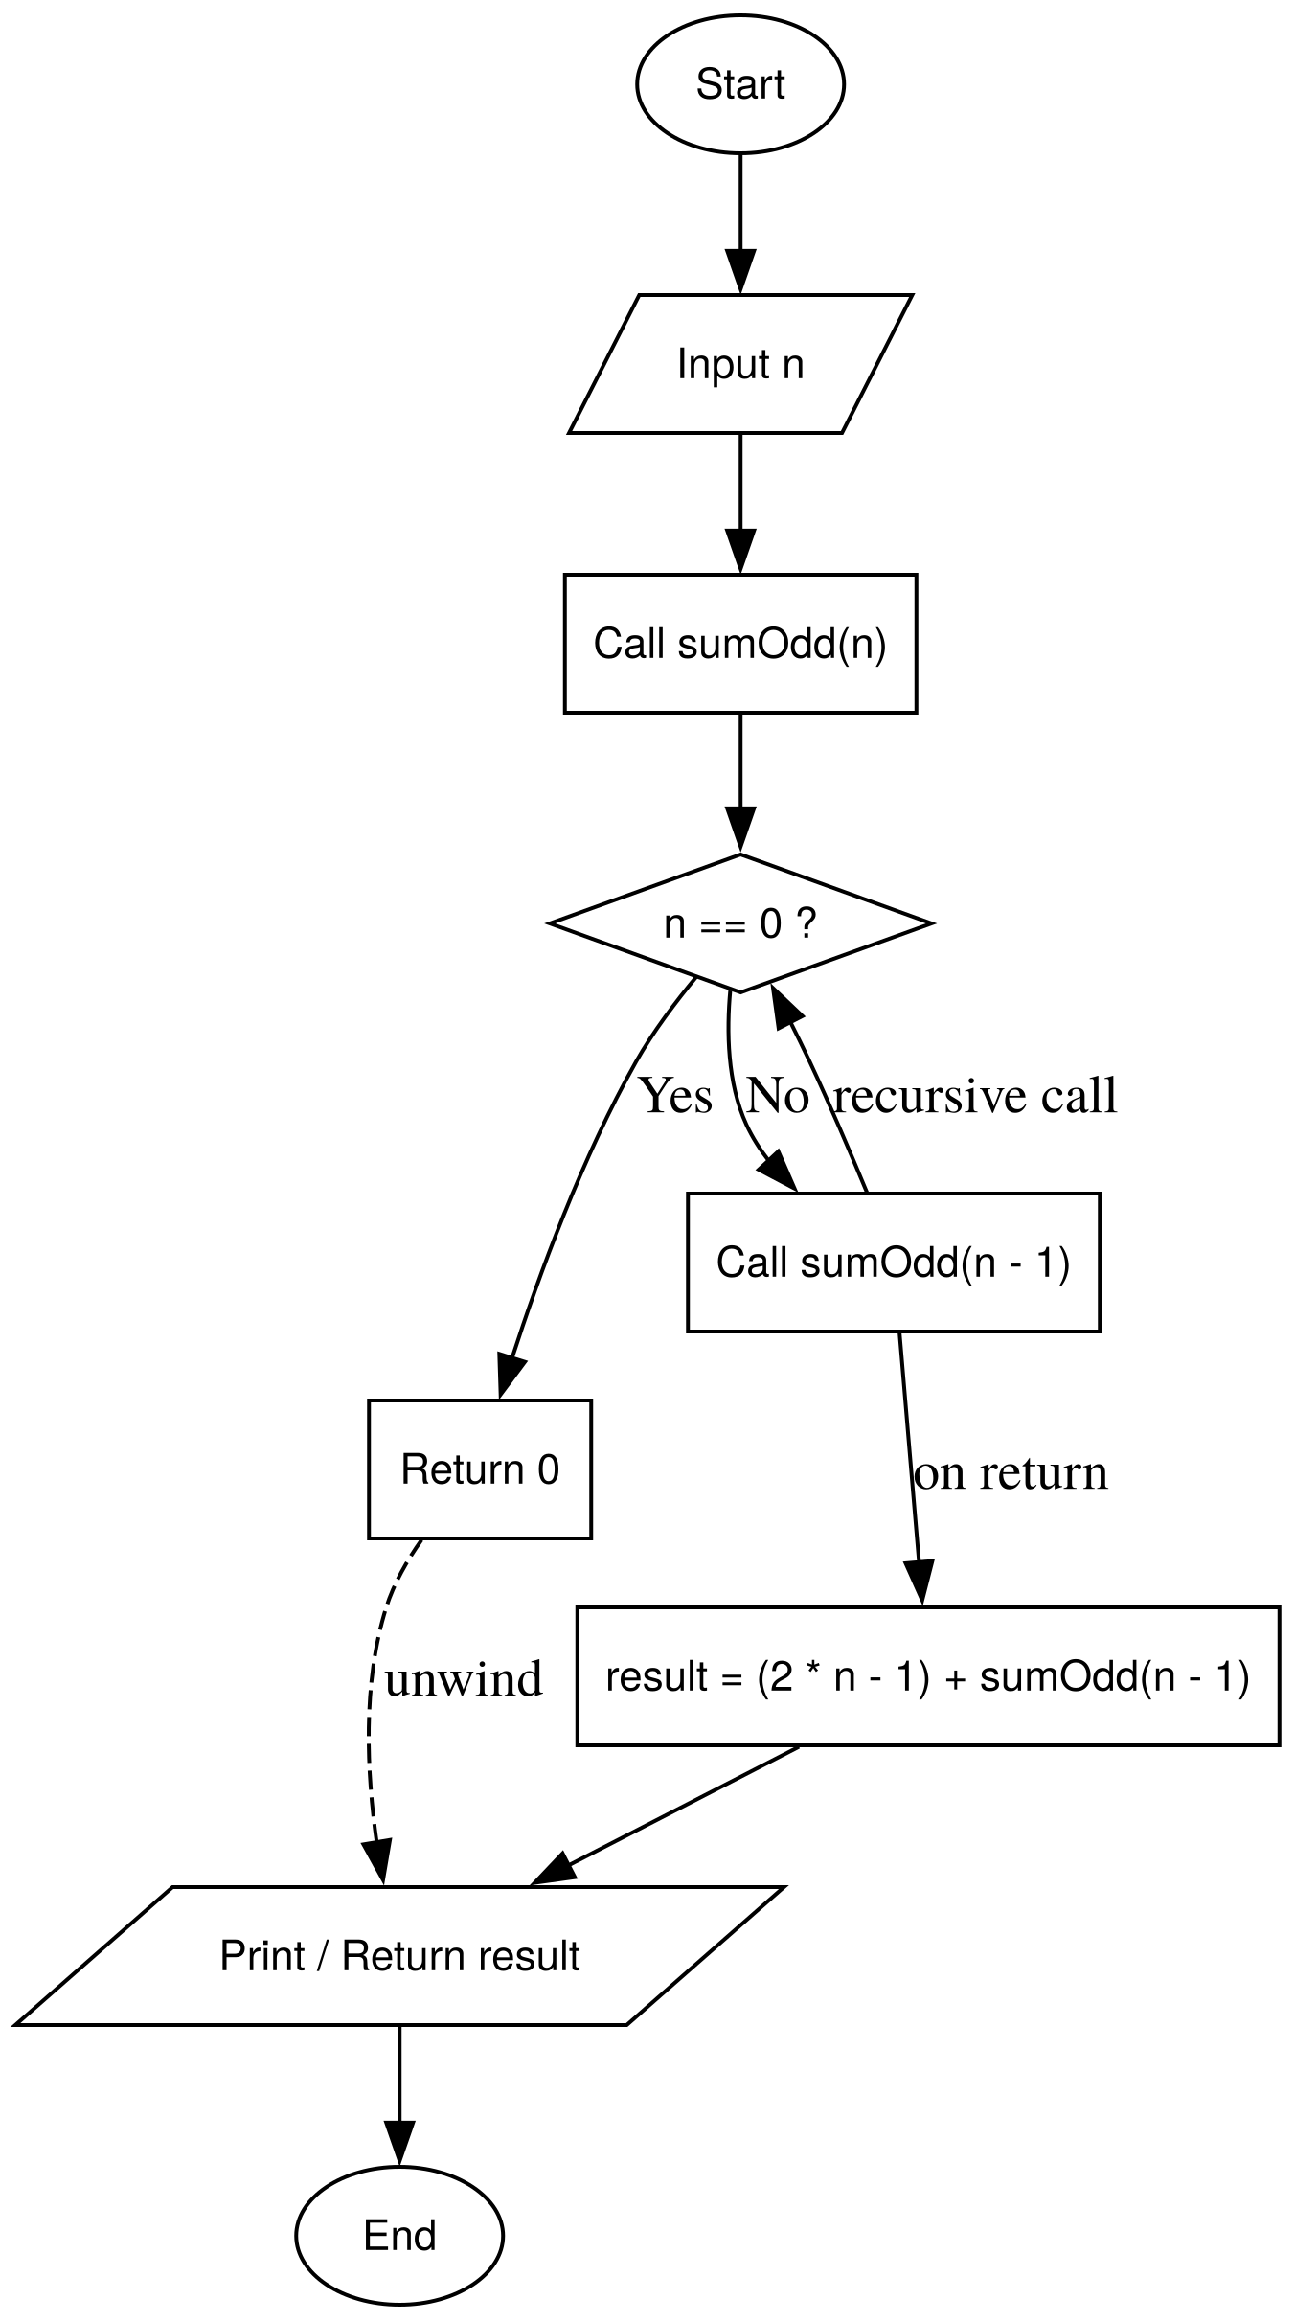 | ll sum_first_n_odd(ll n) {  if (n==0) return 0;  return (2 * n - 1) + sum_first_n_odd(n-1);  }

Question 6
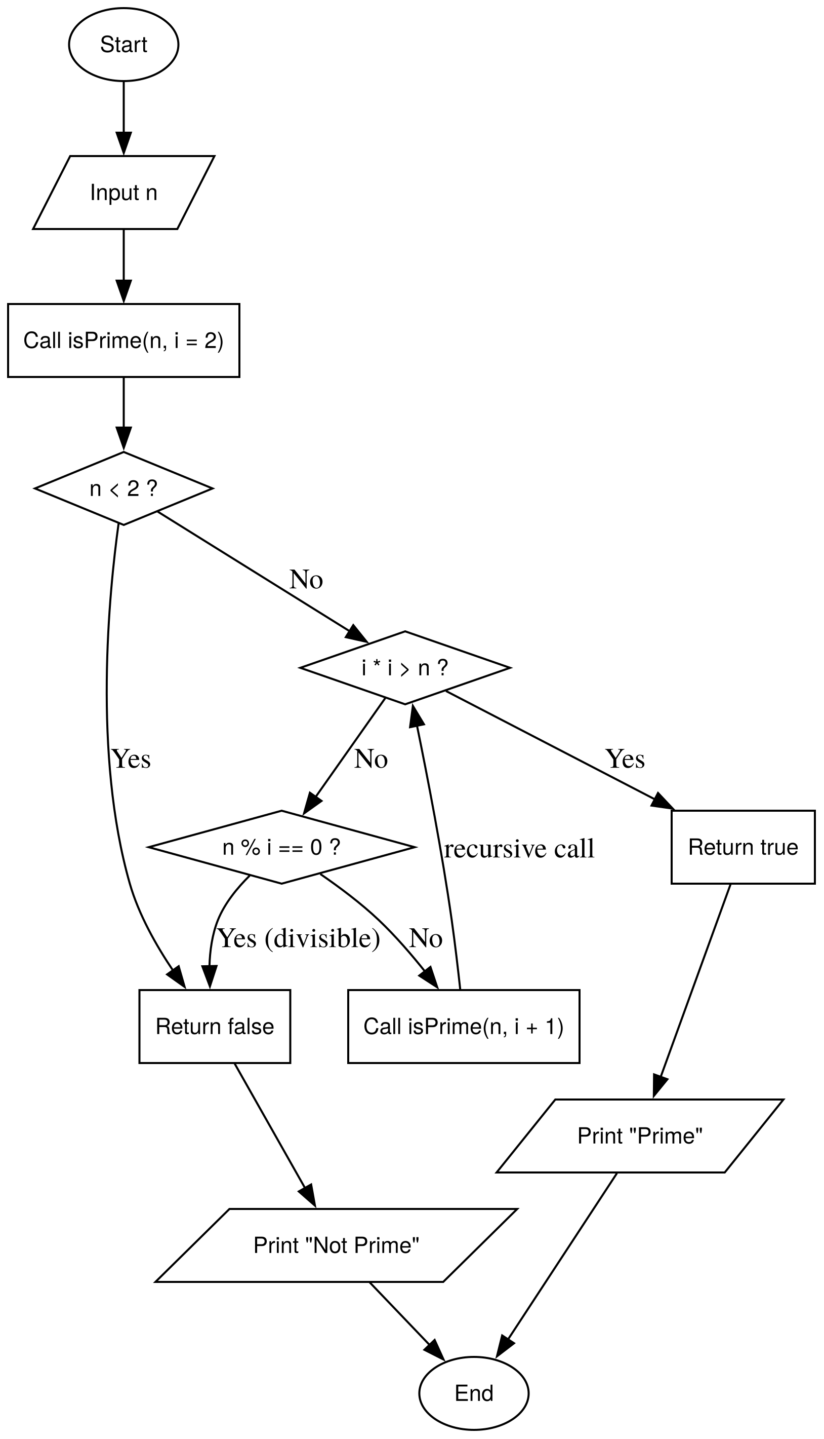 | bool is_prime_recursive(ll n, ll divisor = 2) {  // first base case  if (n <= 1) return false;  // second base case  if (divisor * divisor > n) return true;  //3rd base case when a num is a divisor  if (n % divisor == 0) return false;  // Recursive Step: Increment divisor and check again  return is_prime_recursive(n, divisor + 1);  }

Question 7
int count_prime(ll n) {
if (n == 0) return 0;
int dig = n % 10;

if (is_prime_recursive(dig)) return 1 + count_prime(n / 10);
return 0 + count_prime(n / 10);
}

Question 8
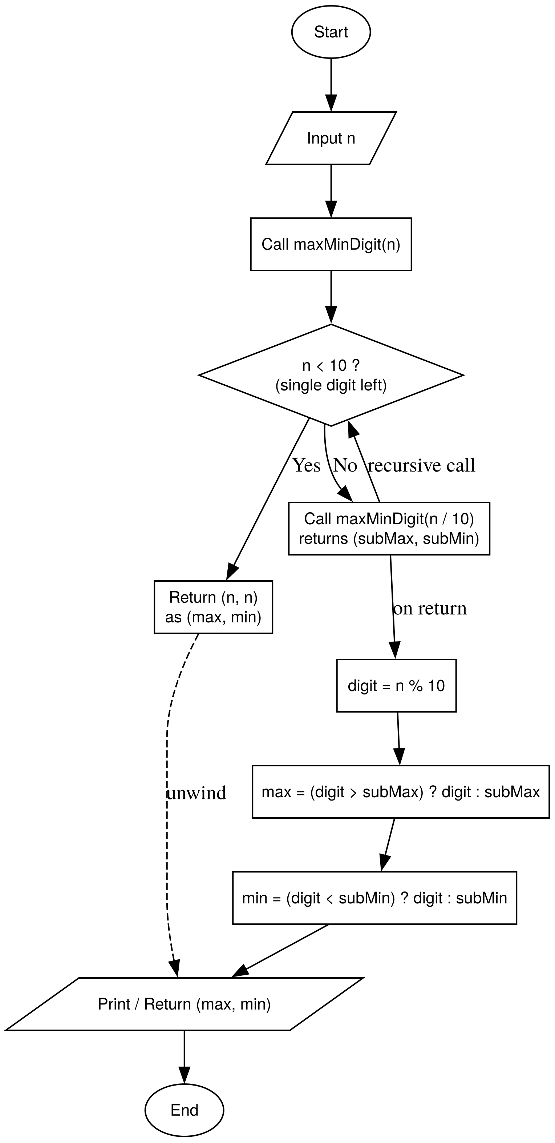 | void find_min_max(int n, int &min, int &max){  static int min_digit = 9;  static int max_digit = 0;  // base case  if (n == 0){  // copy static results to the reference varialbes  min = min_digit;  max = max_digit;  // resets static variables  min_digit = 9;  max_digit = 0;  return;  }  int current = n % 10;  if (current < min_digit) min_digit =current;  if (current > max_digit) max_digit = current;  find_min_max(n/10, min, max);  }

Question 9
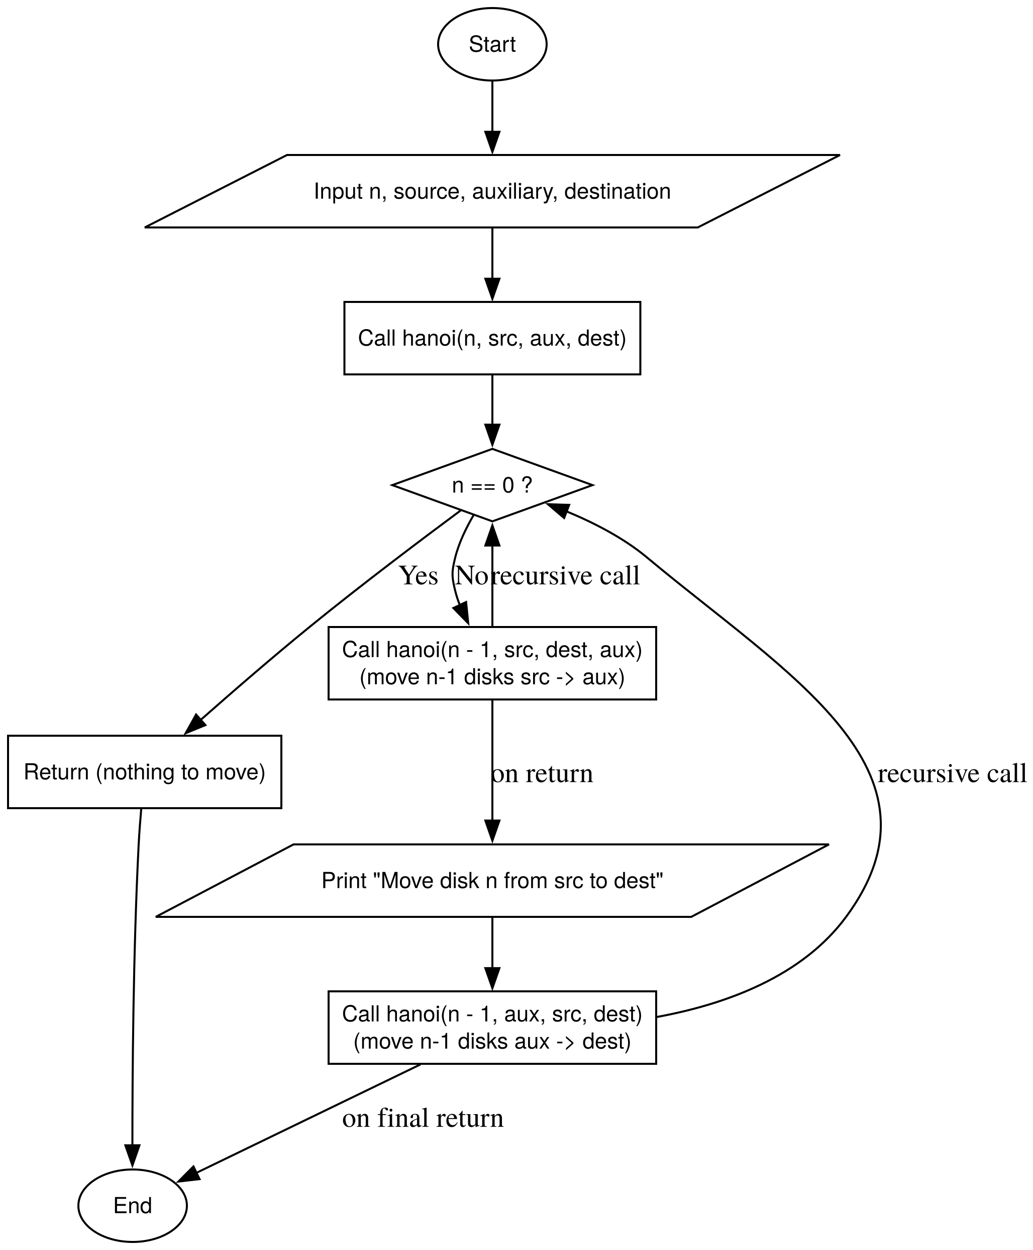 | void tower_of_hanoi_problem(int n, char from_rod, char to_rod, char aux_rod) {  if (n == 0) return;  tower_of_hanoi_problem(n-1, from_rod, aux_rod, to_rod);  cout << "moving disk " << n << " from rod " << from_rod << " to rod " << to_rod << endl;  tower_of_hanoi_problem(n-1, aux_rod, to_rod, from_rod);  }

Question 10
int count_occurances(ll n, int digit) {
if (n==0) return 0;
int dig = n % 10; //gets the last digit

if (dig == digit) return 1 + count_occurances(n / 10, digit);
else return 0+ count_occurances(n/ 10, digit);
}

Question 11
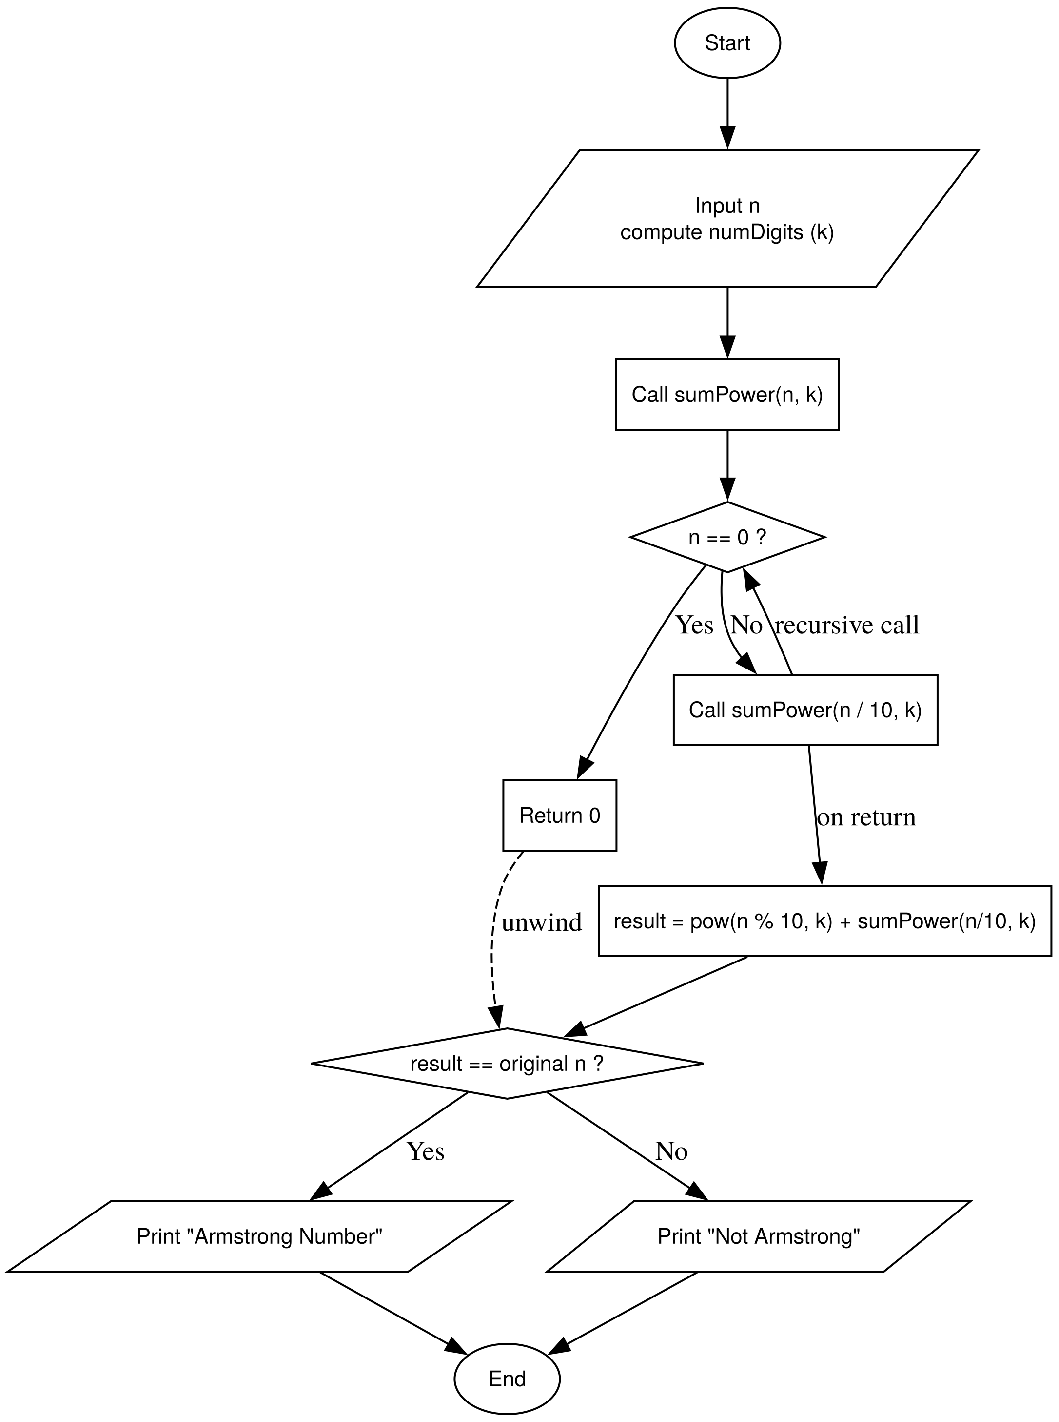 | bool check_armstrong(int n, int orig_num, int k, int sum) {  // base case  if (n == 0) return (orig_num == sum);  int digit = n % 10;  sum += pow(digit, k);  return check_armstrong(n/10, orig_num, k, sum);  }  int count_digit(int n) {  // this to find k  if (n==0) return 0;  return 1+count_digit(n/10);  }  bool is_armstrong(ll n) {  if (n < 0) return false;  if (n == 0) return true;  return check_armstrong(n, n, count_digit( n), 0);  }

Question 12
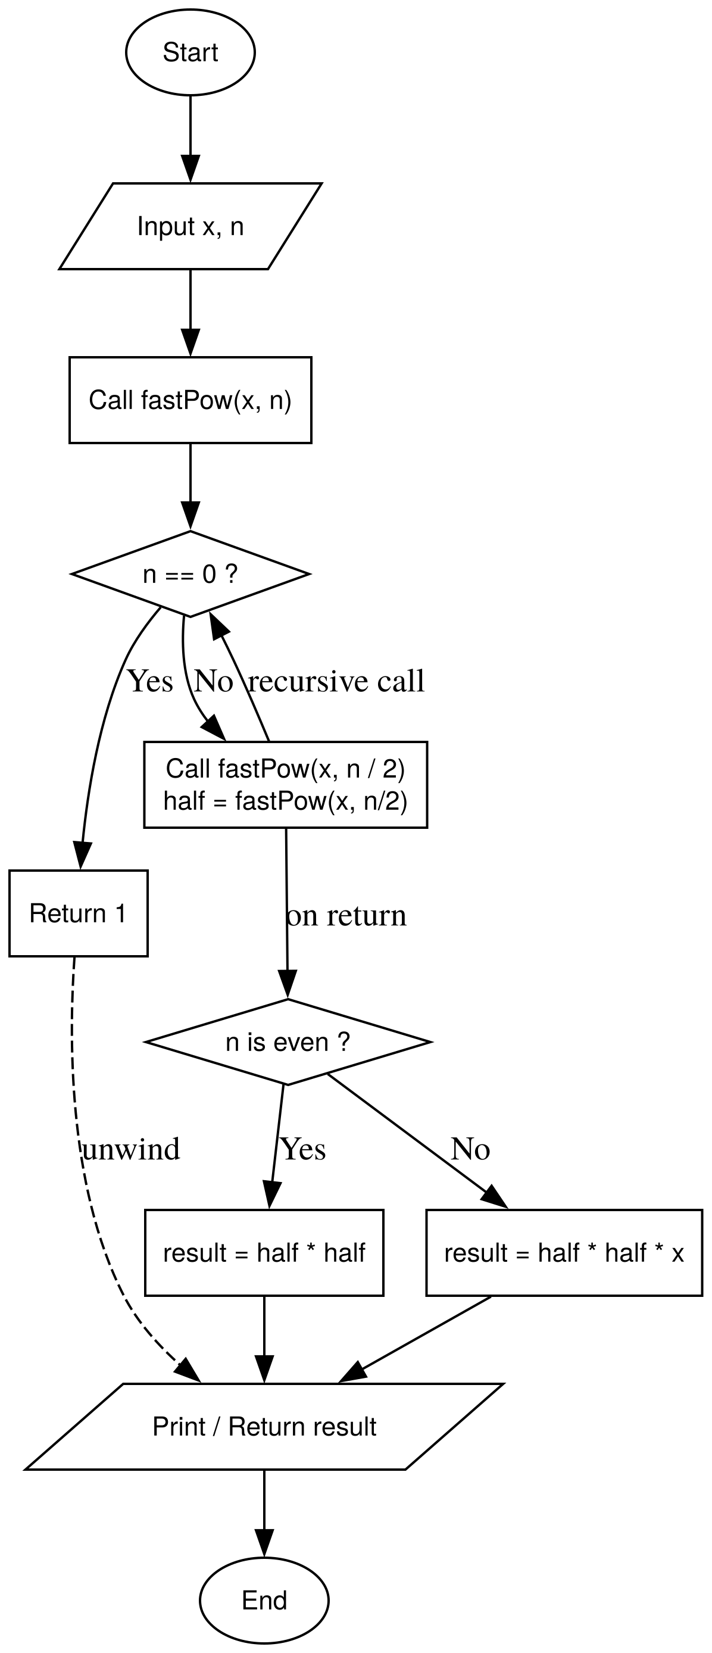 | ll exponentiation_by_sq(ll n, int k) {  if (k == 0) return 1;  ll half_power = exponentiation_by_sq(n, k /2);  if(k % 2 == 0) {  return half_power * half_power;  }  else {  return n * half_power * half_power;  }  }

Question 13
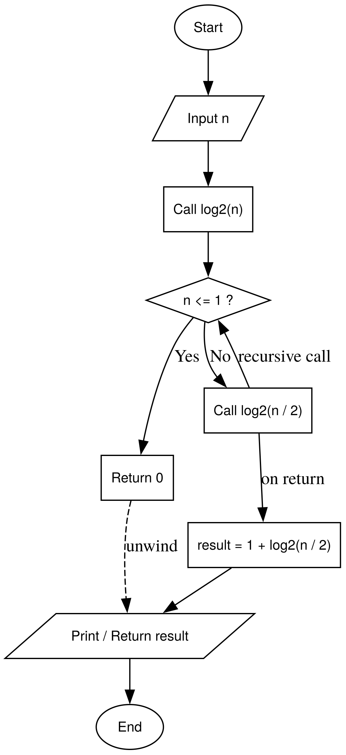 | int log2_recursive(int n) {  if (n <= 1) return 0;  return 1 + log2_recursive(n/2);  }

Question 14
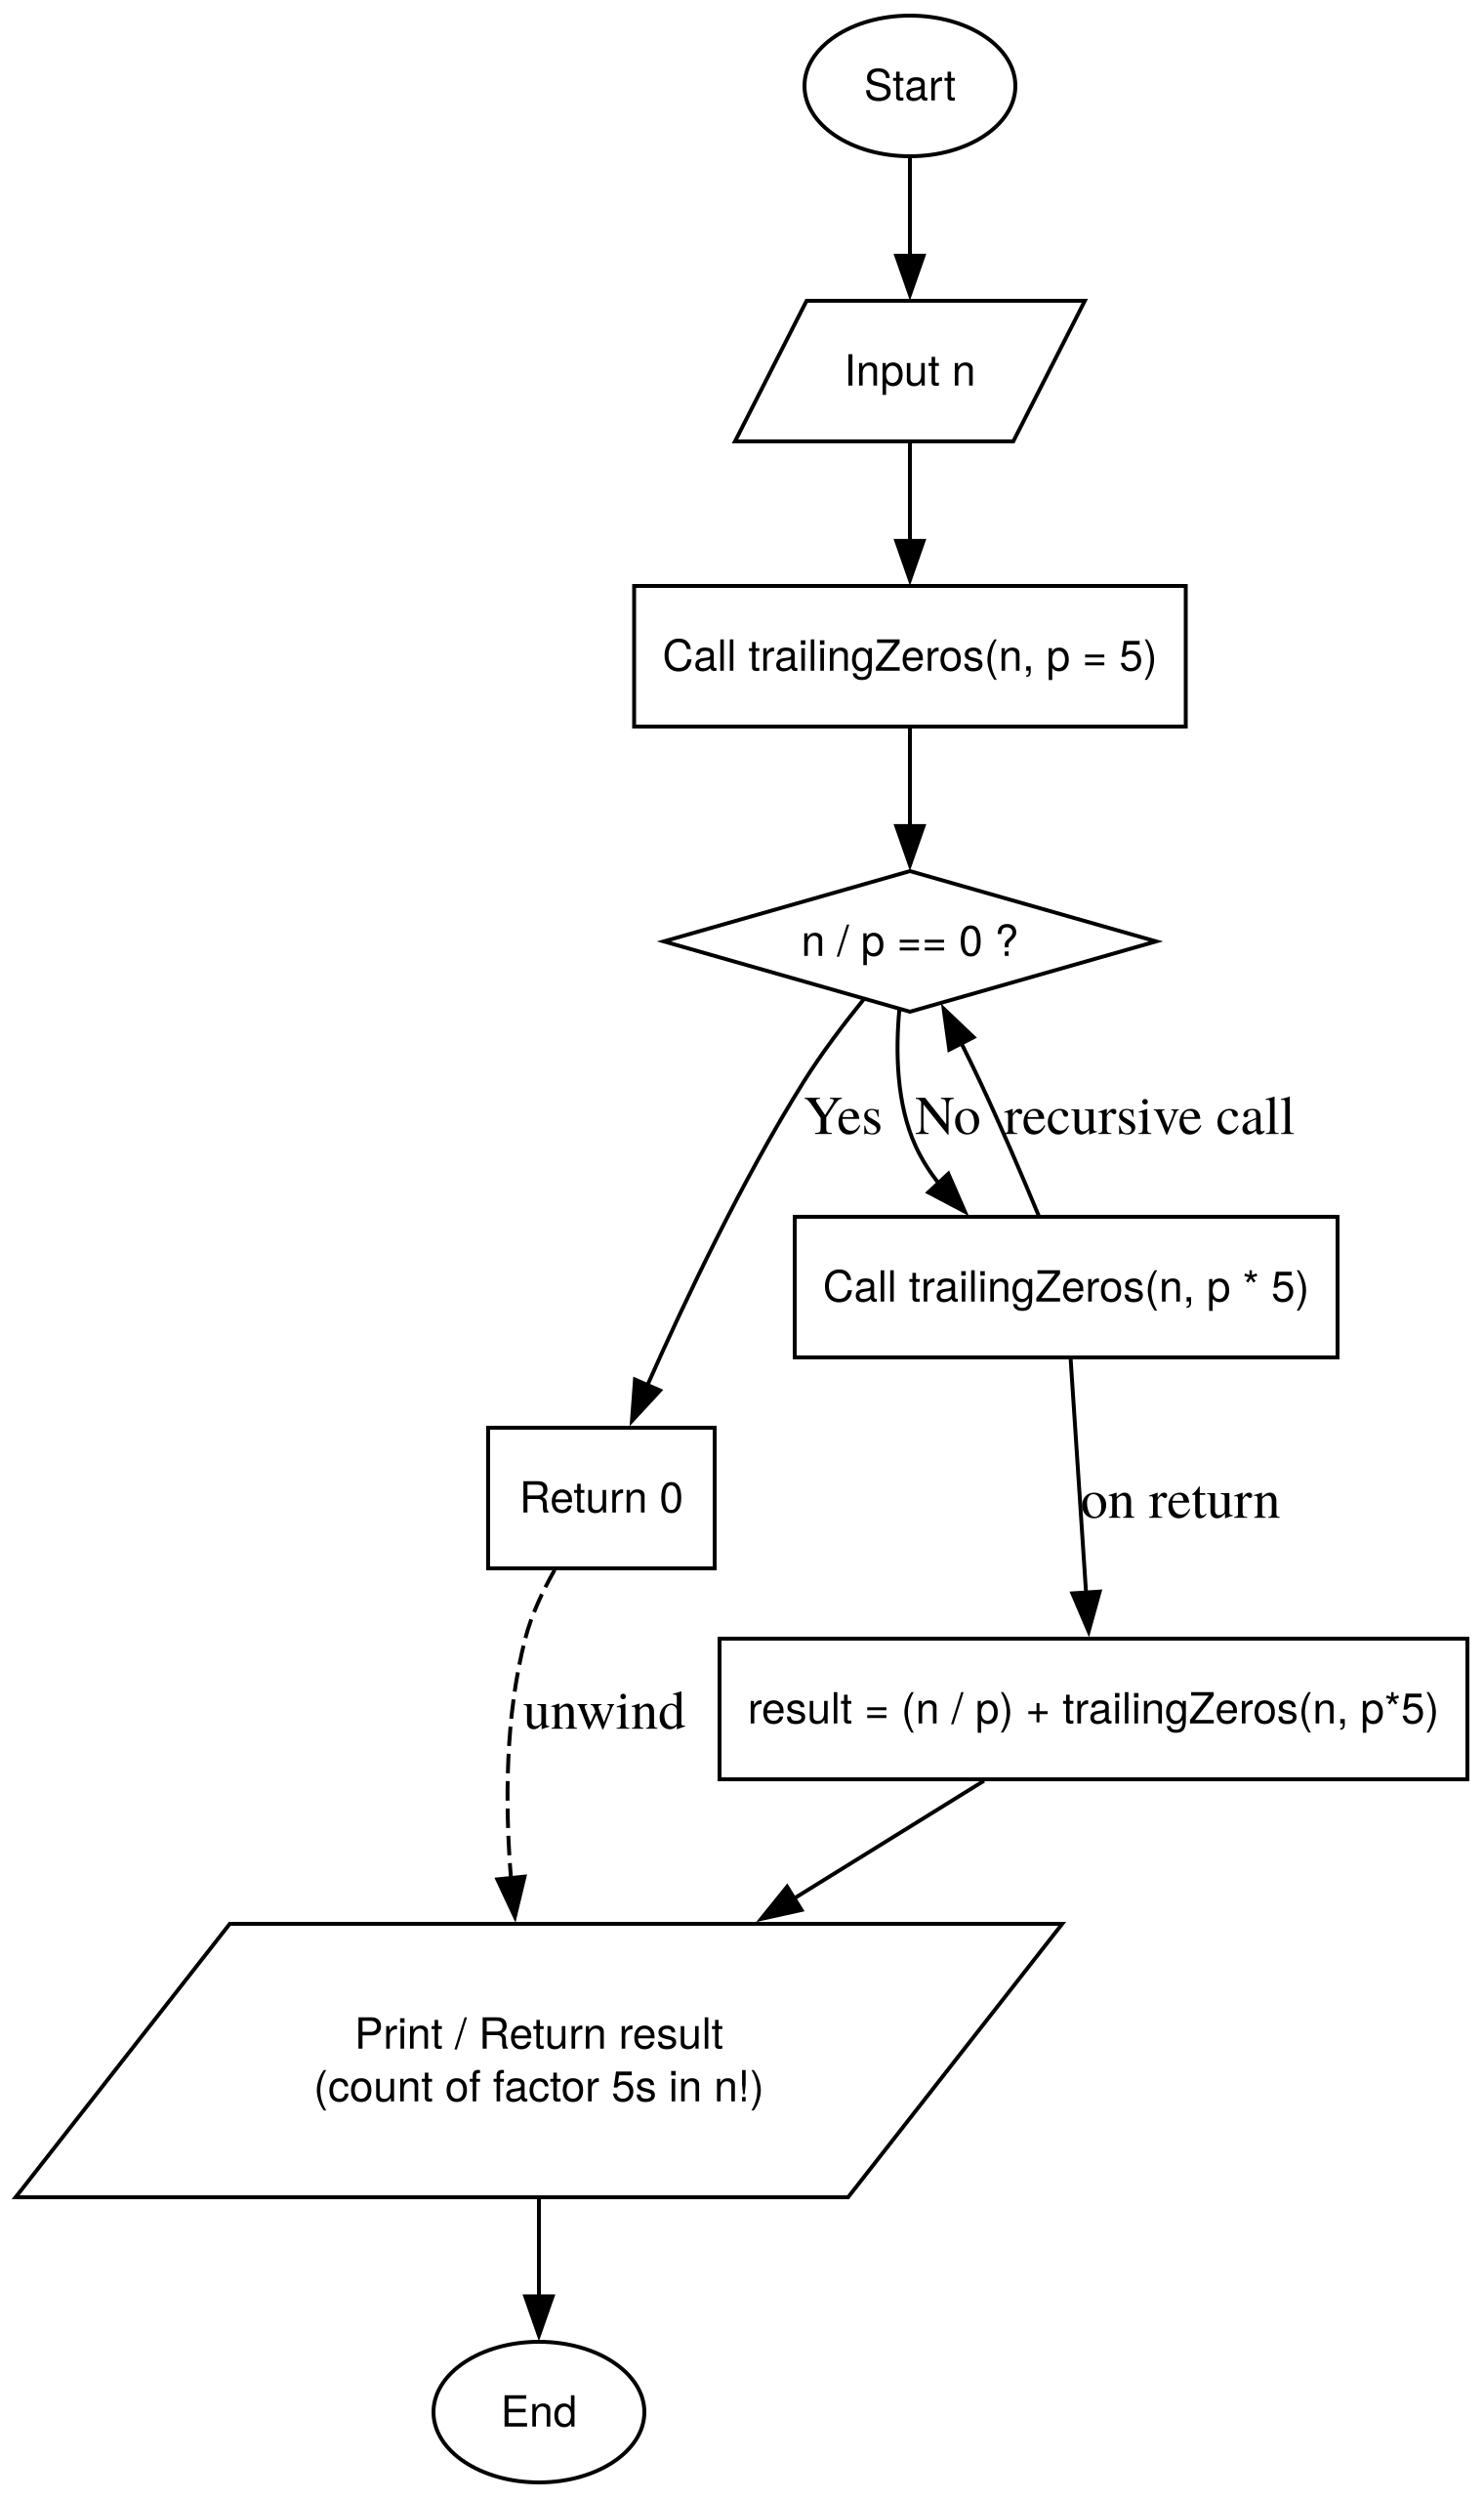 | ll count_trailing_zeros(ll n) {  if (n < 5) return 0;  return (n / 5) + count_trailing_zeros(n/5);  }

Question 15
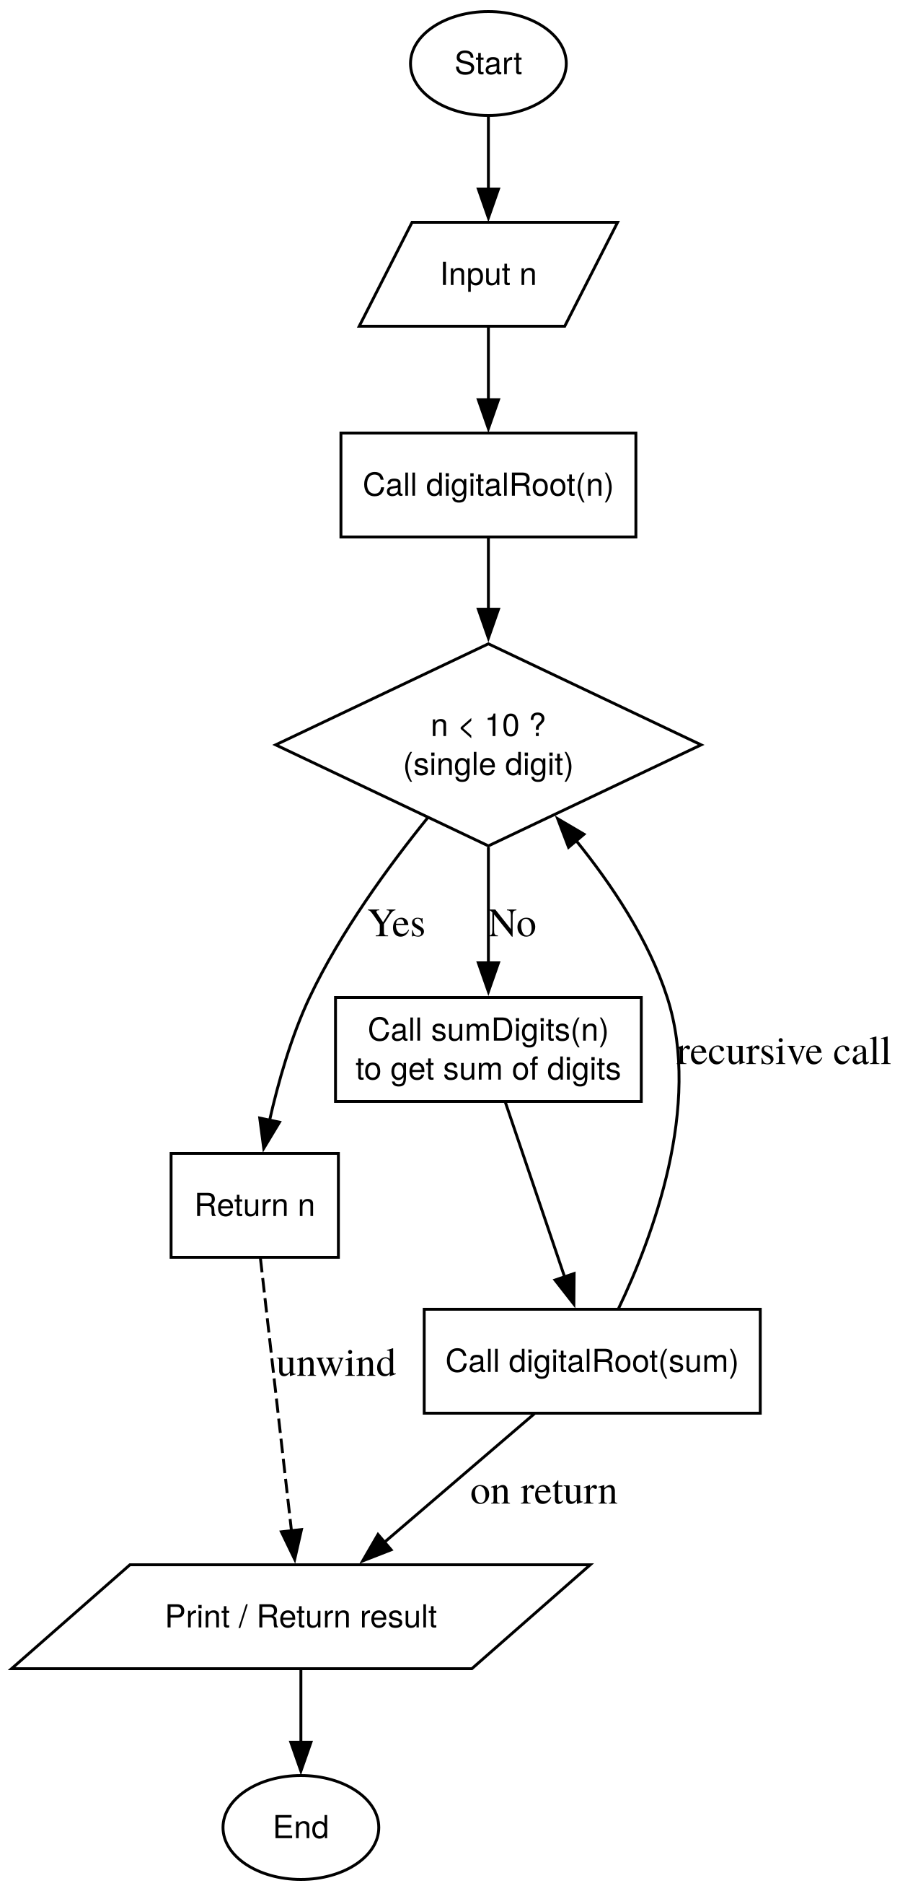 | int sum_digits(int n) {  if (n==0) return 0;  return (n % 10) + sum_digits(n/10);  }  int digital_root(int n) {  if (n < 10) return n;  int sum = sum_digits(n);  return digital_root(sum);  }

Phase 4 – Controlled Printing & Patterns

Question 1
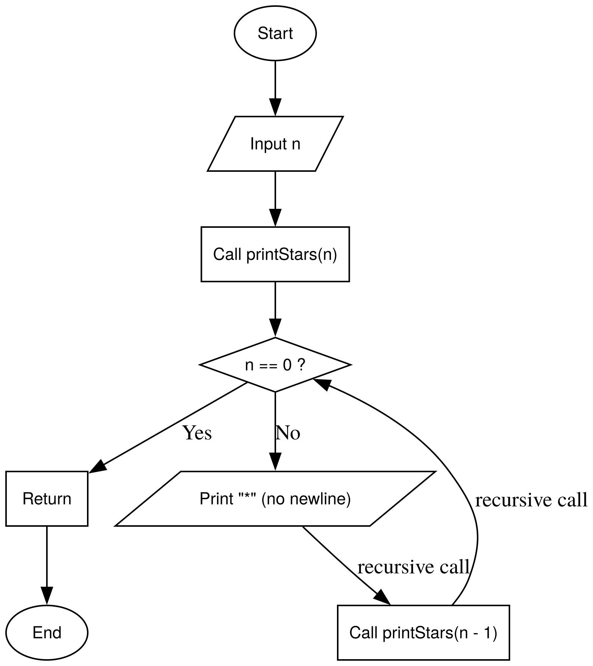 | void print_line(ll n) {  if (n == 0) {cout << endl; return ; }  cout << "*";  print_line(n-1);  }

Question 2
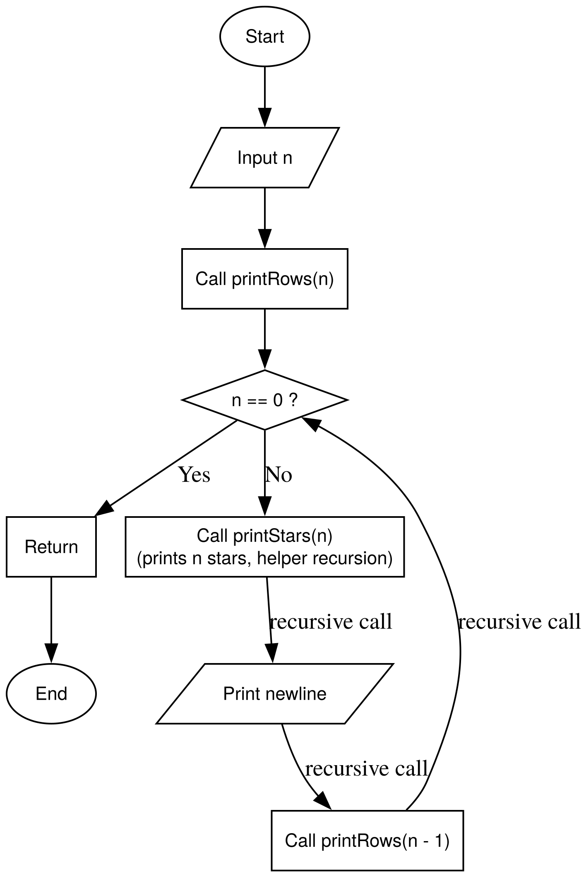 | void print_line(ll n) {  if (n == 0) {  cout << endl;  return;  }  cout << "*";  print_line(n-1);  }  void print_sq(int n, int current_row = 0) {  if (current_row >= n) return;  print_line(n);  print_sq(n, current_row + 1);  }

Question 3
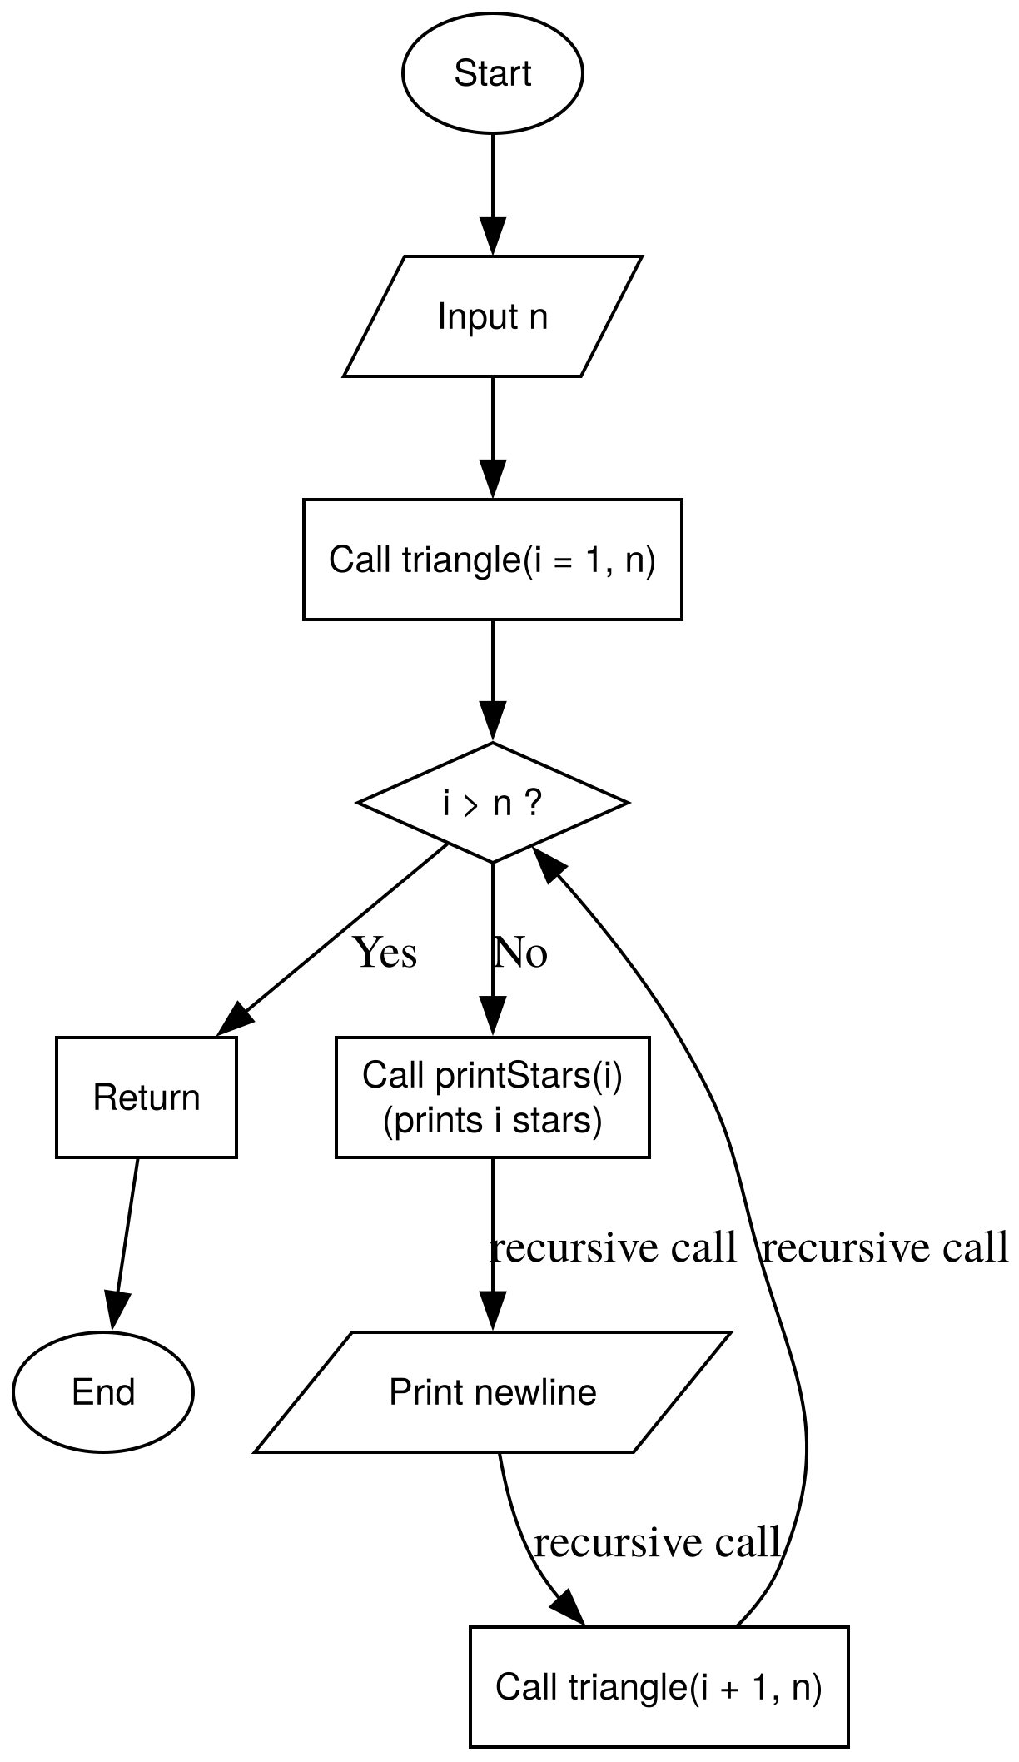 | void print_row(int n) {  if (n == 0) return;  cout << "*";  print_row(n-1);  }  void print_top_down_triangle(int n, int current_row = 1) {  if (current_row > n) return;  // printing statrs for current row  print_row(current_row); cout << endl;  print_top_down_triangle(n, current_row+1);  }

Question 4
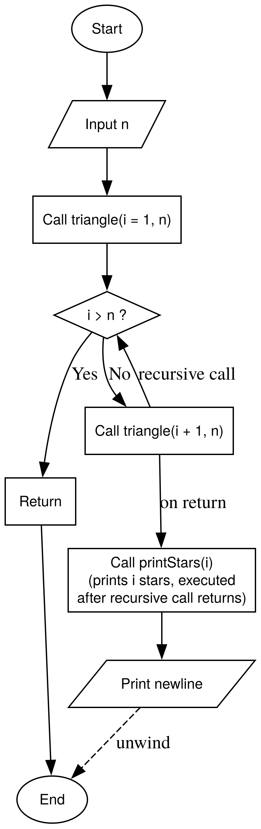 | void print_bottom_up_triangle(int n, int current_row = 1) {  if (current_row > n) return;  print_bottom_up_triangle(n, current_row + 1);  print_row(current_row);  cout << endl;  }

Question 5
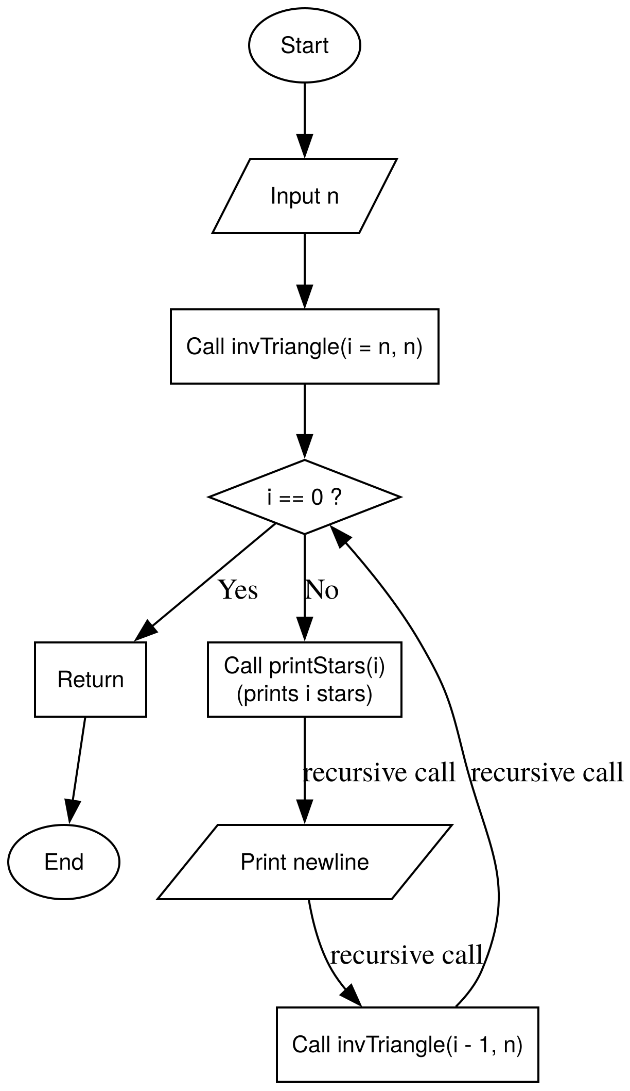 | void print_row(int n) {  if (n == 0) return;  cout << "*";  print_row(n-1);  }  void print_inverted_triangle(int n, int cur) {  if (cur <= 0) return;  print_row(cur);  cout << endl;  print_inverted_triangle(n, cur - 1);  }

Question 6
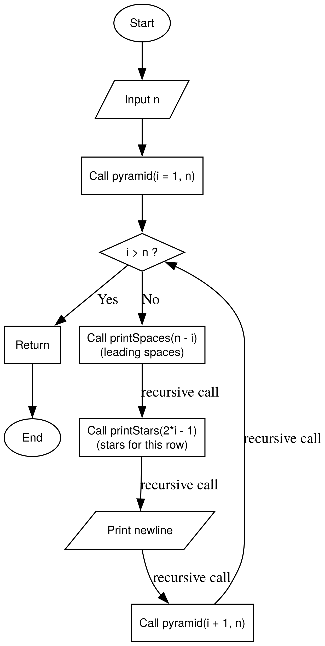 | void print_space(int n) {  if (n == 0) return;  cout << " ";  print_space(n-1);  }  void print_row(int n) {  if (n == 0) return;  cout << "*";  print_row(n-1);  }  void print_pyramid(int n, int i = 1) {  if (i > n) return;  print_space(n - i);  print_row(2 * i - 1);  cout << endl;  print_pyramid(n, i + 1);  }

Question 7
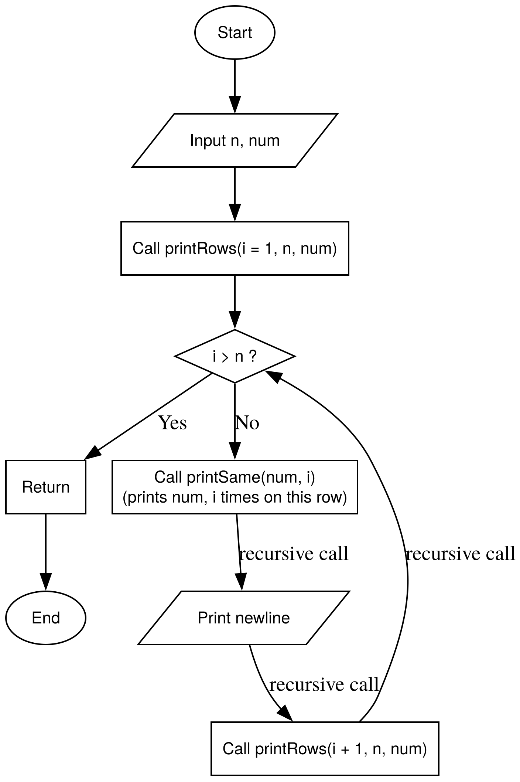 | void print_number(int num, int cols) {  if (cols <= 0) return;  cout << num << " ";  print_number(num, cols-1);  }  void print_num_grid(int n, int current_row = 1) {  if (current_row > n) return;  print_number(current_row, n);  cout << endl;  print_num_grid(n, current_row+1);  }

Question 8
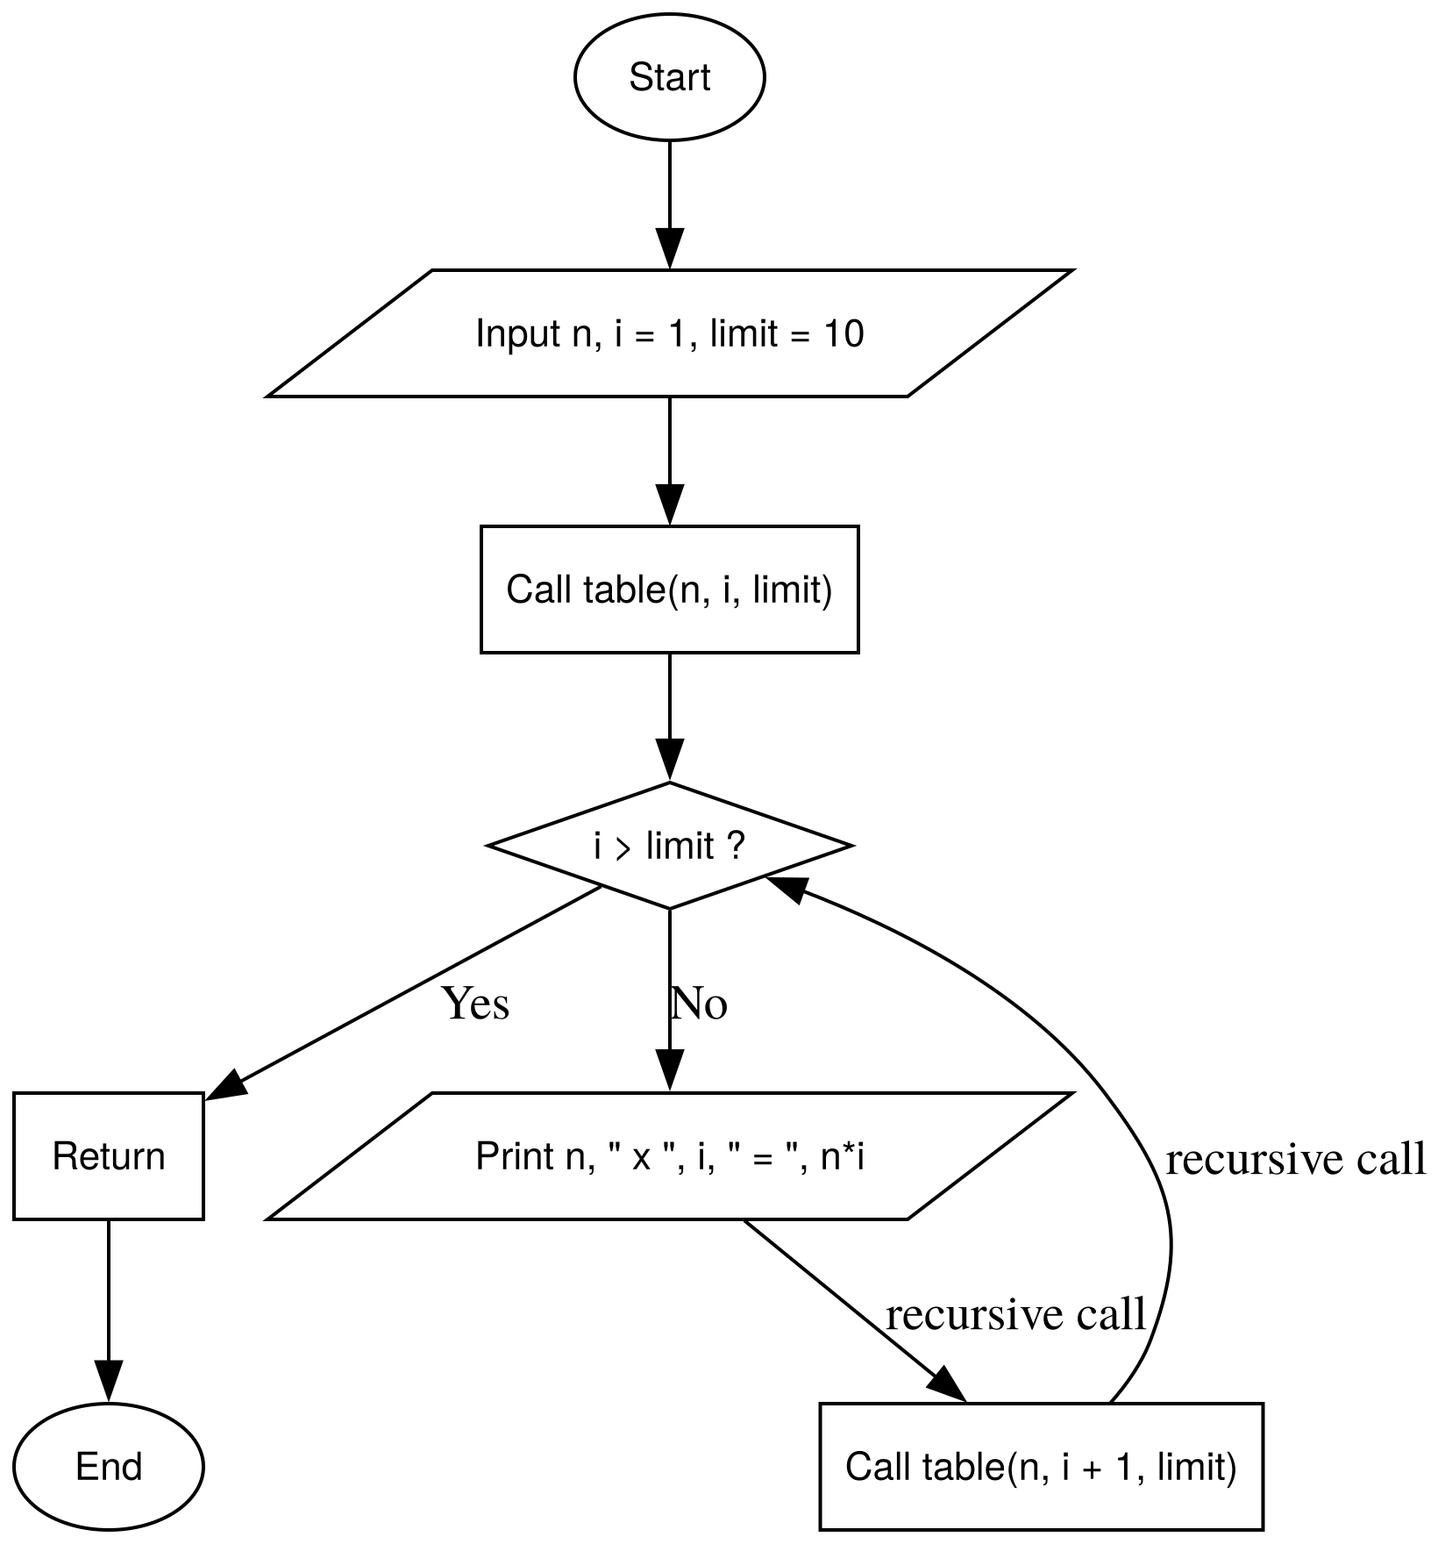 | void print_mult_table(int n, int mut = 12) {  if (mut == 0) return;  print_mult_table(n, mut - 1);  cout << n << "* " << mut << "= " << n*mut << endl;  }

Question 9
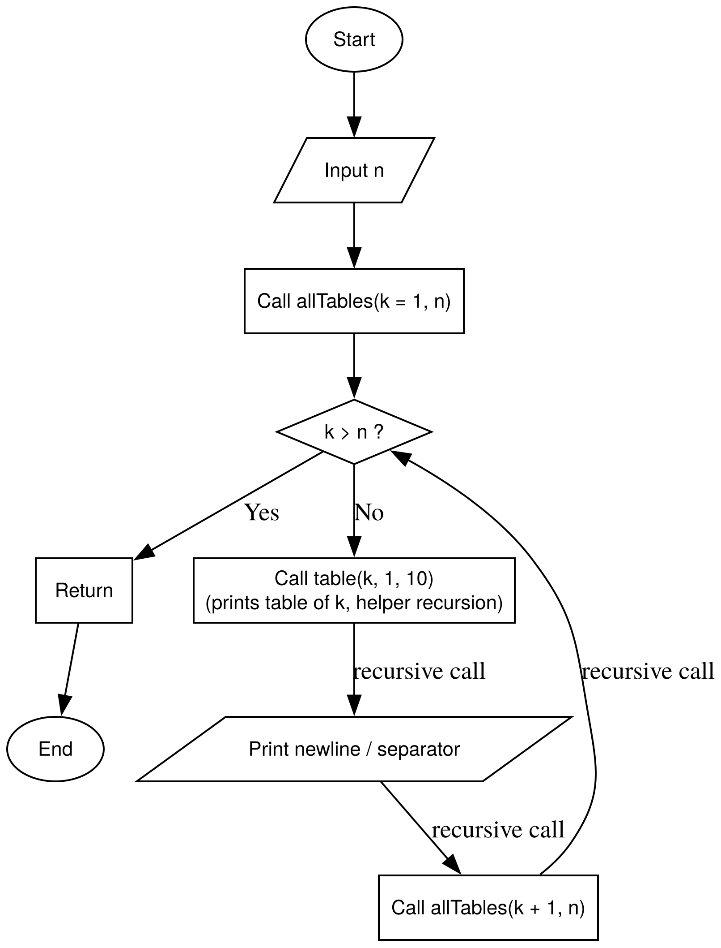 | void print_all_tables(int n, int k = 1) {  if (k > n) return;  print_mult_table(k, 10);  cout << "----------" << endl;  print_all_tables(n, k + 1);  }

Question 10
void inc_then_dec(int n) {
if (n <= 0) return;

cout << n << " ";

inc_then_dec(n-1);

cout << n << " ";
}

Question 11
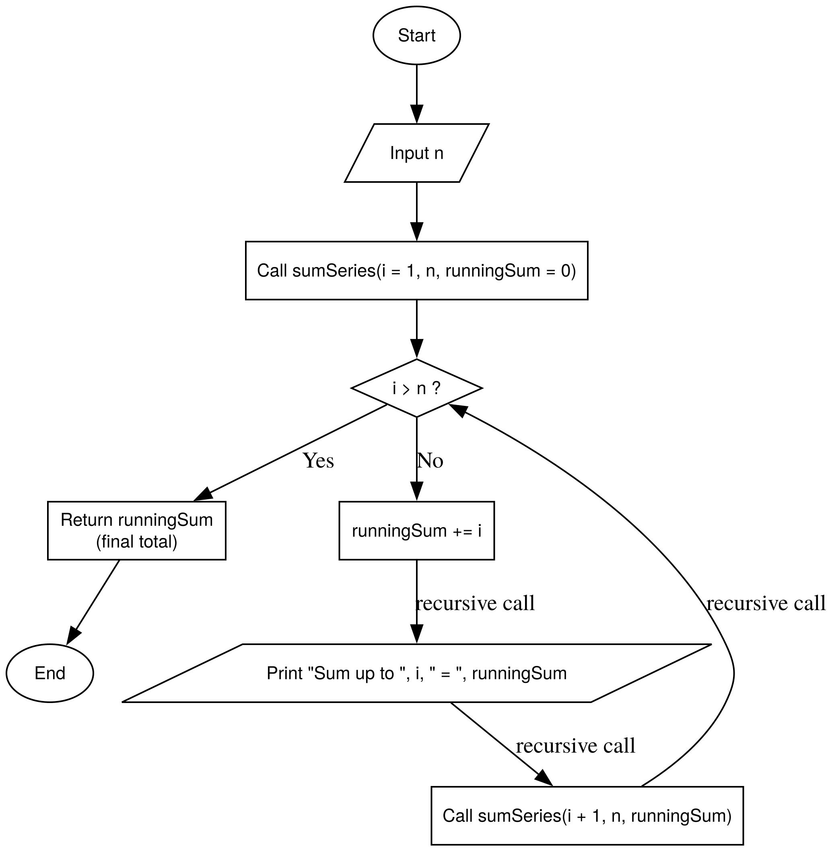 | ll print_sum_series(ll n) {  if (n == 0) return 0;  ll prev_sum = print_sum_series(n-1);  ll currnet = prev_sum + n;  cout << "n: " << n << "-> current sum: " << currnet << endl;  return currnet;  }

Question 12
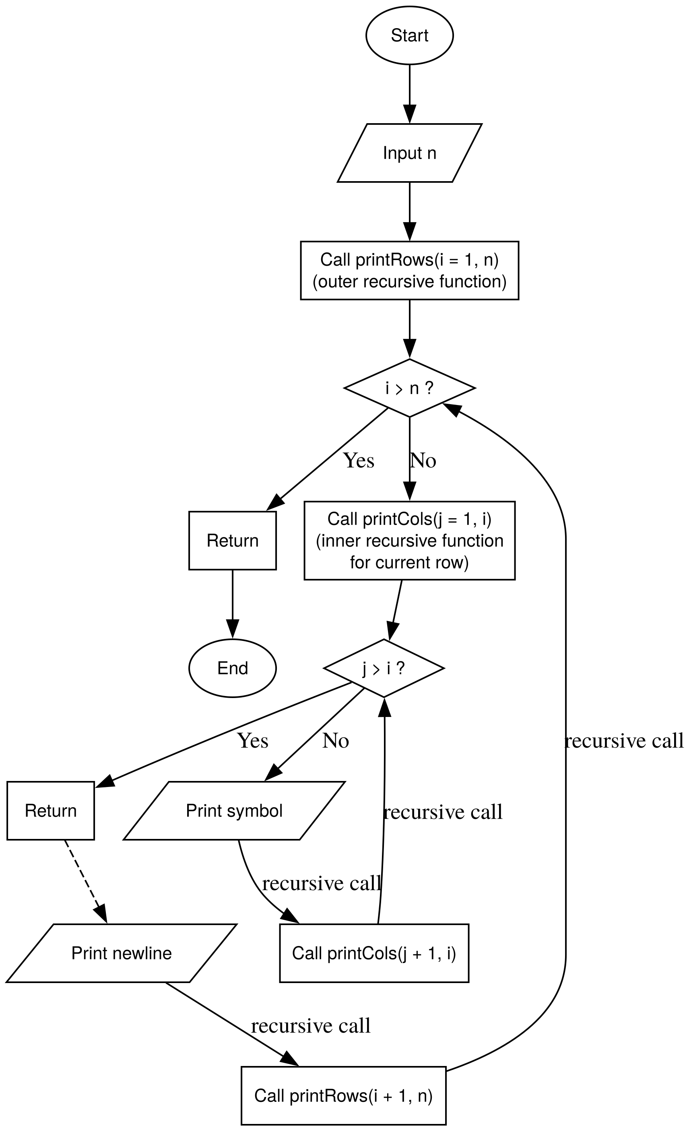 | void print_cols(int n) {  if (n <= 0) return;  cout << "*";  print_cols(n-1);  }  void print_pattern(int n) {  // this prints an inverted right angle triangle  if (n == 0) return;  print_cols(n); cout << endl;  print_pattern(n-1);  }

Question 13
void print_triangle(int n, int curr_row = 1, int curr_col = 1) {
if (curr_row > n) return;

if (curr_col <= curr_row) {
cout << "*";
print_triangle(n, curr_row, curr_col + 1);
}
else {
cout << endl;
print_triangle(n, curr_row + 1, 1);
}
}

Question 14
void print_diagonal(int n, int i = 1) {
if (i > n) return;

print_space(i - 1);
cout << "*" << endl;
print_diagonal(n, i + 1);
}

Question 15
void print_param_pattern(int n, int start_val, int step, int i = 1) {
if (i > n) return;

print_row(start_val + i * step);
cout << endl;
print_param_pattern(n, start_val, step, i + 1);
}

Phase 5 – String Recursion (Index Based Thinking)

Question 1
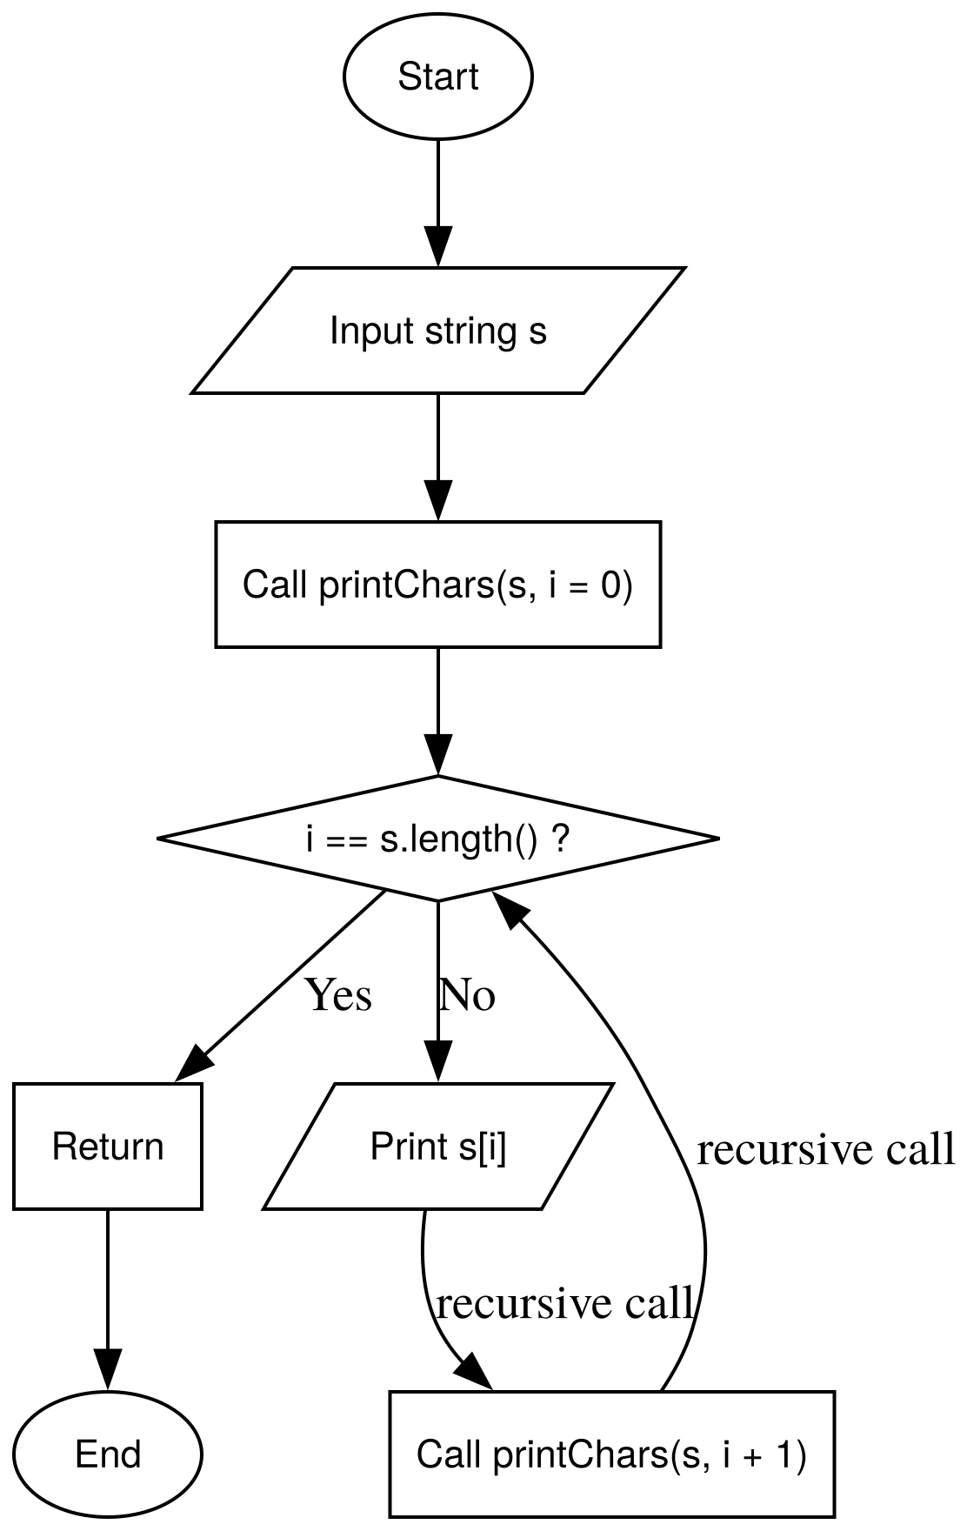 | void print_string(string s, int n) {  if(n == 0) return ;  print_string(s, n-1);  cout << s[n-1] << endl;  }

Question 2
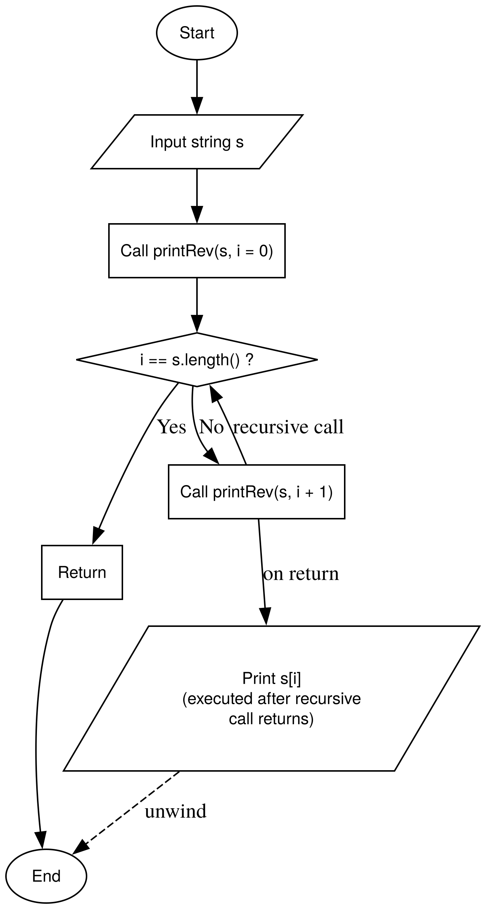 | void print_output_rev(string s, int n) {  if (n == 0) return;  cout << s[n-1] << endl;  print_output_rev(s, n-1);  }

Question 3
void rev_string(string s, int len) {
if (len == 0) return;
cout << s[len - 1];
rev_string(s, len-1);
}

Question 4
bool palindrome(string s, int i = 0) {
// false when s[left] != s[right,
if ( i >= s.length() / 2) return true;
if (s[i] != s[s.length()- i -1]) return false;
else return palindrome(s, i+1);
}

Question 5
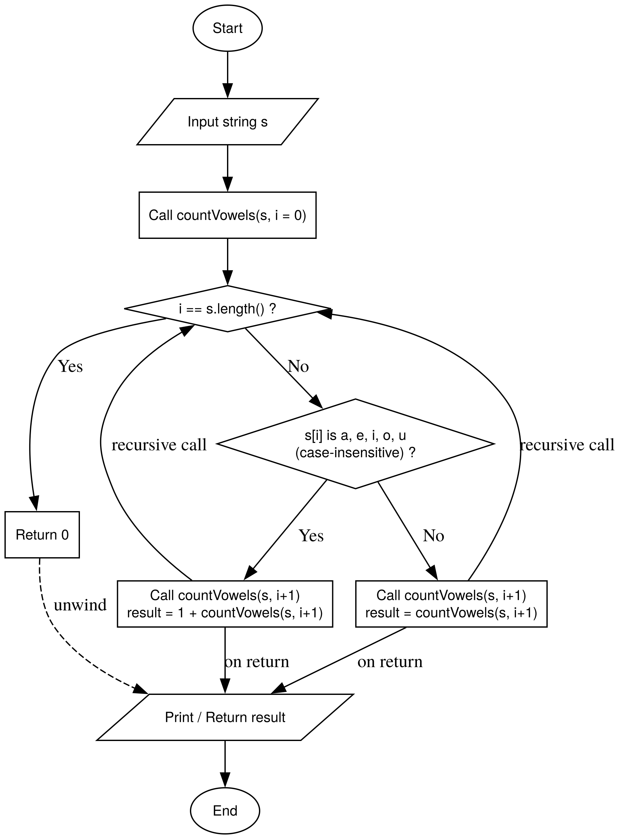 | int count_vowels(string s, int n) {  if (n == 0) return 0;  char c = s[n-1];  if (c == 'a' || c == 'e' || c == 'i' || c == 'o' || c == 'u' || c == 'A' || c == 'E' || c == 'I' || c == 'O' || c == 'U')  {  return 1 + count_vowels(s, n-1);  } else {  return 0 + count_vowels(s, n-1);  }  }

Question 6
bool vowel(char c) {
return ((c == 'a' || c == 'e' || c == 'i' || c == 'o' || c == 'u' || c == 'A' || c == 'E' || c == 'I' || c == 'O' || c == 'U'));
}

int consonants(string s, int n) {
if (n == 0) return 0;
if (!vowel(s[n-1])) return 1 + consonants(s, n-1);
else return 0 + consonants(s, n-1);
}

Question 7
string remove_spaces(string s, int n) {
if (n == 0) return "";

if (s[n-1] == ' ') return remove_spaces(s, n-1);
else return remove_spaces(s, n-1) + s[n-1];
}

Question 8
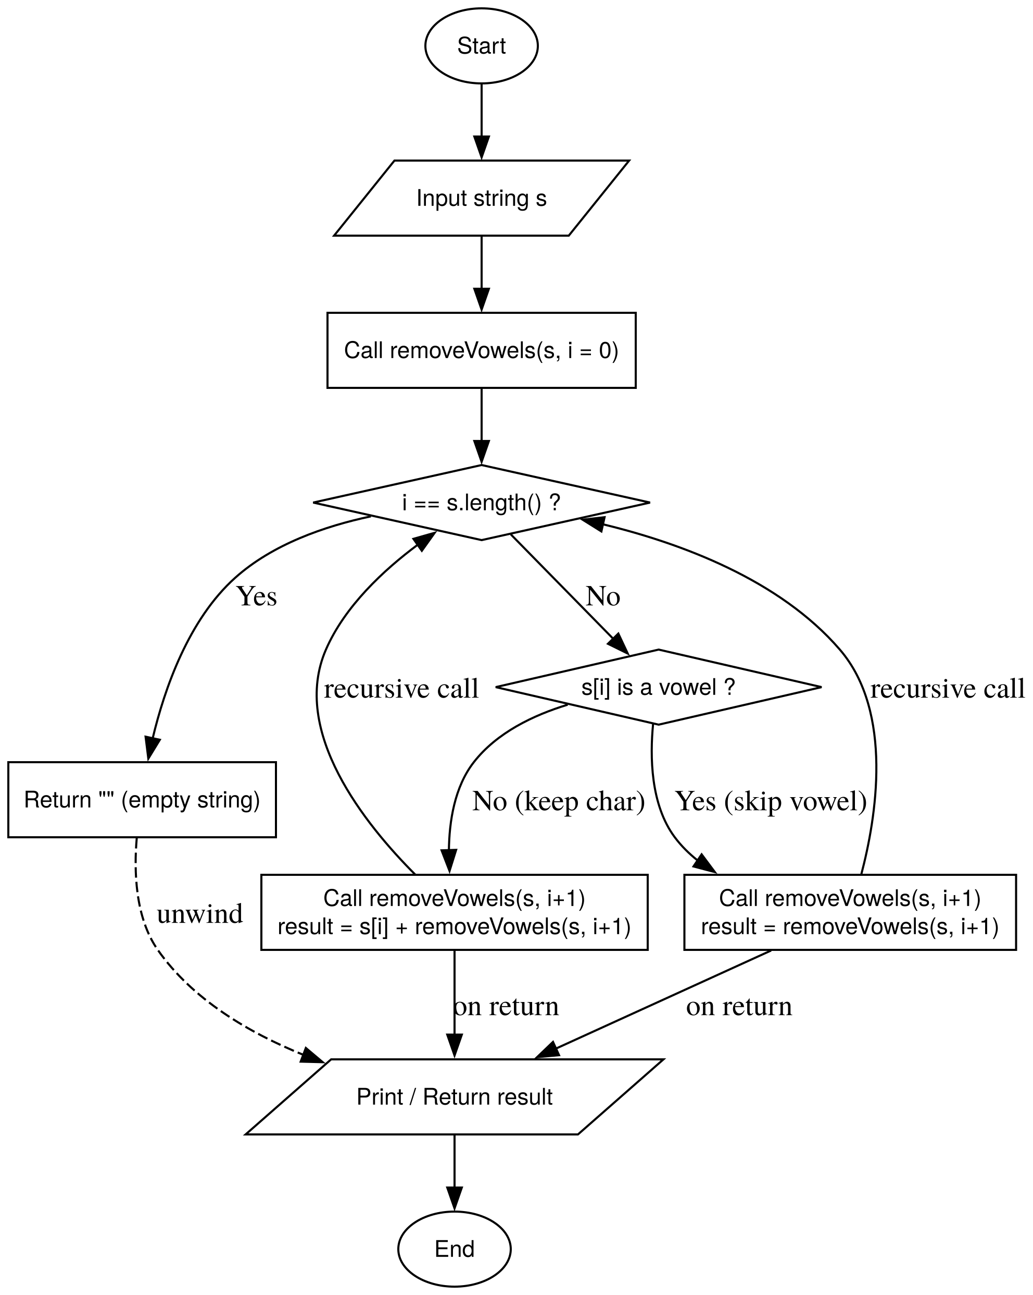 | bool vowel(char c) {  return ((c == 'a' || c == 'e' || c == 'i' || c == 'o' || c == 'u' || c == 'A' || c == 'E' || c == 'I' || c == 'O' || c == 'U'));  }  string remove_vowel(string s, int n) {  if (n == 0) return "";  if (vowel(s[n-1])) return remove_vowel(s, n-1);  return remove_vowel(s, n-1) + s[n-1];  }

Question 9
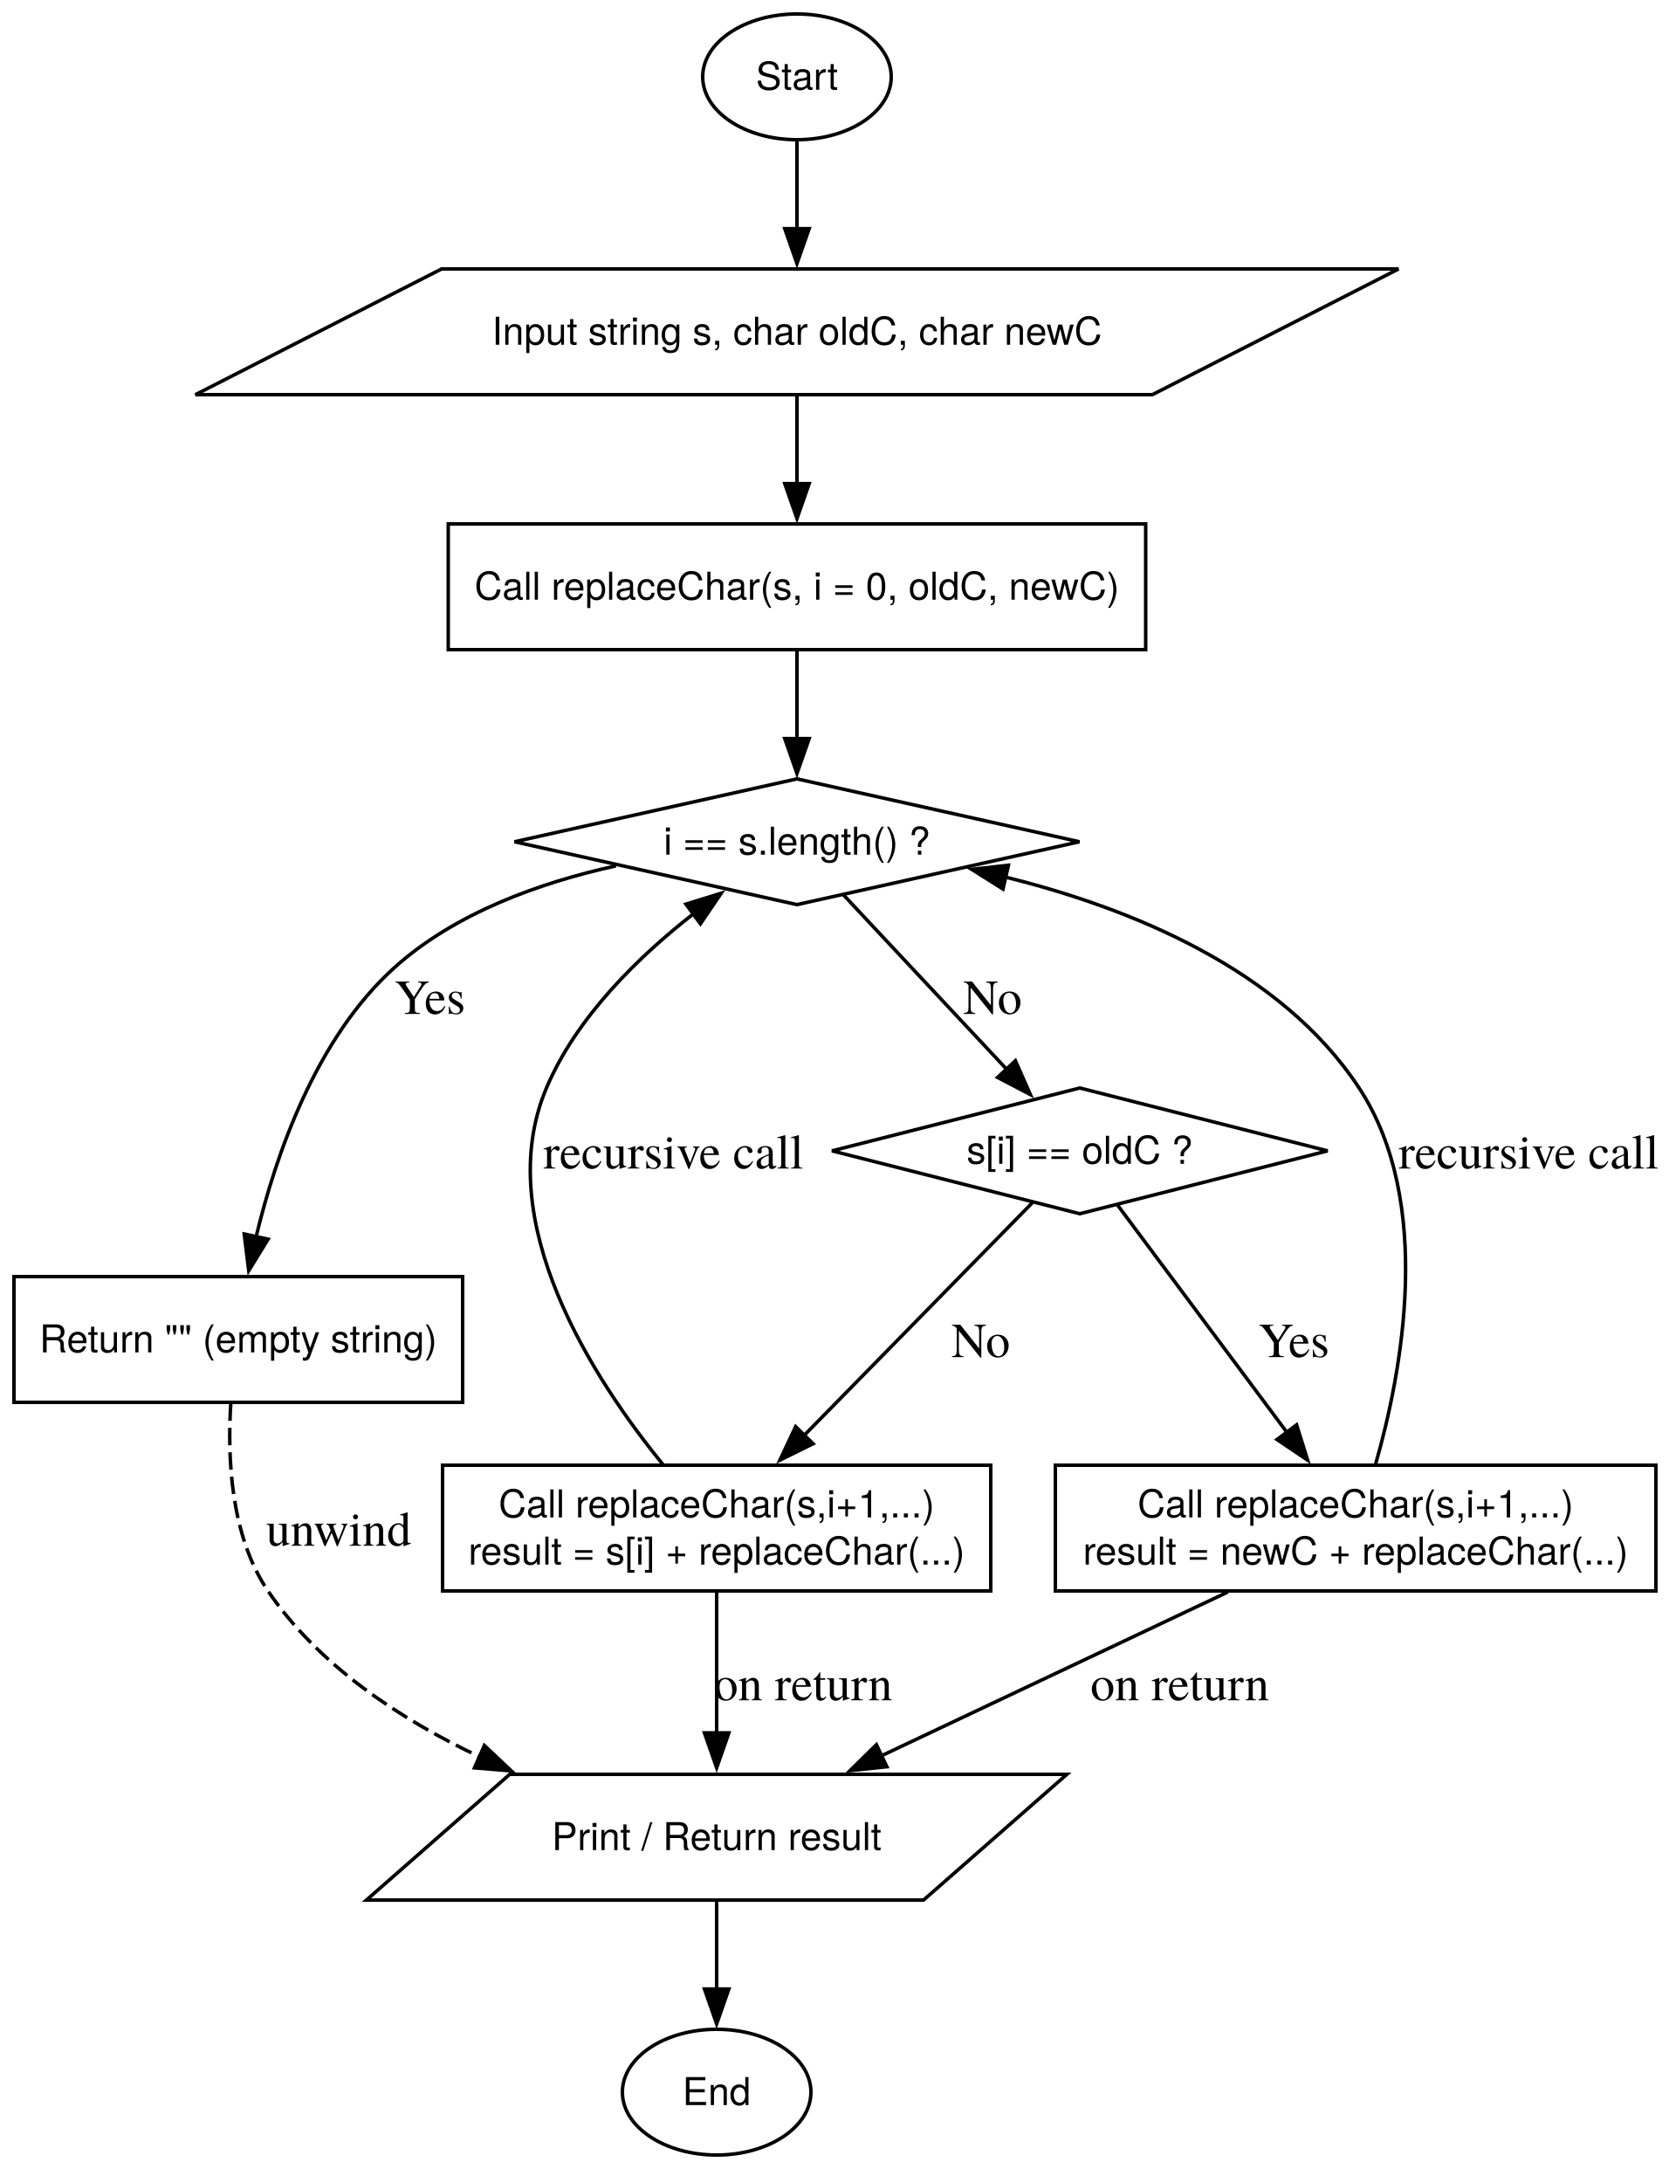 | string replace_occur(string s, char c, char r, int n) {  if (n == 0) return "";  if (s[n-1] == c) return replace_occur(s, c, r, n-1) + r;  return replace_occur(s, c, r, n-1) + s[n-1];  }

Question 10
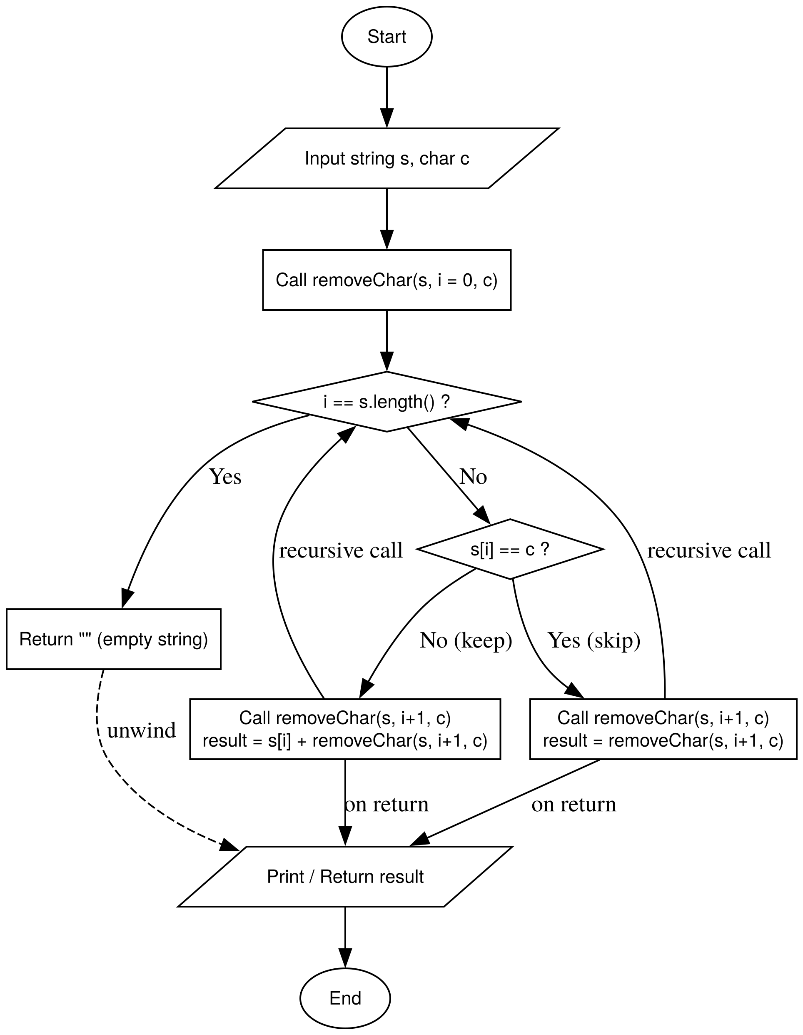 | string remove_occur(string s, char c, int n) {  if (n==0) return "";  if (s[n-1] == c) return remove_occur(s, c, n-1);  return remove_occur(s, c, n-1) + s[n-1];  }

Question 11
int count_freq(string s, char c, int n) {
if (n == 0) return 0;

if (s[n-1] == c) return 1 + count_freq(s, c, n-1);
else return 0 + count_freq(s, c, n-1);
}

Question 12
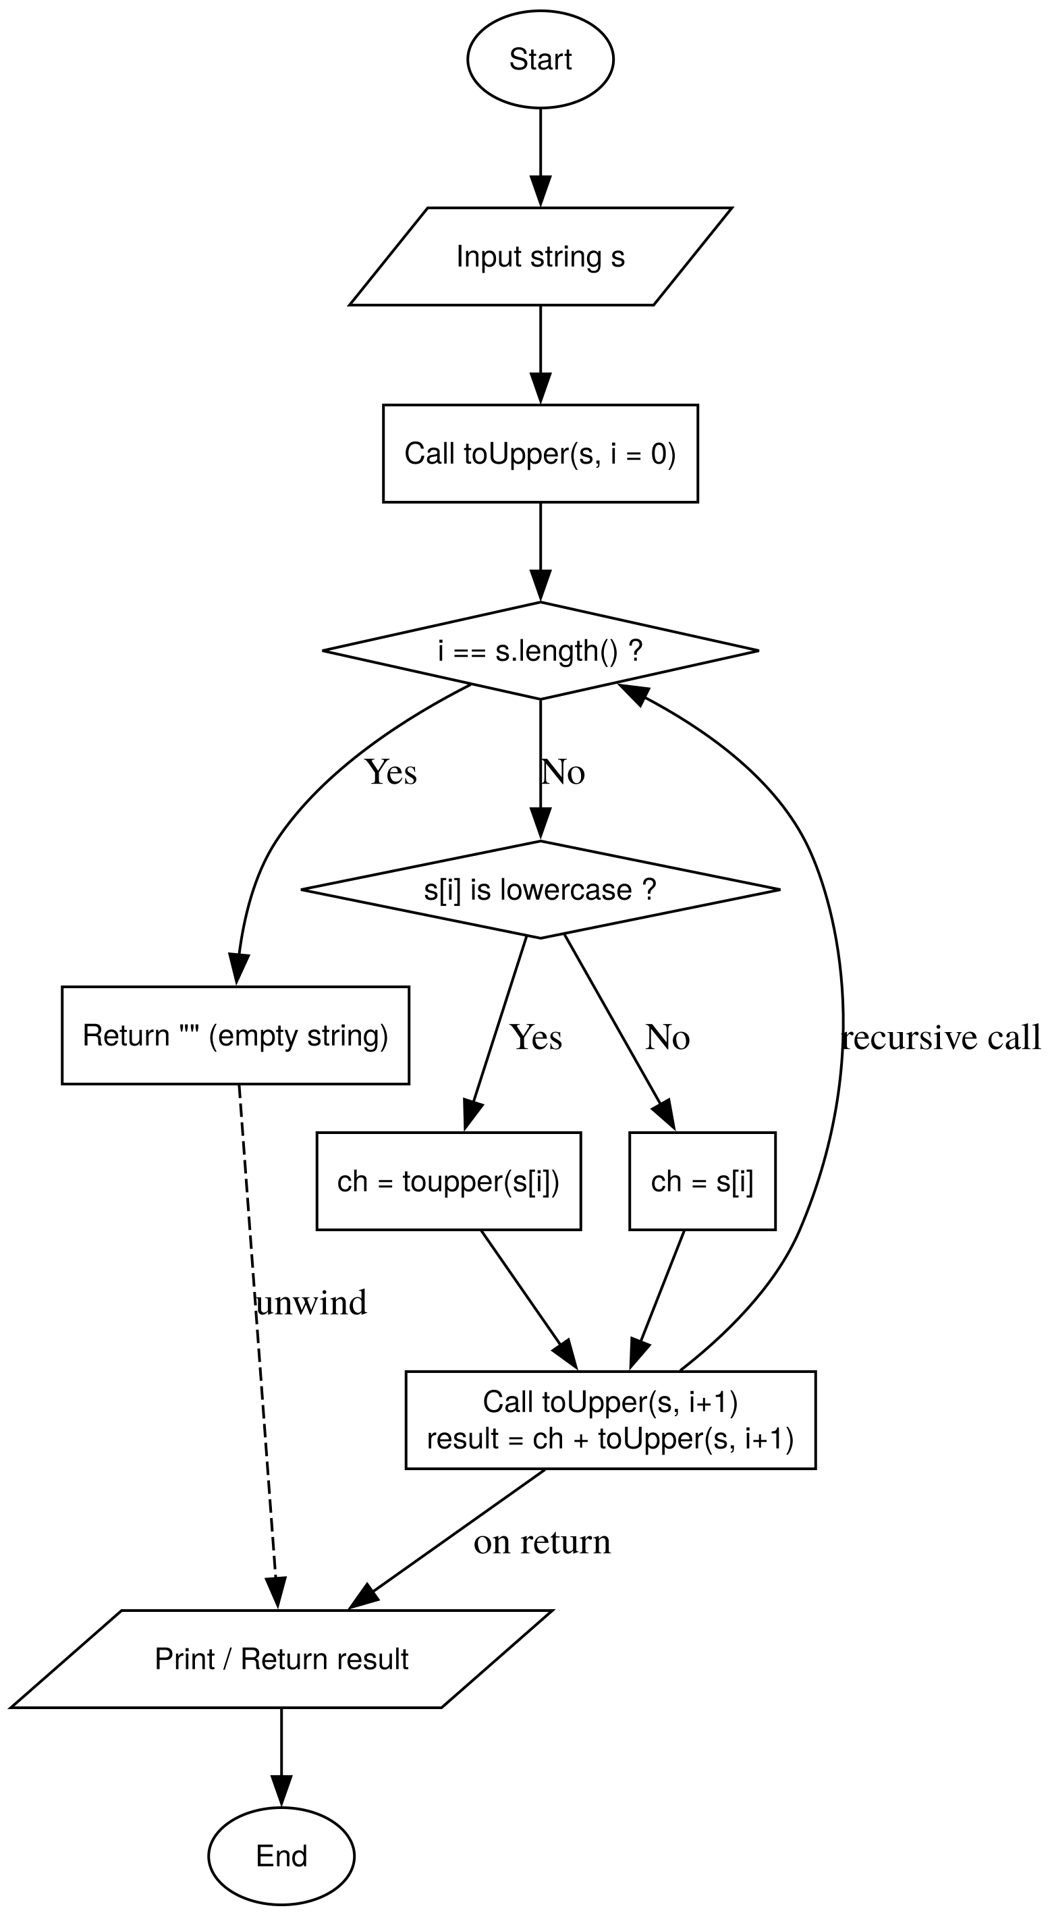 | string to_uppercase(string s, int n) {  if (n == 0) return "";  char current = s[n-1];  if (current >= 'a' && current <= 'z') current = current - 32;  return to_uppercase(s, n-1) + current;  }

Question 13
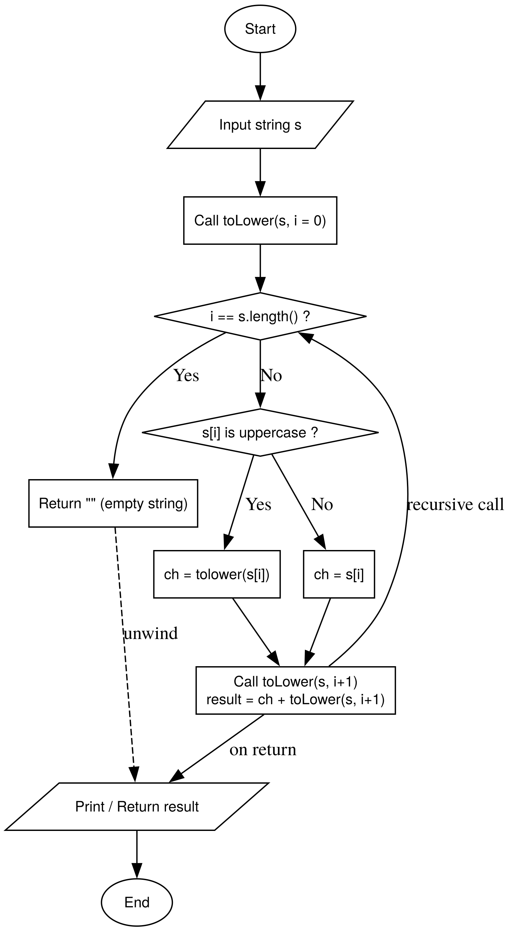 | string to_lowercase(string s, int n) {  if (n == 0) return "";  char current = s[n-1];  if (current >= 'A' && current <= 'Z') current = current + 32;  return to_lowercase(s, n-1) + current;  }

Question 14
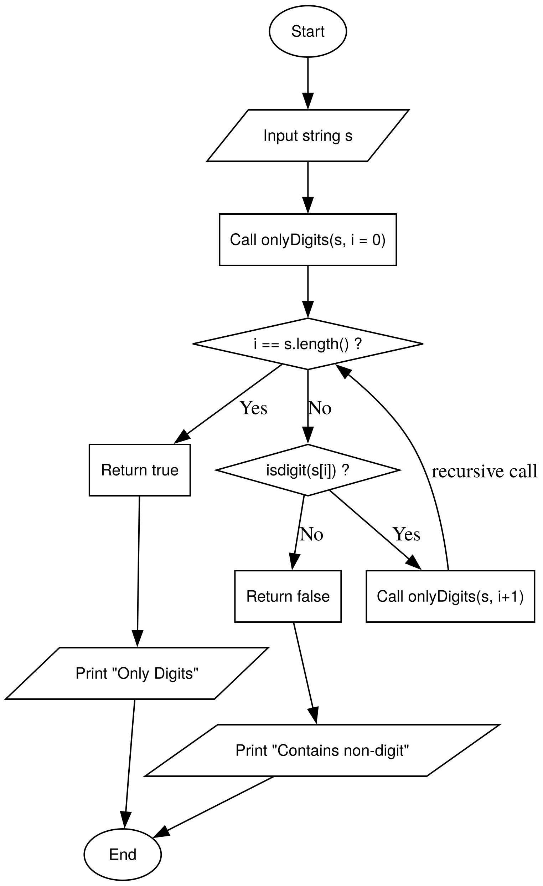 | bool only_digits(string s, int n) {  if (n == 0) return true;  if (s[n-1] >= '0' && s[n-1] <= '9') return only_digits(s, n-1);  return false;  }

Question 15
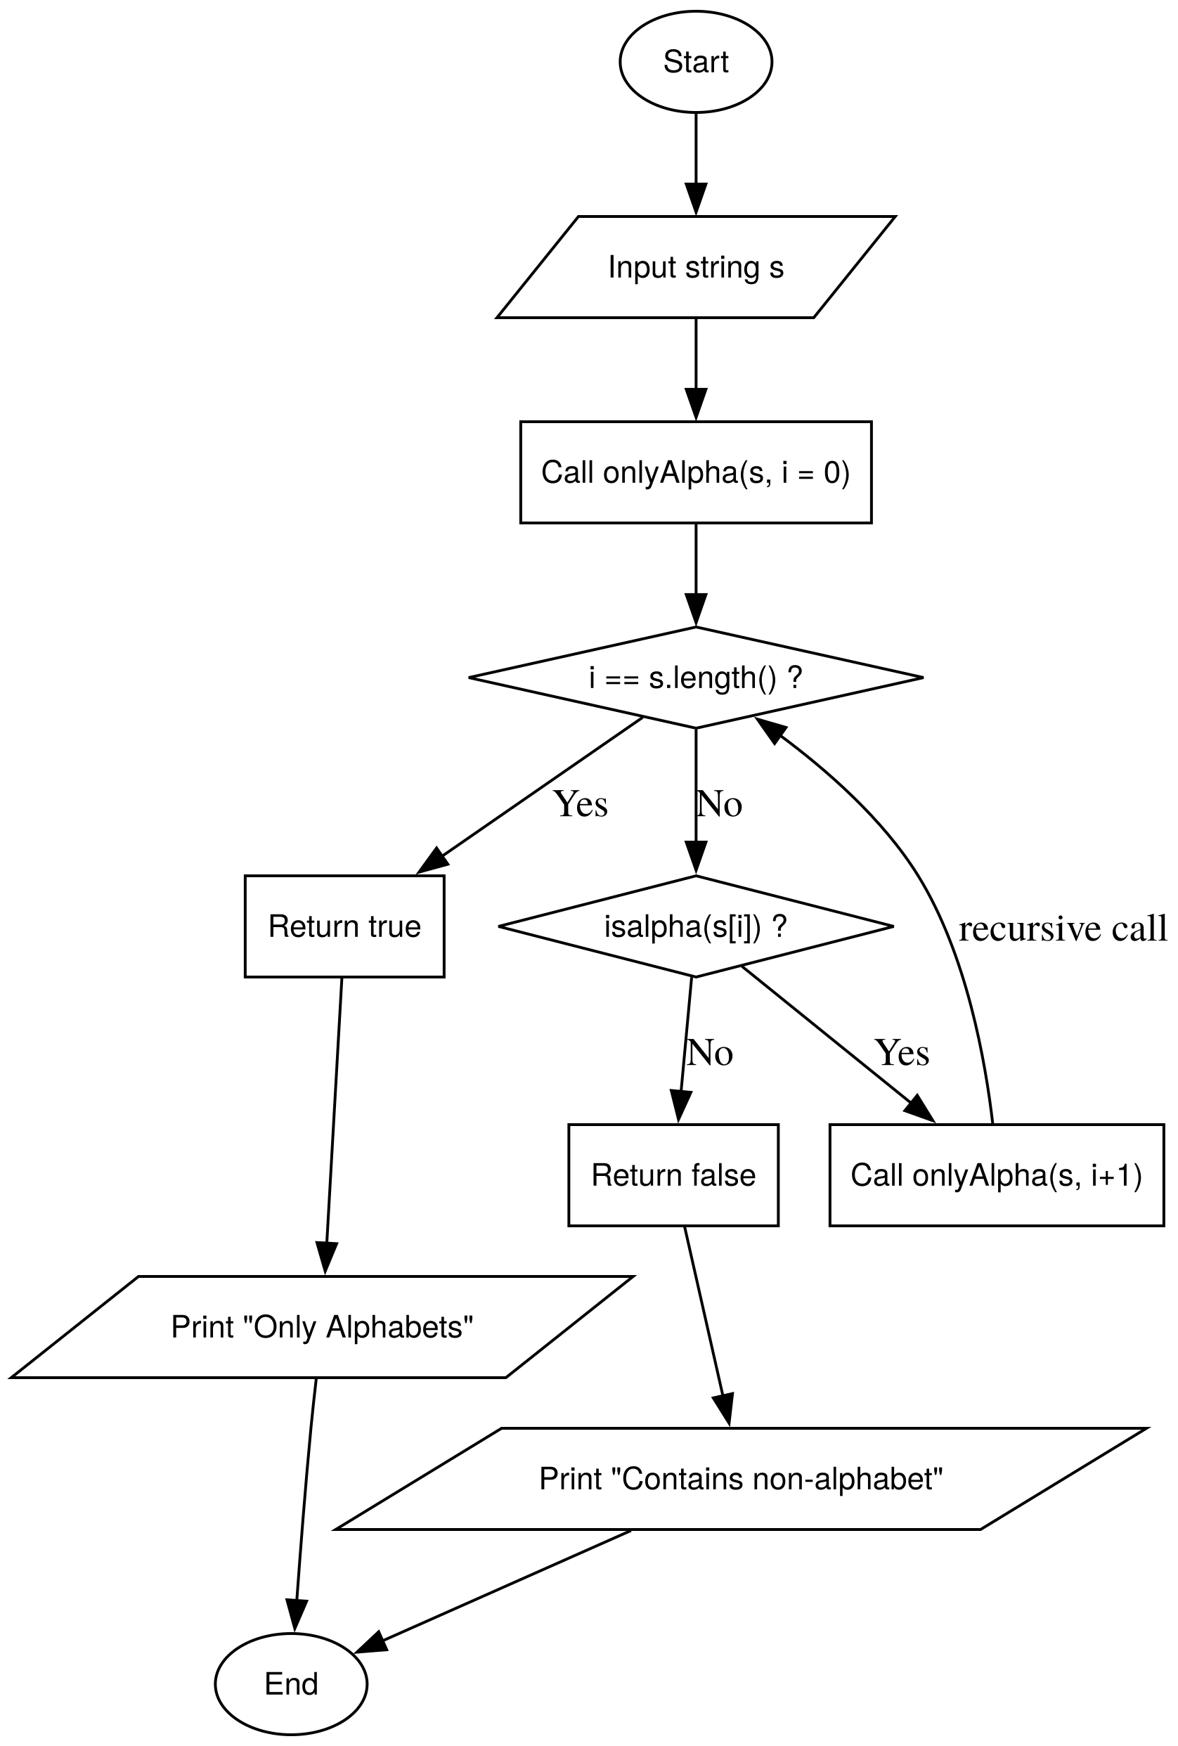 | bool only_alphabets(string s, int n) {  if (n == 0) return true;  char c = s[n-1];  if ((c >= 'a' && c <= 'z') || (c >= 'A' && c <= 'Z')) return only_alphabets(s, n-1);  return false;  }

Question 16
int count_words(string s, int n) {
if (n == 0) return 0;

if (s[n-1] != ' ' && (n == 1 || s[n-2] == ' ')) return 1 + count_words(s, n-1);
return 0 + count_words(s, n-1);
}

Question 17
bool char_exists(string s, char c, int n) {
if (n == 0) return false;
if (s[n-1] == c) return true;
return char_exists(s, c, n-1);
}

string remove_duplicates(string s, int n) {
if (n == 0) return "";

if (char_exists(s, s[n-1], n-1)) return remove_duplicates(s, n-1);
return remove_duplicates(s, n-1) + s[n-1];
}

Question 18
void print2_string(string s, int i = 0) {
if (s[i] == '\0') return;

cout << s[i];
print2_string(s, i + 1);
}

Question 19
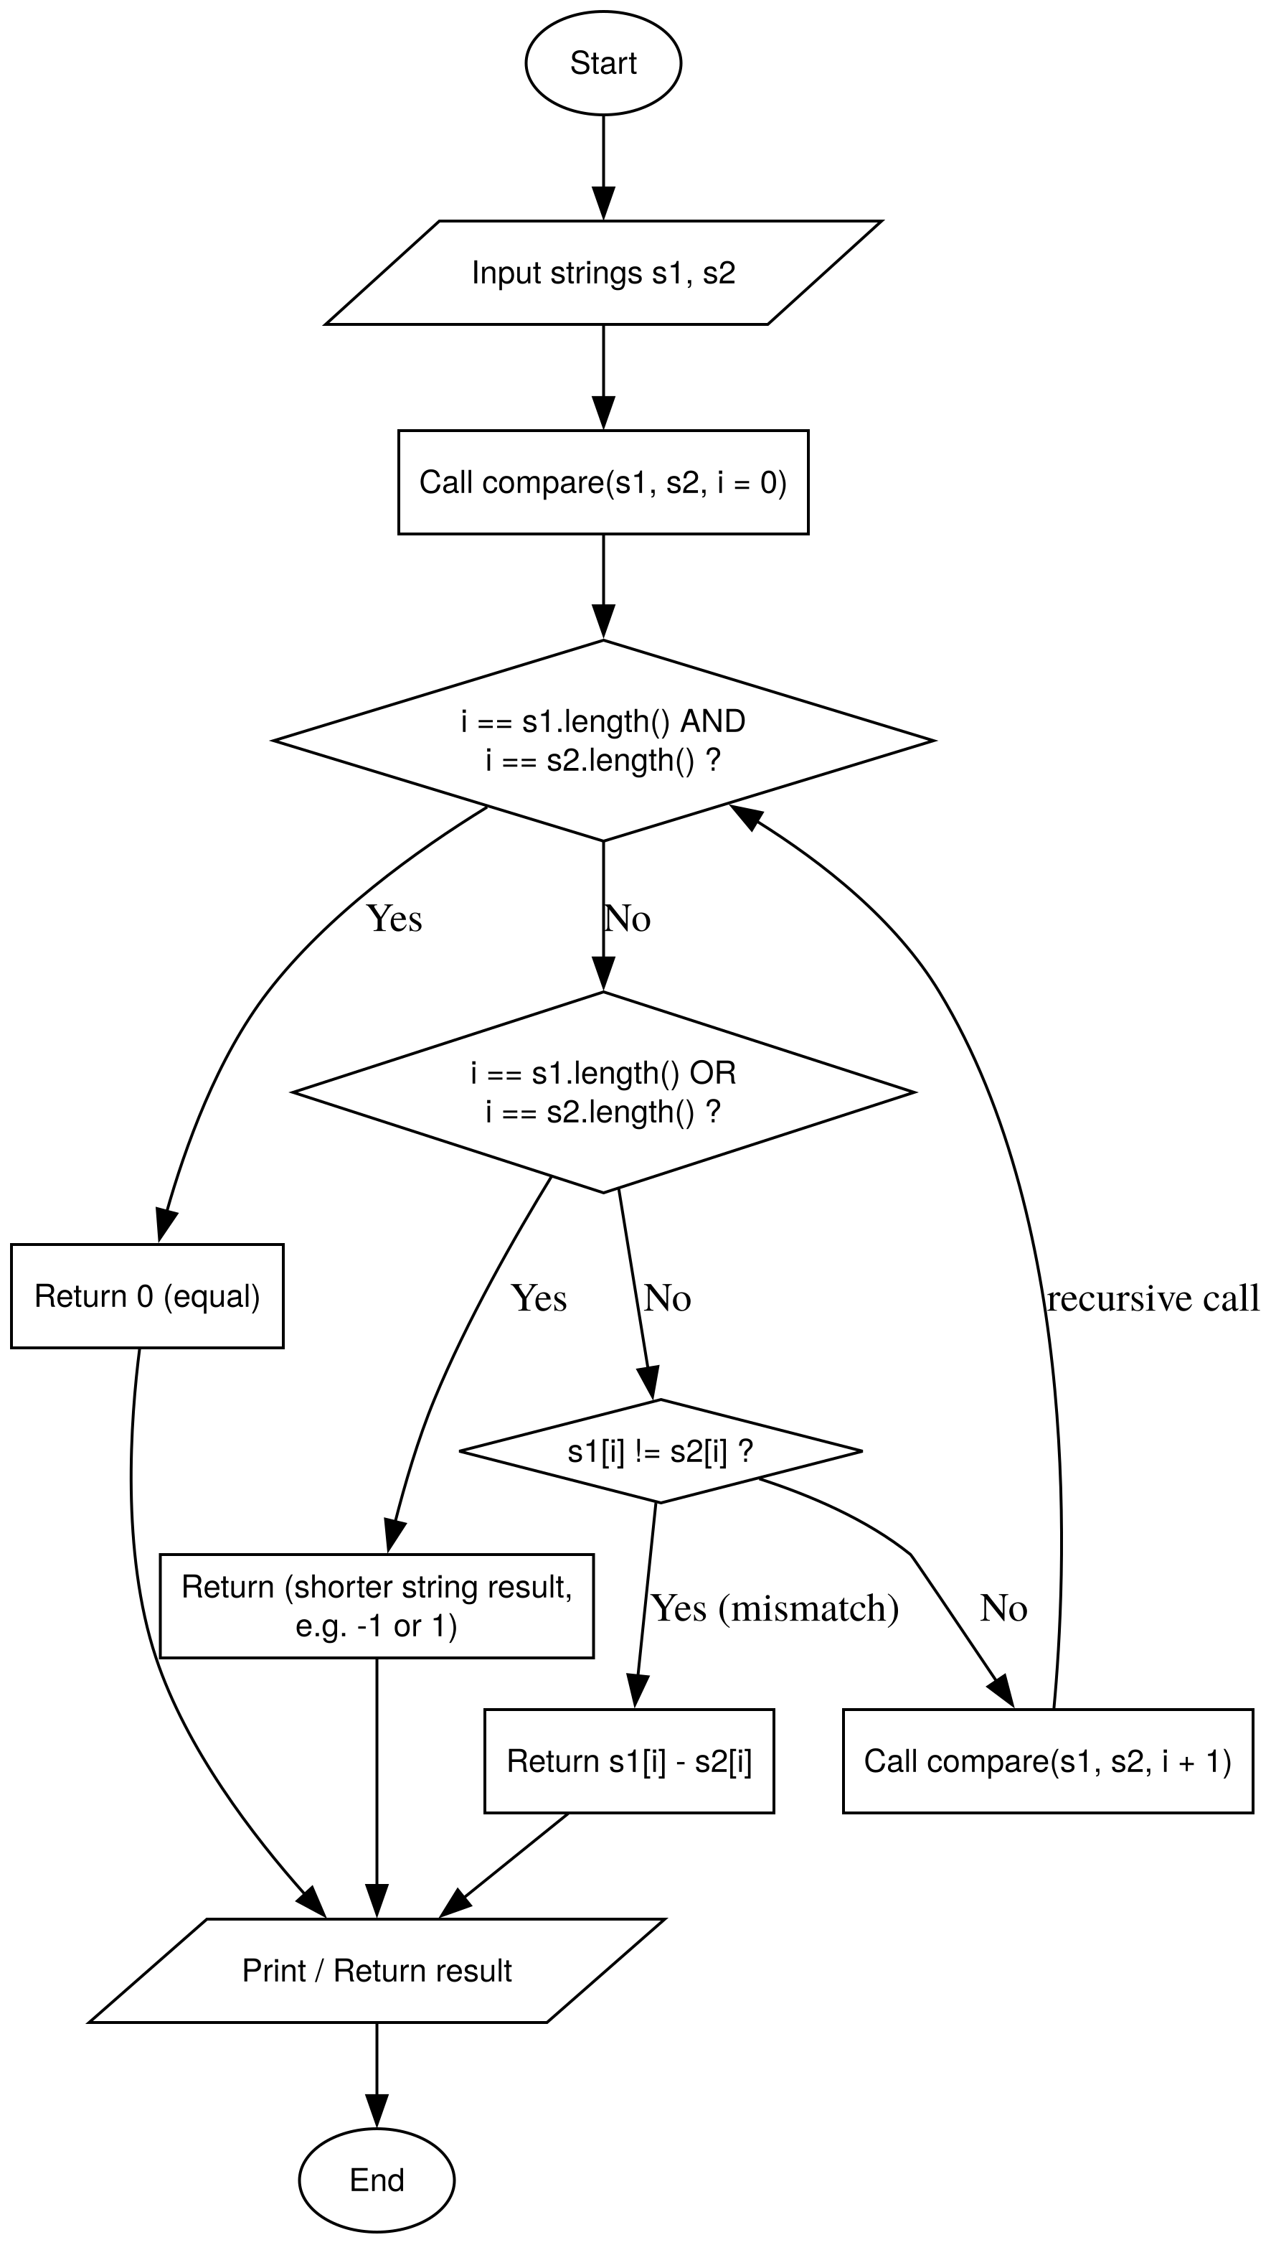 | bool compare_strings(string s1, string s2, int n1, int n2) {  if (n1 == 0 && n2 == 0) return true;  if (n1 == 0 || n2 == 0) return false;  if (s1[n1-1] != s2[n2-1]) return false;  return compare_strings(s1, s2, n1-1, n2-1);  }

Question 20
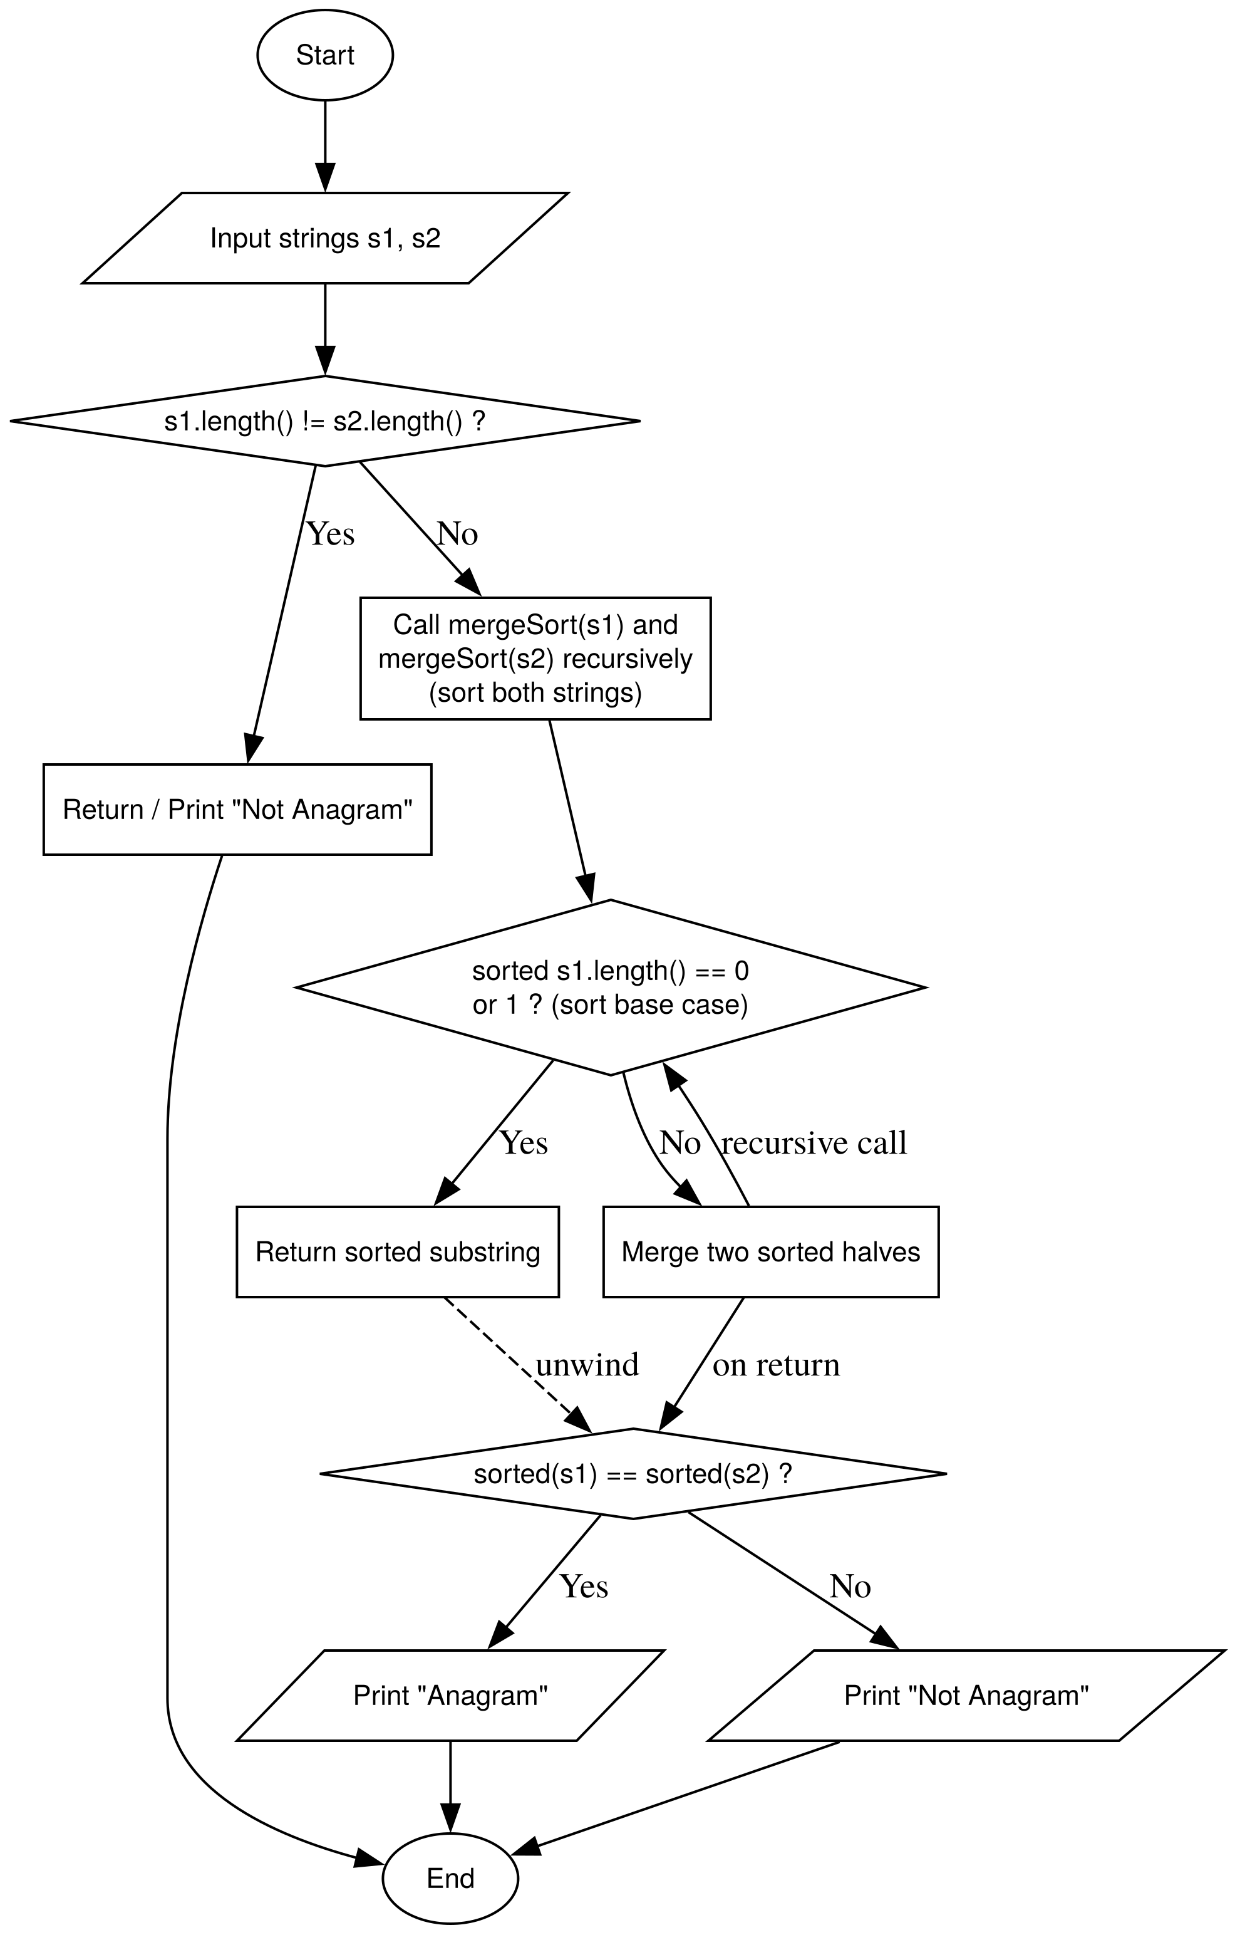 | bool presence_check(string &s, char c, int i = 0) {  if (i == s.length()) return false;  if (s[i] == c) {  s[i] = '0'; // this shte flag that we use to mark that this place hath been checked  return true;  }  return presence_check(s, c, i+1);  }  bool check_anagram(string x, string y, int i = 0) {  if (x.length() != y.length()) return false;  if (i == x.length()) return true;  if (!presence_check(y, x[i])) {  return false;  }  return check_anagram(x, y, i+1);  }

Phase 6 – Array Recursion (No Loops Allowed)

Question 1
void print_elements(int a[], int n) {
if (n == 0) return;

print_elements(a, n-1);
cout << a[n-1] << " ";
}

Question 2
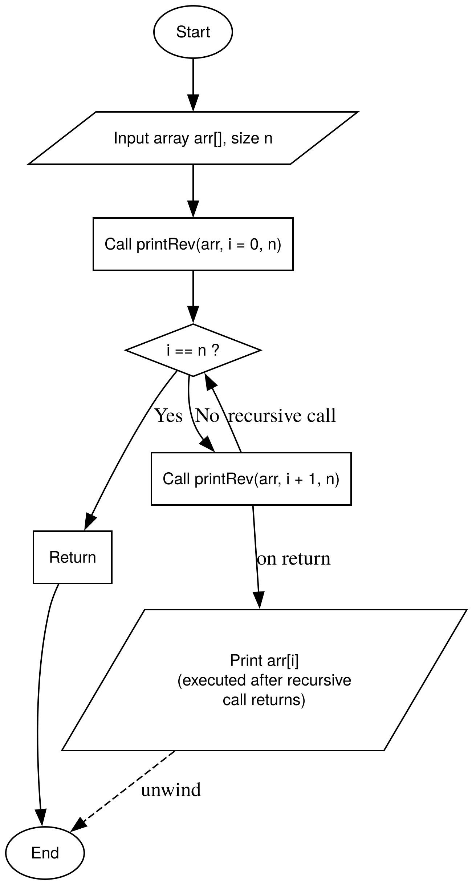 | void print_elements_rev(int a[], int n) {  if (n == 0) return;  cout << a[n-1] << " ";  print_elements_rev(a, n-1);  }

Question 3
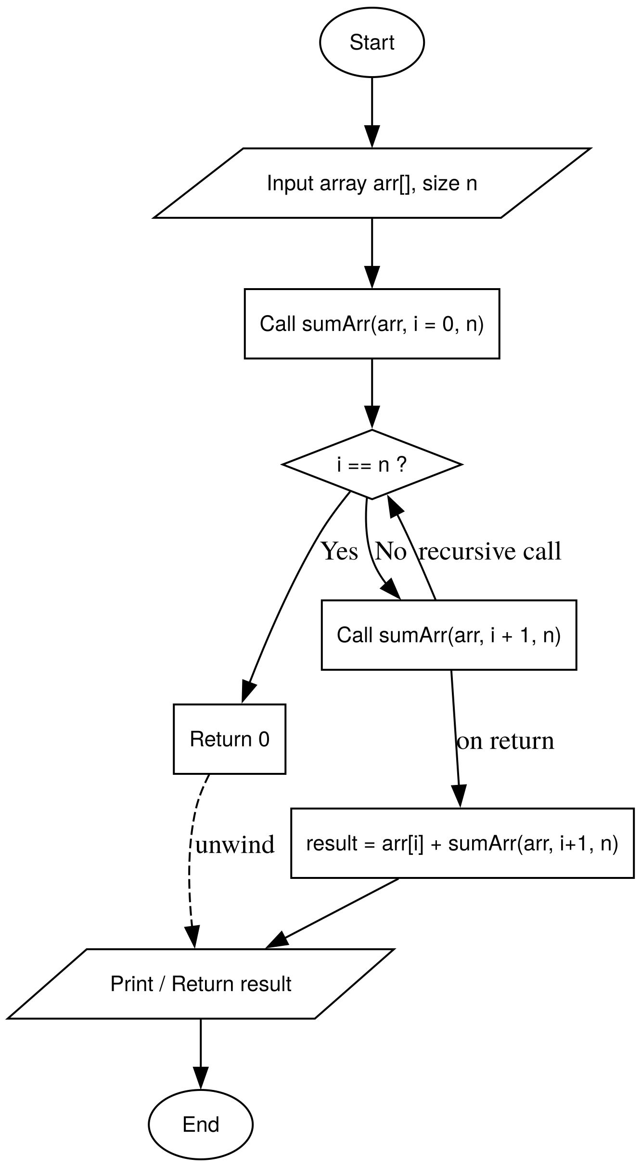 | ll arr_sum(int a[], int n) {  if (n == 0) return 0;  return a[n-1] + arr_sum(a, n-1);  }

Question 4
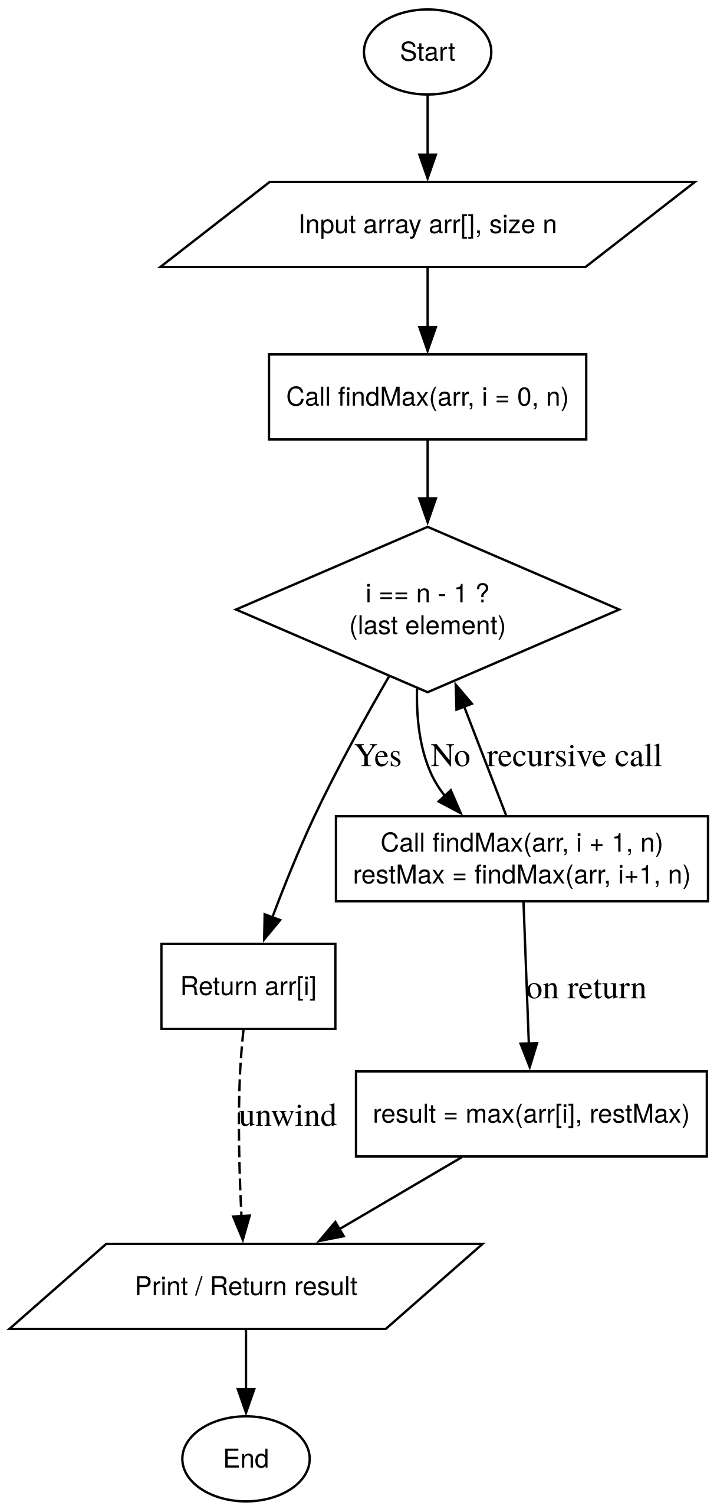 | int find_max(int arr[], int n) {  if (n == 1) return arr[0];  int max_rest = find_max(arr, n - 1);  if (arr[n - 1] > max_rest) return arr[n - 1];  return max_rest;  }

Question 5
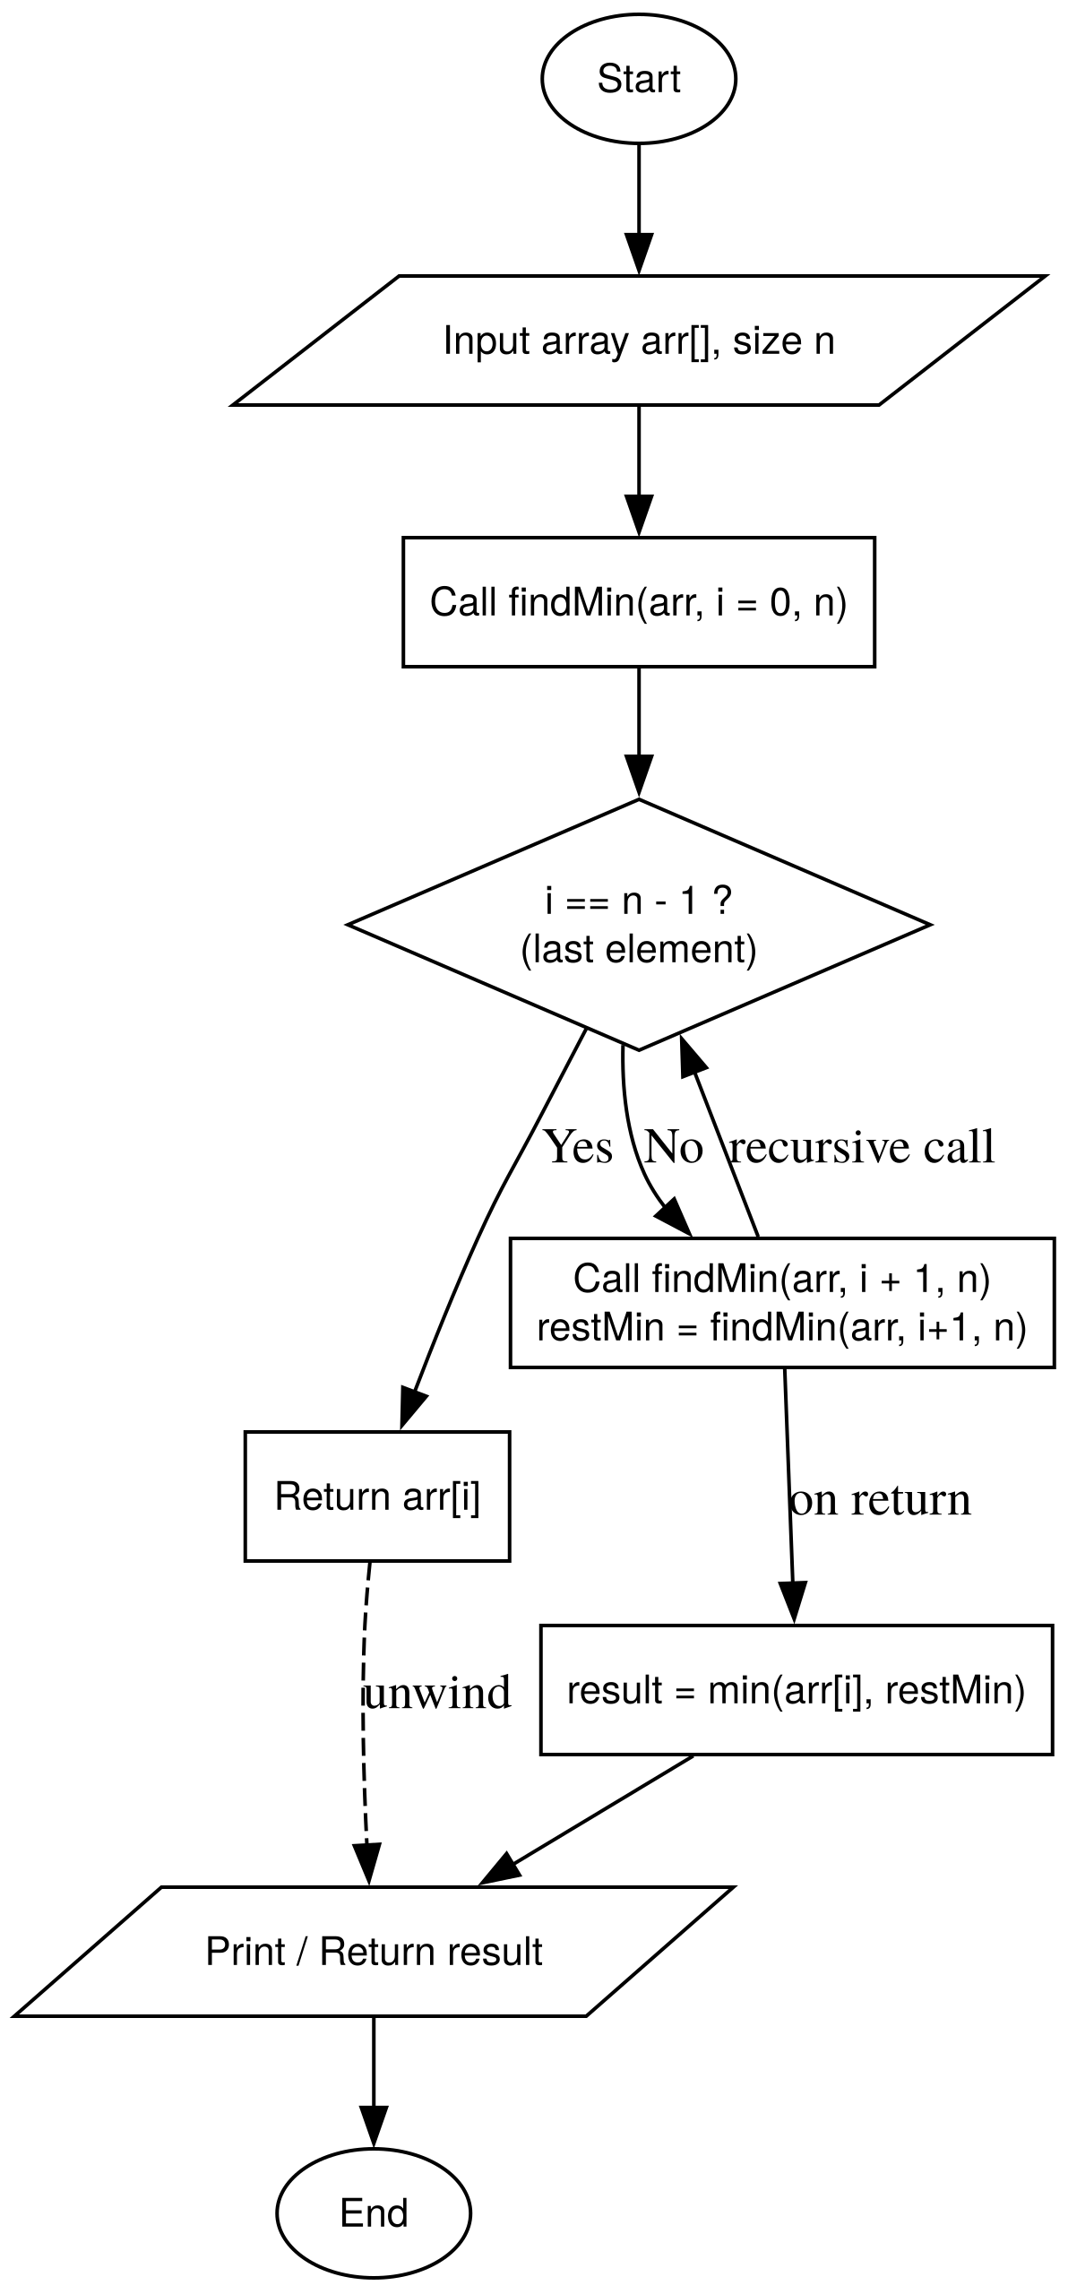 | int find_min(int arr[], int n) {  if (n == 1) return arr[0];  int min_rest = find_min(arr, n - 1);  if (arr[n - 1] < min_rest) return arr[n - 1];  return min_rest;  }

Question 6
int count_even(int a[], int n) {
if (n == 0) return 0;

if (a[n-1] % 2 == 0) return 1 + count_even(a, n-1);
return 0 + count_even(a, n-1);
}

Question 7
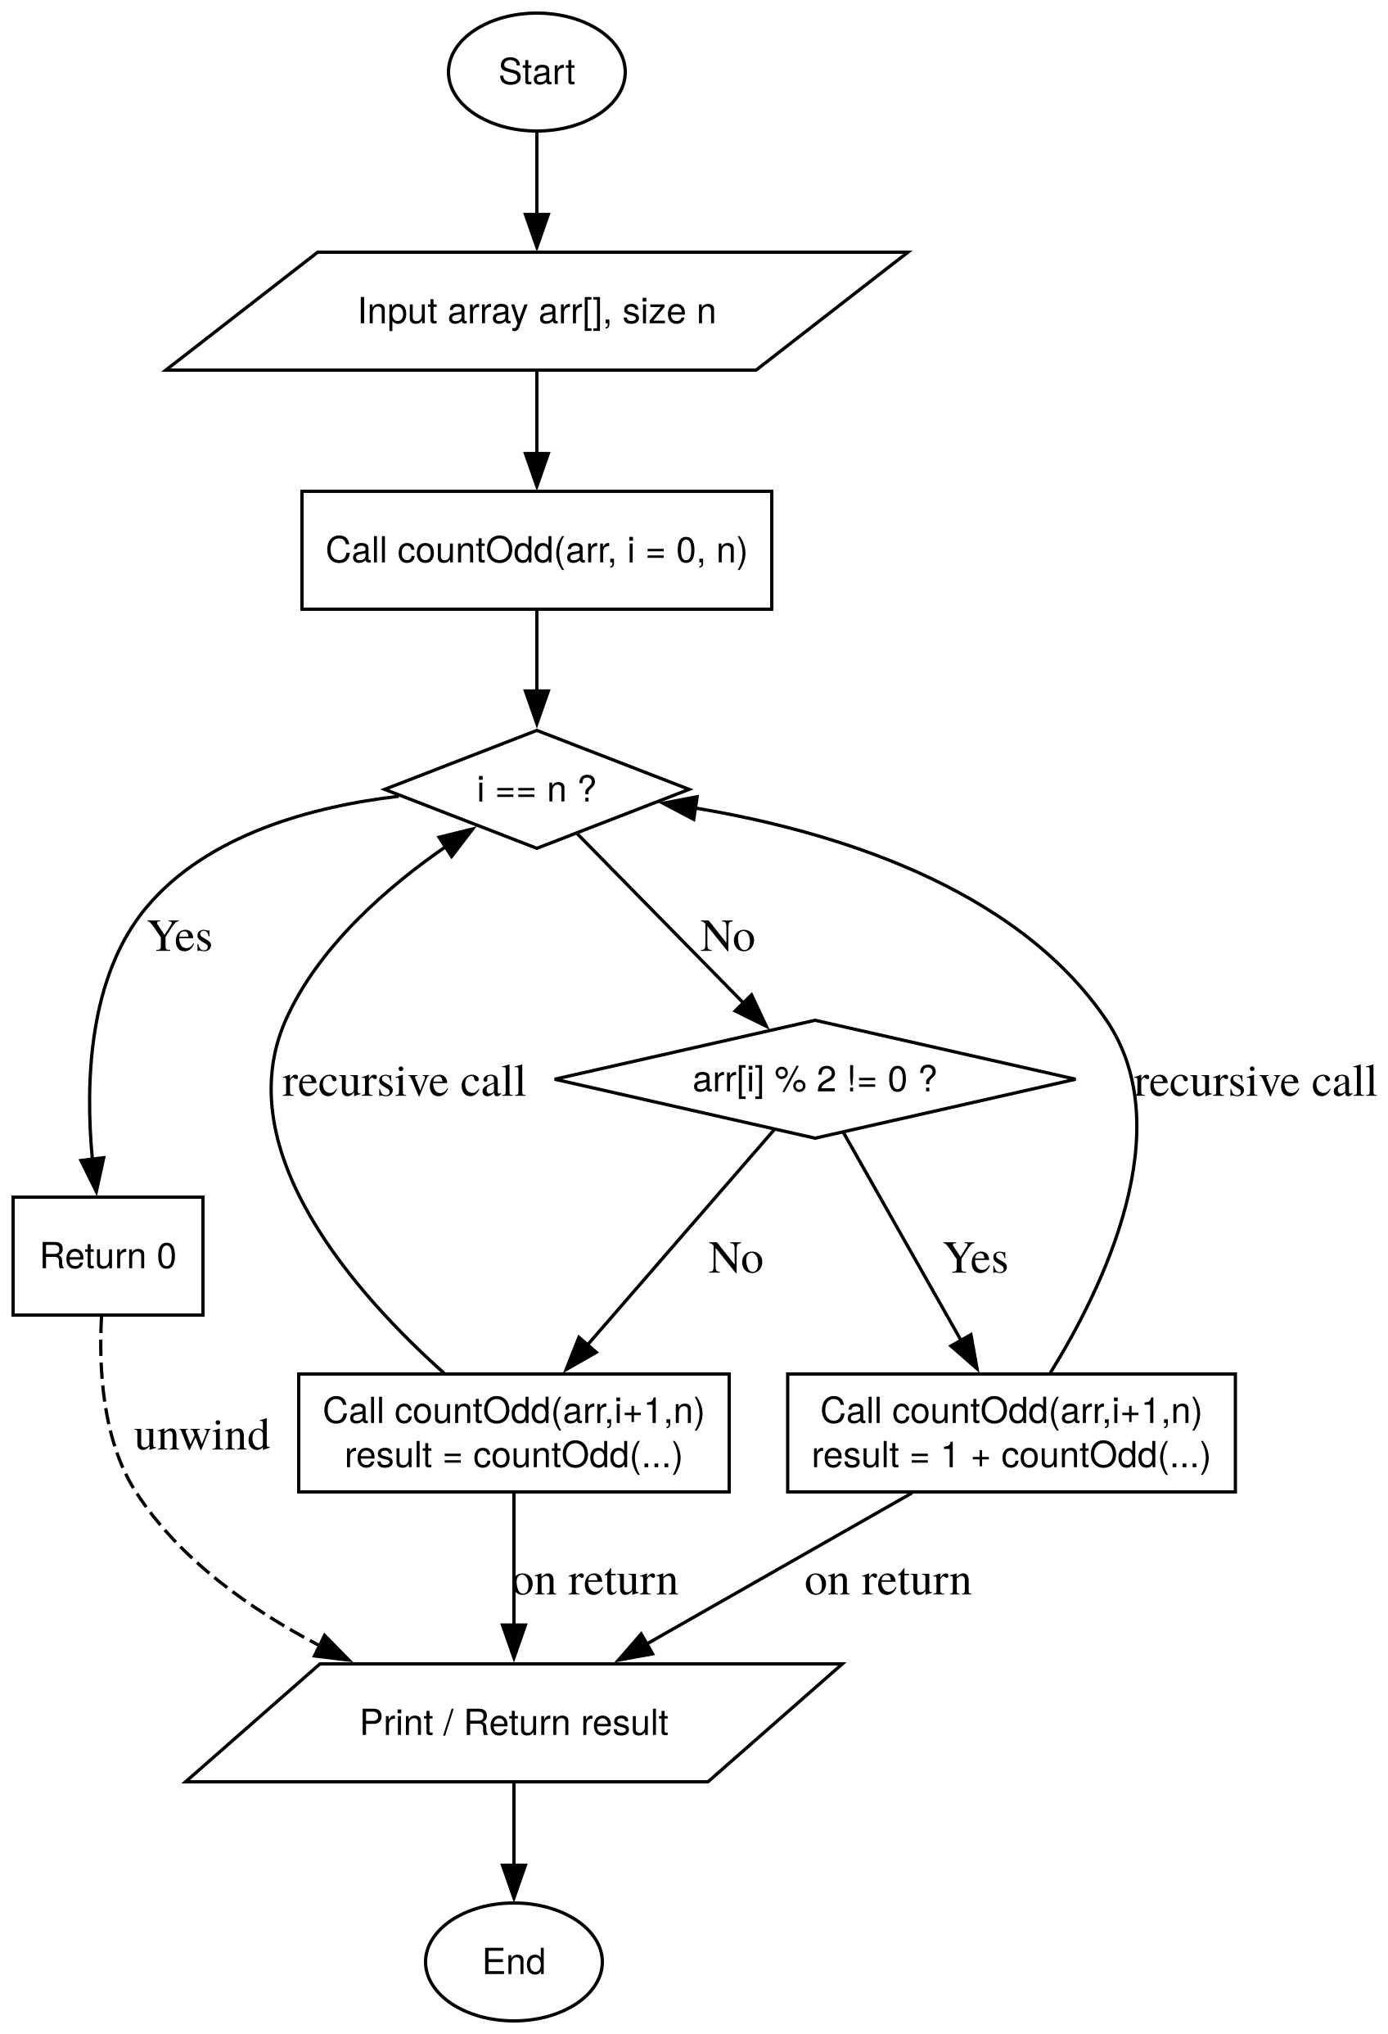 | int count_odd(int a[], int n) {  if (n == 0) return 0;  if (a[n-1] % 2 != 0) return 1 + count_odd(a, n-1);  return 0 + count_odd(a, n-1);  }

Question 8
bool check_for_asc(int a[], int n) {
if (n == 0 || n == 1) return true;

if (a[n-1] < a[n-2]) return false;

return check_for_asc(a, n-1);
}

Question 9
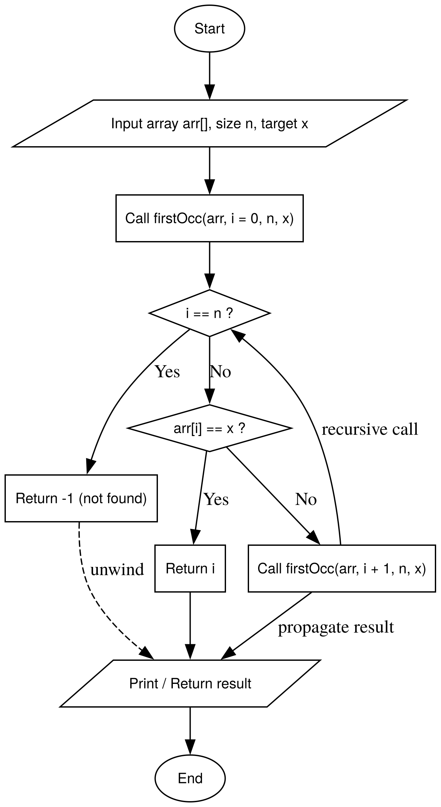 | int first_occurence(int a[], int n, int x, int i = 0) {  if (i == n) return -1;  if (a[i] == x) return i;  return first_occurence(a, n, x, i+1);  }

Question 10
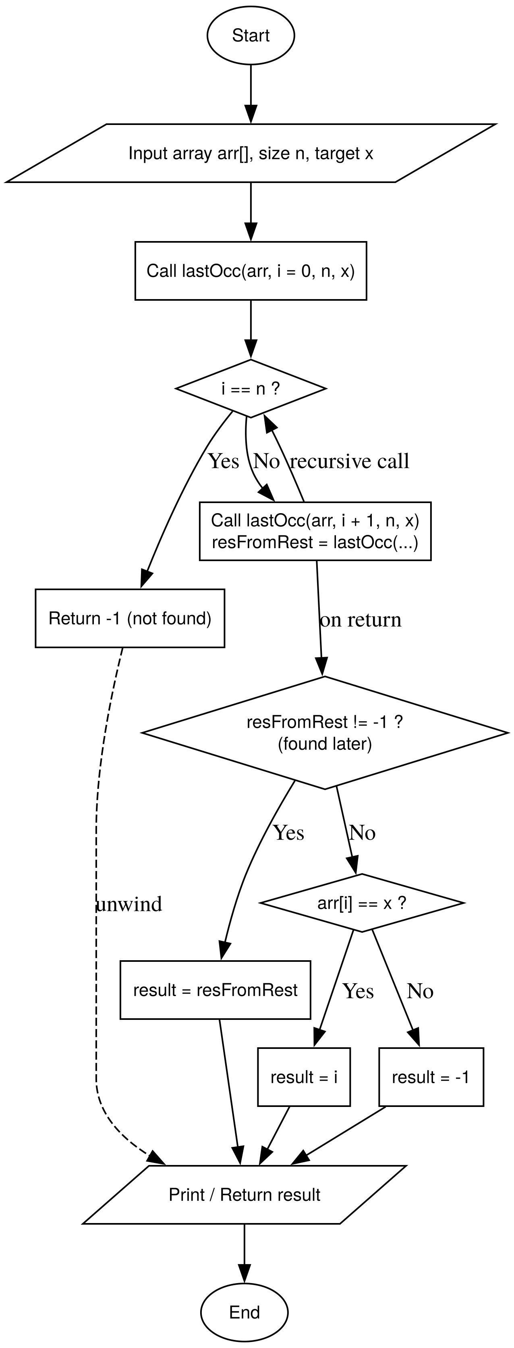 | int last_occurence(int a[], int n, int x) {  if (n ==0) return -1;  if (a[n-1] == x) return n-1;  return last_occurence(a, n-1, x);  }

Question 11
int tot_occurances(int a[], int n, int c) {
if (n == 0) return 0;

if (a[n-1] == c) return 1 + tot_occurances(a, n-1, c);
return 0 + tot_occurances(a, n-1, c);
}

Question 12
void rev_array(int a[], int n, int i = 0) {
if (i >= n / 2) return ;

int temp = a[i];
a[i] = a[n - i - 1];
a[n - i - 1] = temp;

rev_array(a, n, i + 1);
}

Question 13
bool palindrome(int a[], int n, int i= 0 ) {
if (i >= n / 2) return true;

if (a[i] != a[n - i -1]) return false;
return palindrome(a, n, i+1);
}

Question 14
void replace_even_zero(int a[], int n) {
if (n == 0) return;

if (a[n-1] % 2 == 0) {
a[n-1] = 0;
}

replace_even_zero(a, n-1);
}

Question 15
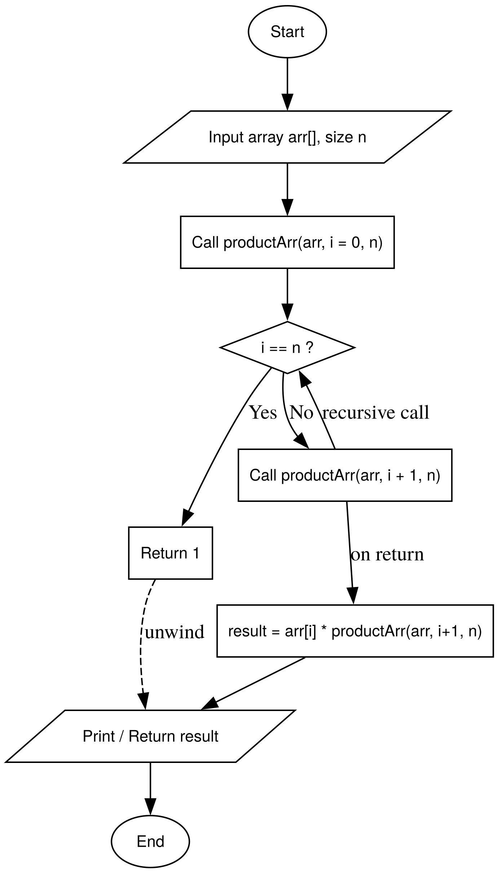 | ll arr_product(int a[], int n) {  if (n == 0) return 1;  return a[n-1] * arr_product(a, n-1);  }

Question 16
void print_alternate(int a[], int n, int i = 0) {
if (i >= n) return;
cout << a[i] << " ";

print_alternate(a, n, i + 2);
}

Question 17
int find_max_index(int a[], int n) {
if (n == 1) return 0;

int max_idx_rest = find_max_index(a, n - 1);

if (a[n - 1] > a[max_idx_rest]) return n - 1;
return max_idx_rest;
}

Question 18
int find_min_index(int a[], int n) {
if (n == 1) return 0;

int min_idx_rest = find_min_index(a, n - 1);

if (a[n - 1] < a[min_idx_rest]) return n - 1;
return min_idx_rest;
}

Question 19
bool exists_in_array(int a[], int n, int target) {
if (n == 0) return false;
if (a[n - 1] == target) return true;
return exists_in_array(a, n - 1, target);
}

bool has_duplicates(int a[], int n) {
if (n <= 1) return false;
if (exists_in_array(a, n - 1, a[n - 1])) return true;
return has_duplicates(a, n - 1);
}

Question 20
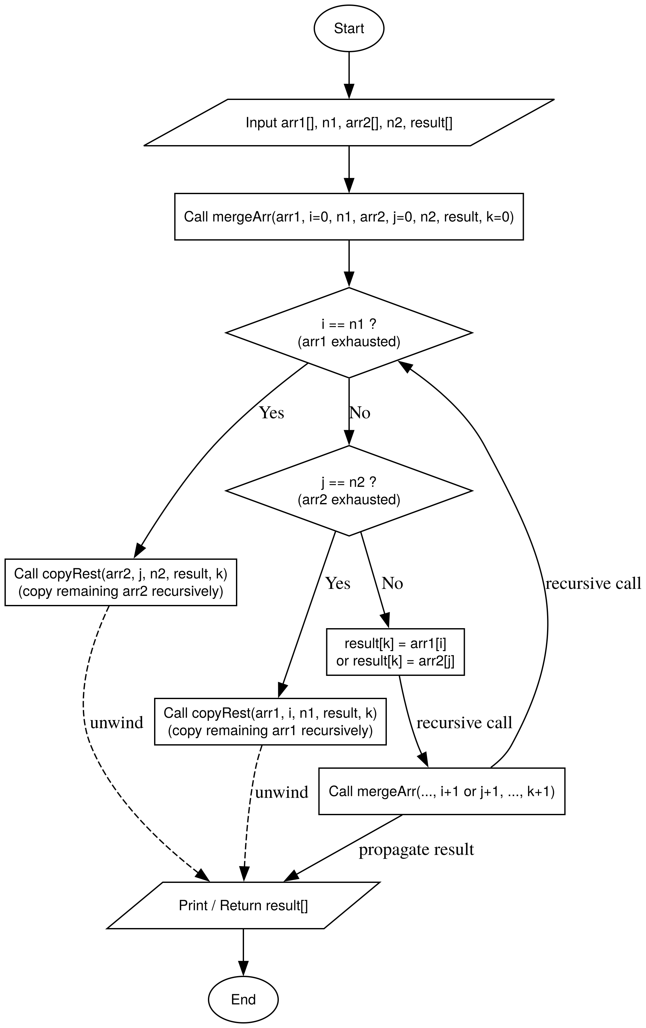 | void merge_arrays(int a[], int n1, int b[], int n2, int merged[], int i = 0) {  if (i == n1 + n2) return;  if (i < n1) {  merged[i] = a[i];  }  else {  merged[i] = b[i - n1];  }  merge_arrays(a, n1, b, n2, merged, i+1);  }

